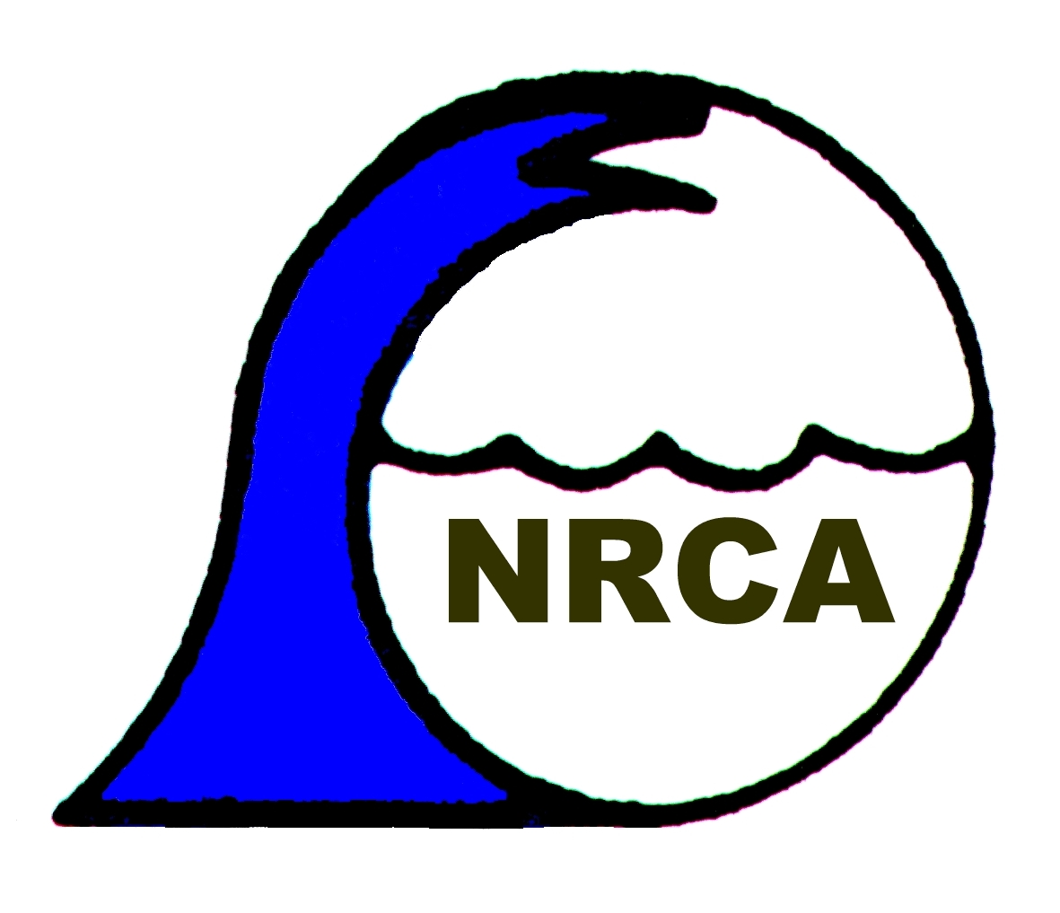
.000.
FORM 2
THE ENDANGERED SPECIES (PROTECTION, CONSERVATION AND REGULATION OF
TRADE) ACT, 2000

Import/Export/Re-Export of Animal Specimens

Application No.

IMPORT PERMIT
EXPORT PERMIT
RE-EXPORT CERTIFICATE
OTHER CERTIFICATES

Name of Applicant:
Please print or type
Address of Applicant:

Telephone No.
Fax No.
E-Mail
TRN No.

I/We hereby apply for CITES Permit(s)/Certificate(s) for: ______________________________________
Name of Consignee
_____________________________________________________________________________________
Address of Consignee

_____________________________________________________________________________________
City/State Zip Code Country

Indicate the name of Broker if applicable
Purpose of transaction
Commercial Zoos Circus and Travelling Exhibitions Scientific

Hunting Trophies Personal Biomedical Research Educational

Reintroduction or introduction into the wild Breeding in captivity

Please describe the purpose in detail on additional sheets.

If the specimen(s) is living indicate provisions to house and care it in country of import, export or re-export.

Indicate the name of each specimen(s) in each shipment in the table below. If additional space is required please attach additional sheets.

Common  Name | Scientific Name  (Genus & species) | Number of Specimens | Description of  Specimen (marks or numbers, age/sex if live) | Indicate if Captive Bred (C),  Reared in Captivity  (R ) or  Collected from the Wild (W) | Date of Birth | Country of Origin | Country of last  Re-export | Country of  Export | Date
Please note the following, where applicable:-

- This application form must be completed to commence processing. Where space is not provided attach additional sheets. Paragraphs that are not applicable to your application should be marked as N/A.

- If species were collected from the wild, indicate name of location and parish/state/country.

- A permit is required for each shipment of animals.

- Any Certificate of last re-export should be attached to the application form.

- Any import of animals shall be subject to the grant of an Animal and Importation Permit from the Veterinary Division, Ministry of Agriculture. Any export permit or re-export certificate shall be subject to the grant of a Health Certificate from the Veterinary Division, Ministry of Agriculture.

- If the specimens are protected animals/birds taken from the wild in Jamaica provide (a) exemption from the Minister of Environment and (b) the purpose that the specimen was removed from the wild.

- If the specimens are required for the purpose of re-export, attach copies of cancelled CITES Export Permits or Re-export Certificate issued by the appropriate CITES office in the country from which the animal was imported. If you were not the importer, provide copies of the importer’s documents above and the invoice or receipt that shows you purchased the animal from the original importer.

- For a Pre-Convention animal, an application will only need to be made to the Management Authority for a Pre-Convention Certificate.

- For living wildlife, describe the type, size and construction of any shipping container and arrangement for caring for the animal(s) during transport.

- For CITES Appendix I species, attach a copy of the CITES Import Permit issued by the Management Authority of the country to which you plan to export or re-export the wildlife (not required if specimen qualifies as Pre-Convention).

- List the Jamaican port through which the export, re-export or import will occur.

(12) This application is only applicable to animal species for which there is no quota system

APPLICANTS DECLARATION

I hereby certify that I have read and am familiar with the Endangered Species (Protection, Conservation and Regulation of Trade) Act.

I hereby certify that the information contained in this application is true and complete to the best of my knowledge and belief. I understand that any misrepresentation contained in this form shall lead to the discontinuation of the processing of the application and the revocation or suspension of any permit granted and also may lead to prosecution.

Signature of Applicant Date

FOR OFFICIAL USE ONLY

Date Received

Registration Number of Captive breeding Facility

Date of NRCA Inspection

Quantity of specimen

Name of Officer

Application fee enclosed

Appendix No. ____________________________

