Prepared by:    Environmental Science & Technology Limited  14 Carvalho Drive  Kingston 10  Jamaica W.I  Tel: (876)929-8824  (876)929-0023  (876)929-0025  Fax: (876)929-8823  . | Addendum to  The Environmental Impact Assessment  For  Grand Palladium Lady Hamilton Resort & Spa  at Point, Hanover
For:

Fiesta Hotel Group
February 2006
Document No.: ES*PRJ 1004/04

Table of Contents

Table of Contents i
GENERAL COMMENTS 1
1 Development Concept and Alternatives 1
2 Sewage 1
TILE FIELD/EMERGENCY ABSORPTION BED DESIGN 2
Process Description 3
3 Drainage and Sedimentation 6
4 Shoreline Stability 6
5 Storm Surge 7
6 Beach Use Prescriptive Rights 8
7 Beach Aesthetics 9
8 Community Project Awareness 11
9 Fauna Impacts 12
10 Managing Invasive Species 13
11 Development on Slopes 14

GENERAL COMMENTS

The comments raised by the NEPA’s Internal Review Committee are generally reasonable and acceptable. This document seeks to answer or provide reference/justification for all issues raised.

Development Concept and Alternatives
- The EIA must provide a defence for the scale of the design being proposed. Why does the development have to have 2000 rooms? What are the forces, whether environmental, physical or economic, that has lead to the design outlined? Additionally, the responses to the questions asked previously must also be represented in the context of an evaluation of other alternatives, including that of a reduction in the scale of the development as proposed.

The carrying capacity for the area is not being exceeded, with habitable rooms per unit area being within national standards. Furthermore, the feasibility and international competitiveness of the project are factors that underpin the development over its projected economic life. This is integral to the level of investment and is also supported by the physical infrastructure (airport, highway, water etc.) in place.
The forces that have lead to the design outlined include the desire to reduce the profile of the buildings in terms of building height and footprint to further preserve the natural look and feel of the area.
Additionally, the alternatives to the development and scale of the development are addressed in Section 2: Alternative Analysis, of the submitted EIA Report.

Sewage
- It is anticipated that the sewage treatment system will be designed to treat wastewater to the tertiary level and that irrigation will be used as the means of disposal. There are a number of possibilities that must be considered in the course of examining the impacts associated with the use of this or any sewage system.

These are outlined as follows:

- The possibility exists that any system can malfunction or not treat to specifications. What are the measures to be taken to mitigate against this, either in the design of the system or in the method of disposal?

The system has been designed to treat to or exceed the specified levels provided by NEPA. The system proposed, is designed to treat to the tertiary level with a 15% capacity excess. Fiesta has similar systems operational in tropical environments similar to Jamaica with no significant impacts to note. Fiesta Resorts operates numerous resort and hotel properties worldwide and have a record of maintaining high standards in all aspects of their operations, waste handling and treatment included.

If the system were to malfunction, methods of troubleshooting, remediation and re-commissioning will be clearly stated in the Operation and Maintenance manual that will be a part of the system. Where necessary, alternate methods of disposal will be utilised including the use of an onsite emergency tile field/soakaway (for treated effluent) and septic disposal companies. A directory of sewage haulage contractors from the entire north coast region will be maintained onsite for use as needed.

Additionally, personnel hired to operate the WWTP will be adequately trained, qualified and certified as appropriate to ensure proper operation and maintenance of the facility. Regular monitoring and testing of effluent will conducted on the schedule and timeframes prescribed by NEPA. This is to ensure compliance with NEPA sewage effluent standards and regulations.

Full details of the system have been provided in the EIA report in Section 1.3 Sewage/Wastewater Treatment.

- Weather conditions (note Tropical Depression/ Hurricane Wilma for example) may prevent the use of effluent for disposal by irrigation. What are the alternative sewage disposal options in this event? What are the possible impacts and mitigations related to the alternative method/s

There are two basic alternative methods of treated effluent disposal being considered by the proponents at this time. These are:

- An emergency tile field/soakaway
- Private cesspool emptying companies

The Emergency Tile Field/Soakaway System

TILE FIELD/EMERGENCY ABSORPTION BED DESIGN
Fiesta Hotels proposes to utilize an absorption bed disposal system for emergency disposal of treated effluent during periods of excessive rainfall. Rather than a series of trenches, one large bed will be utilized. This design is beneficial for this system for the following reasons:
- System will be used in emergency situations only
- If used, system will need to be able to accept large quantities of effluent
- Individual trenches to achieve the capacity required would utilize too much land space
- The absorption bed will be easier to construct and maintain at this site
Proposed absorption bed dimensions 50m long
x 26m wide
x 4m deep
Bed capacity without drain rock 5,200 m³
Bed capacity with drain rock (assuming 35% pore space reduction) 3,380.m³
Maximum volume of wastewater possible (daily) 1,350 m³

Process Description

The following basic installation process will be utilized in constructing the bed (see Figure 1 below):

- It is proposed that the bed will be excavated using a backhoe or similar equipment. If compaction or smearing is observed on the walls or bottom of the excavation, they will be raked to a minimum of depth of 25mm (one inch) before the clean drain rock is placed.
- The excavated bed will be filled from bottom to within approximately 600mm (24 inches) of ground level with clean drain rock ranging from 19mm (¾ inch) to 50mm (2 inches) in diameter.
- Perforated pipe of at least 100mm (4 inches) in diameter will be placed horizontally on this bed of rock with holes pointing down. Drain holes will be in double rows of 6-13mm diameter (1/4 - 1/2 inch) located at approximately 150mm (6inch) intervals. Ends of the pipes will be capped.
- An additional 150mm (6 inches) of drain rock will be placed carefully on top of the pipes.
- Four (4) breather pipes of 100mm (4 inch) diameter will be placed vertically in the bed (two at each end) to allow for venting of the bed.
- A silt barrier (porous geotextile material) will be placed atop the drain rock to support the backfill material and minimize the potential for silting of the drain rock.
- 450mm (18 inches) of backfill material (native soil) will be placed on top of the silt barrier, compacted and landscaped to fit into the existing décor of the site.

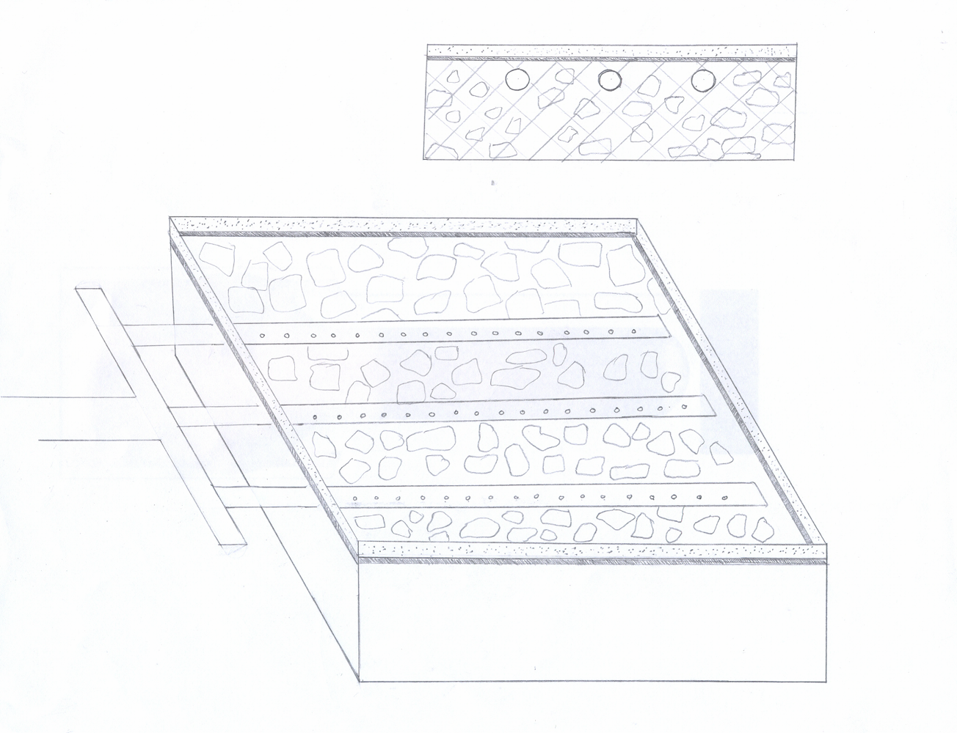
4” Ø
DISTRIBUTION
FEEDER

6” Ø SUPPLY PIPE
FROM TREATMENT
FEEDER
4” Ø DISTRIBUTION
PIPE
50M
26M
4M
CLEAN DRAIN ROCK
(¾” – 2”)
SILT BARRIER
TOPSOIL
GROUND SURFACE
6.5M
13M
19.5M
END VIEW
TOP VIEW
50M

Figure 1: Proposed Absorption Bed Design

- The property’s substrate apparently has high clay content, as was reflected in extensive ponding and waterlogging observed on the site during a recent inspection. This may reduce soil infiltration and subsequent plant uptake. What are the mitigations, as they relate to the use of the soil/plant medium as a point of disposal?

Observed ponding and waterlogging can be caused by a variety of soil types or subsurface conditions which may include high clay content but not exclusively. The property will have in excess of 474,618.60 m² of golf course, open spaces and vegetated verges that will be irrigated with treated water from the system. Landscaped areas tend to have a looser “worked” soil profile that is typically accepting of water and under normal conditions will not cause ponding or waterlogging. The largest areas to be irrigated are to the south of the main residential areas of the resort, across the main road. The primary geology of the area comprises cretaceous sandstones, shales and conglomerates which are reasonably porous in terms of permeability. Details on the geology and hydrology of the site are provided in the EIA report Sections 3.1.3 Geology and 3.1.4 Hydrology.

- Grey water can be a significant contribution of phosphates to the final effluent flow. What are the hotel management measures to be implemented to reduce these contributions?

Low phosphate or phosphate free detergents and cleaning solutions will be utilised in the facility wherever possible. This is in keeping with the company’s environmental and business principles which speak to waste minimisation and environmental protection.

Drainage and Sedimentation
- Previous EIAs reviewed have been notoriously negligent in the review of impacts associated with drainage, particularly impacts resulting from the development changes that will be imposed on previously undeveloped land and impacts associated with building layouts in flood-prone areas. An evaluation of the drainage discharge changes that will occur as a result of site permeability and vegetation changes is needed, along with the mitigations that will be required to ensure that there are no net changes in water discharged from the site and sediment loading to the marine environment. Additionally, the EIA must outline and rationalize its use of specific storm event return periods in its evaluation of impacts.

The northern portion of the site has three areas of natural drainage that effectively drain the site to the sea. This drainage regime will be preserved in the resort and has been incorporated into the new design (see Figure 1-13 of submitted EIA). Changes to drainage due to the construction of the structures will be negligible since the buildings are being spaced with natural vegetation and landscaped areas between. Runoff, where it occurs will be channeled to the natural drains which will be improved during construction. It is not anticipated that the potential for impacts from sediment loading into the marine environment will extend into the occupation phase of the project as most areas of bare soils will be landscaped. The EIA addresses storm event return periods in Section 3.1.8.1 of the report.

Shoreline Stability
- It is very clear that there are areas on the property, particularly east of the headland on the property, where soil erosion has occurred, apparently due to wave action.

  - Has the location of the waterline changed over time (note significance of shoreline retreat in Negril and implications for coastline development)?
  - What are the implications for building stability and, more importantly, what are the impacts that could occur due to wave interactions with buildings?

Shoreline Stability is addressed in Section 3.1.1: Climate and Section 3.1.8.3: Flooding Vulnerability.
Additionally
Observation of the coastline during the EIA process and assessments made have not indicated any major or recent change in the orientation of the shoreline, the waterlineor any significant shoreline retreat. Discussions with locals in the area indicate that the various beaches in the area are much like they have been for the past two decades or more. The location of the hotel at this site will not increase the potential for shoreline retreat, if anything the development of the beaches to resort standards will be a benefit.
According to Jamaica building standards there is a defined setback limit from the mean high tide mark that must be adhered to. Providing the relevant authorities enforce this regulation there should be no problem regarding implications for building stability.
It is important to the developers that an investment of this magnitude be constructed in keeping with all local and international codes for construction of buildings of this type and in this type of location and climate. Additionally, the increased incidence of hurricanes in recent years and their impacts in this area have been taken into consideration during the design process. It is not anticipated that their will be any appreciable problems with wave interactions with buildings under normal conditions. Under adverse (hurricane) conditions it is difficult to predict what may occur, however, the designs have taken this into consideration. Incidentally, much of the natural re-vegetation that has occurred on the shoreline at the site due to the roadway being relocated, will remain in place as the developers strive to maintain as much of the natural vegetation, look and feel of the area.
The developers are aware of and have designed and will construct bearing in mind the extent of storm surge events experienced during hurricane conditions as outlined in the wave direction diagrams in the EIA in Section 3.1.1: Climate, and Section 3.1.8.3: Flooding Vulnerability.

Storm Surge
- The influence of Hurricanes Ivan and Allen should trigger a need for an evaluation of the impacts that could occur due to storm surge.
- What are the expected storm surge run-up distances in the event of the passage of a Hurricane Allen equivalent?
- Will buildings in close proximity to the shoreline require surge mitigation designs or setbacks?
- What will these designs be?
- How will the designs assure shoreline stability?

The designs have been done in keeping with local setback requirements, building codes of Jamaica, international building codes and with a defined knowledge, awareness and respect for the climate and geographical region on which this project is situated. All buildings have been located in areas where impact from surges will be minimal or non-existent. This is due to the elevated location or distance from the surf of most of the buildings.

As best as possible, the natural shoreline will be maintained, the primary activities to be conducted on areas close or on the shoreline will be the development of beaches on the property.

Beach Use Prescriptive Rights
- This Agency is aware that the beach area is accessible to, and has been used in the past by the public. It is certain that there will be prescriptive rights issues and the EIA must evaluate either the mechanisms to ensure that these rights are preserved or must evaluate the feasibility of providing alternative beach accesses

The issue of beach use prescriptive rights is addressed in the EIA in the following sections
Executive Summary pg x
Section 6: Impact Identification pg 6-7

Activity | Action | Environmental Receptor | Magnitude & Duration | Significance | Economic Value
Socio-Economic/Cultural/Loss of Traditional Use and Access to Beach | Pre-Construction, Construction & Operation  [Entire Development] | Human | Large & Long-term | Minor Negative/direct impact | Not Quantifiable
Mitigation Measures:
Positive socio-economic impacts. Provide public access if possible or prudent to beaches. Identify optional public resources in proximity for bathing, fishing, etc. Recognize Prescriptive Rights of population to utilize beach. Secure any identified cultural heritage resources through JNHT.

Additionally
There are additional coastal areas on either side of the property that have been used for public bathing by the residents of the surrounding communities. Despite the loss of the specific area, the public will not be seriously restricted from beach access in the area.
Where possible the developers will work with the local communities to prepare the adjacent beaches to a similar quality for their use and enjoyment.

Beach Aesthetics
- Previous experiences with beach modification and seagrass removal projects have now lead to the requirement that the impacts associated with same be detailed at the level of the EIA.

- Where, if any, are the beaches that will require modifications?
- What types of materials will have to be moved from the beach area and where are these areas located?
- Where, if any, will seagrasses be removed from and relocated to?
- How much seagrass will be removed/relocated?
- Where, if needed, will replacement sand be sourced?
- How much will be needed?
- How will it be transported to and deposited on the site?
- What are the various methods proposed to effect the activities outlined above and what mitigations will be required?

- Note that there are shallow coralline materials close to the surface at some sections of the two natural beaches occurring on the western side of the peninsula on the property. This coralline material may have live coral within and may provide a tidal habitat for marine organisms.

The nature of the shallow coralline materials close to the surface at some sections of the two natural beaches occurring on the western side of the peninsula is addressed in Section 3.2.4 on pg. 3-34.
Additionally
The beaches that may require modifications are outlined in Figure 2 below.
1
2
3
4
5
6
7
Figure 2: Beach and Sand Deposit Location for The Proposed Resort Development at Point, Hanover
The type of material to be moved from the beach area include; rubble on sandy shoreline and in shallow water that is in no way living material, washed up debris similar to that found along a typical beach front in Jamaica and sea grasses to provide appropriate bathing access
If necessary, sea grasses will be removed from beaches 3, 4, 5, 6, and 7 in Figure 2 above. The sea grass will be relocated to areas to the western and eastern boundaries of the shore front where sea grasses already exist.
The quantity of sea grass to be removed/relocated is unknown at this time, however the beach permit application will provide all the details.
It is not anticipated at this time that any replacement sand will be required at this site. The quality and quantity of sand available at the site appears to be sufficient.
Potential Impact | Action | Environmental Receptor | Magnitude & Duration | Significance | Economic Value
Removal of Vegetation, Loss of Habitat | Pre-Construction  [Site Clearance] | Land, Flora, Fauna, Endemic Species | Medium & Immediate/Long-term | Direct/Minor Negative / Reversible impact | Included in cost of construction
Mitigation Measures:
The removal of vegetation and ecological habitats is unavoidable and is the main trade-off to be made against the economic benefits to be derived from project implementation. By design many mature trees will be left intact, and by extension, any endemic terrestrial fauna. Species re-introduction should occur naturally in these areas.
Activity | Action | Environmental Receptor | Magnitude & Duration | Significance | Economic Value
Beach Aesthetics | Construction  [Vegetation Removal/Construction Activities/Coastline Modification] | Soils, Groundwater, Coastal Waters and Marine Flora & Fauna therein, | Medium & Short-term | Minor negative, direct, sporadic, avoidable impact | Included in cost of construction
Mitigation Measures:
Requires removal of some sea grass and coarse material (rubble, gravel etc.). Depending on the intensity of the work being undertaken on the beaches and in the water, silt screens will be available and used to contain sedimentation during these exercises. Sea grasses removed will be transplanted at a suitable location along the coast under the direction of NEPA or a designee.
Equipment and chemical storage will be monitored and maintained on a regular basis. Any indication of leaks, discharge to coastal waters will be addressed immediately. Equipment maintenance on site will be minimal and monitored. Construction monitoring will include these potential impacts.

Community Project Awareness
- Any community awareness surveys conducted in the area must have a survey method described and must rationalize the sample area examined. Additionally, there may be a need to target specific interest groups, such as Fishers, or population center groups, such as residents or commercial interests in Lucea.

The community awareness survey is addressed in Section 4: Social Environment on pg. 4-2 with the survey instrument attached as Appendix II. All target groups and stakeholders were covered in the socio-economic survey.

Fauna Impacts
- Have there been any turtle nestings reported on the shorelines bound by the property?
- What are the mitigations to ensure that nestings (which may have been observed but not reported) are not hindered?

Aspects of the faunal impacts as it relates to sea turtles is addressed in the EIA in Section 3.2: Biological Environment.
  - Section 3.2.4 on pg 3-39
  - Section 3.2.5 pg. 3-43
Additionally
It is readily accepted that the urbanisation of the coastline has led to decreased sea turtle nesting on our beaches along with the illegal capture/kill of endangered sea turtles in the marine environment. As such, the following mitigation plan is put forward for the protection of possible turtle nesting beaches at the site.
The proponents will develop materials that will enable visitors and volunteers to distinguish sea turtle species on the basis of nesting crawls, nest sites, eggs, hatchlings, etc. and should be developed with the assistance of the relevant organisations such as NEPA.
- Artificial lighting: Sea turtles, especially hatchlings, are profoundly influenced by light. Baby sea turtles, freshly emerged from the nest, depend largely on a visual response to natural seaward light to guide them to the ocean. In zones of coastal development, sources of artificial light distract hatchlings so that they turn away from the sea and crawl landward. It is essential that artificial light sources be positioned so that the source of light is not directly visible from the beach and does not directly illuminate areas of the beach. Low pressure sodium lights should be used to the maximum extent possible. Low intensity, ground-level lighting is encouraged. Night time and security lighting should be mounted not more than 5 m above the ground and should not directly illuminate areas seaward of the line of permanent vegetation. Window shading is recommended.
Natural or artificial structures rising above the ground should be used to the maximum extent possible to prevent lighting from directly illuminating the beach and to buffer noise and conceal human activity from the beach. Planting native or ornamental vegetation, or using hedges and/or privacy fences is recommended.
- Beach stabilization structures: The construction of seawalls and jetties, and lights shining on the beach at night should be prohibited or closely evaluated in light of the ecological requirements of endangered turtles.
- Design setbacks: Construction setback limits take into consideration beach and backshore characteristics and should be enforced as defined by Jamaica’s building codes. Setbacks should provide for vegetated areas between the hotels and the beach proper.
- Access: The use of motorized vehicles should be prohibited on all beaches at all times and parking lots and roadways (including any paved or unpaved areas where vehicles will operate) should be positioned so that headlights do not cast light onto the beach at night.
- Vegetation cover: All attempts should be made to preserve vegetation above the mean high tide mark. Creeping and standing vegetation stabilizes the beach and offers protection against destructive erosion by wind and waves.
- Physical destruction of coral and sea grass: Anchoring should not occur in reef or sea grass areas. Divers, especially tourists, should be thoroughly coached on diving etiquette so as to preclude trampling, collecting, and touching living coral.

Managing Invasive Species
  - Exotic non-native species of plants and possibly animals have, in the past, been introduced at Hotel sites to add to the aesthetics of the property. There are, however, risks associated with such a practice, particularly if aggressive species are utilized. The use of such species will not be sanctioned and the EIA must outline the measures to be taken to ensure that such activities do not occur.

No exotic species are planned for introduction at the site. Landscaping will utilize plants that are native to Jamaica and the area.
Recommendations
- A nursery will be set up with the plants at the site that will be retained for use on the site as well as all other plants to be incorporated

Development on Slopes
  - It has been noted that a portion of the development is proposed for the sloping and naturally vegetated areas to the south of the main road. This is a concern, owing to the nature of the substrates underlying the slopes. An evaluation of the impacts associated with such a development is required.

An assessment of the geology of the area is given in Section 3.1.3: Geology.

Additionally

The area to the south will be primarily a golf course and associated infrastructure. This means that the majority of the area will be under vegetation that will limit the potential for erosion. Areas of added concern can be addressed through the implementation of natural soil stabilization techniques such as terracing.

Greater than two (2) days capacity (assuming no percolation)

