**ENVIRONMENTAL IMPACT ASSESSMENT**

FOR THE PROPOSED CEMENT PLANT AND QUARRY OPERATION

BY CEMENT JAMAICA LIMITED AT PORT ESQUIVEL INDUSTRIALCOMPLEX, ST CATHERINE AND

ROSE HALL DISTRICT CLARENDON,

JAMAICA

**APPENDICES**

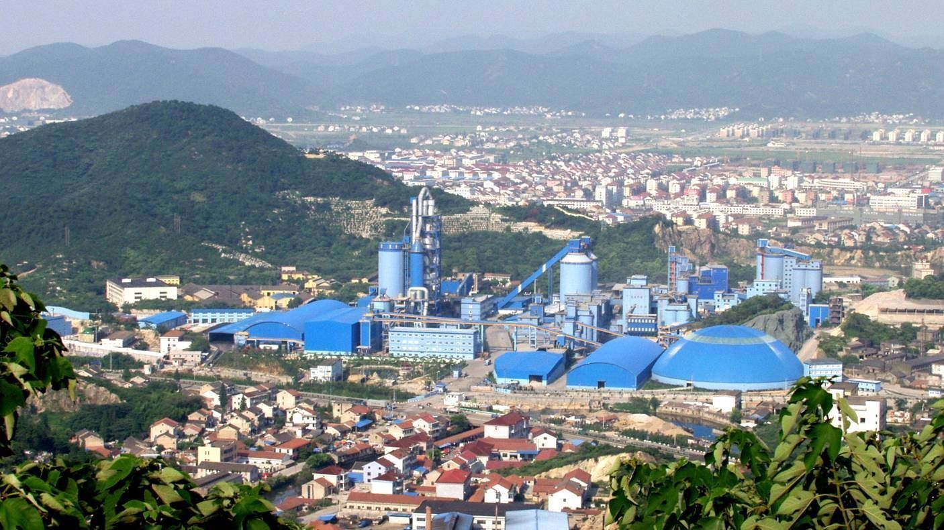

December 2010