Cement Jamaica Limited Proposed Limestone Quarry Rose Hall Clarendon
Hydrogeological Setting
Spatial Extent of Aquifers

The Project Area occurs within the Rio Minho and Rio Cobre hydrologic basins. The conceptual hydrogeologic framework consists of two aquifers. The hydrogeologic setting is defined on the basis of the lithologic and hydrologic properties of the Cretaceous volcanics, Late Tertiary Yellow Limestone and mid-Tertiary White Limestone, and Quaternary alluvial sediments. The Cretaceous volcanics and volcaniclastics, and the dolomitized and recrystallized Yellow Limestone Group represent the oldest stratigraphic sequence, forming an impermeable basement suite. This unit, the Basal Aquiclude, is present in the Rio Cobre and Rio Minho basins and occupies 25 percent of the island's area, outcropping along the ESE - WNW central spine of the island in exposed inliers and in western Jamaica. The mid to late Tertiary White Limestone Group outcrops mainly in the highlands, forming the principal aquifer of the Rio Cobre and Rio Minho basins, and overlying the basement rocks. The White Limestone aquifer is separated from the overlying alluvial aquifer by a thin red marine clay layer that acts as a confining unit to separate the aquifers into independent hydraulic systems (White, 1980). The Quaternary alluvium covers the Coastal Plains in the southern half of the Rio Cobre and Rio Minho basins. Subsurface stratigraphic relationships among these units constitute the hydrogeologic setting of the Project Area. Figure 2 illustrates the spatial distribution of hydrostratigraphic units within the Project Area and environs.

White Limestone Group
The White Limestone is the principal aquifer in the Rio Cobre and Rio Minho basins. Although the White Limestone Group has been subdivided into ten formations (largely on the basis of bio-stratigraphic criteria), it forms one hydrostratigraphic unit. The Limestone Aquifer occurs extensively throughout the Rio Cobre and Rio Minho basins and exclusively in the Project Area as the Newport Formation (Mn). The Newport Limestone occurs as rubbly, reefal deposits with beds ranging in thickness from 10 cm to 1.0 m. Secondary permeability within the white limestone in the study area is considerably high due to post-depositional alteration by chemical diagenetic processes (such as dolomitization and fracturing) and karstification. Dry gullies and solution/karstic features are prevalent in the study area. The result is a highly transmissive aquifer with extensive subterranean drainage along well-defined major structural features (for e.g. faults) that serve as conduits for groundwater movement. Major N-S trending faults coincide with zones of increased transmissivity and are recognized to create preferential flow paths for groundwater movement. Historical records indicate increased well productivity in these zones of higher transmissivity, in the vicinity of Longville Park and Inverness.

Water occurs primarily under unconfined conditions in the permeable, recrystallized zone of the regional limestone aquifer.

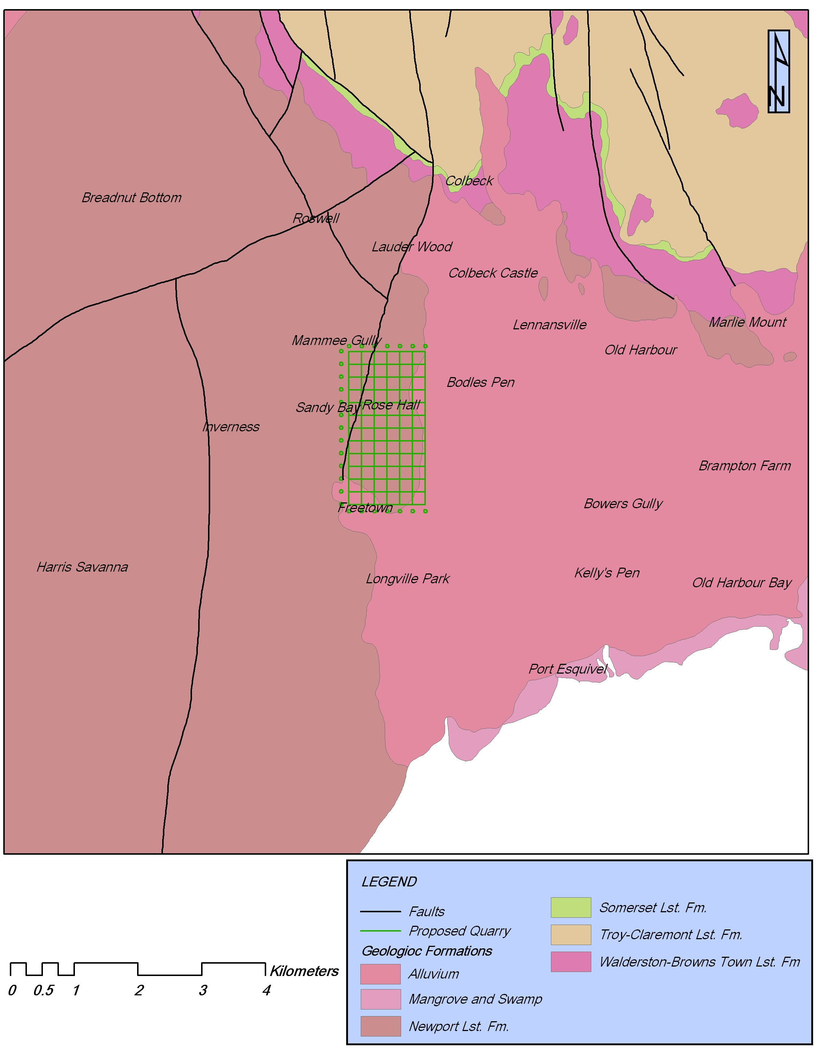
Figure 1: Geology of Project Area and environs.

Recharge to the White Limestone aquifer occurs by infiltration through soils, pores, fractures in exposed rock outcrops, solution enlarged fractures (conduits) and collapsed zones. Water travels through interconnected networks of pores (primary porosity), fractures, and solution cavities resulting in a predominantly conduit type flow.

Water Levels and Groundwater Flow Direction
Water level data were obtained from irregular-spaced wells located in the Limestone Aquifer. There is a paucity of water level data for the highlands at Old Harbour Hill and environs as there are no production wells or bores. Consequently, depth to water was extrapolated on the basis of known depths to water in other regions of similar geology.
Depth to water levels was taken from the Sandy Bay, Toby Abott and Freetown wells (see Figure 2). Depth to water in the vicinity of Old Harbour Hill is an anticipated 9 metres below ground level. Water level gradients are characteristically steep ranging from 7 metres below ground level at Sandy Bay well (to the north) to 1.3 metres below ground level further south at Toby Abott well.
Groundwater flows in a southerly direction toward the coast.

Alluvium Aquifer
The Alluvium Aquifer in the Project Area is represented by Quaternary Alluviums. The alluvium unit is often characterized by much variability in lithology (both laterally and vertically) and has implications on its hydrologic character. Although predominantly a clayey unit, a well developed surficial aquifer may be found in the upper 20 to 30 metres, comprising fluvio-alluvial sands and silt, gravel, clays and marine sediment. The alluvial aquifer is unconfined and lies atop the karstic White Limestone Aquifer.
There appears to be restricted hydraulic continuity between the alluvium and underlying limestone, each functioning as an independent aquifer. This is largely the result of a confining marine clay layer that separates the two. The confining unit allows the underlying White Limestone to become pressurized above atmospheric pressure levels and therefore has a higher hydraulic head than water levels in the alluvium aquifer. The Limestone Aquifer at the southern and western edges of the proposed quarry area is confined (see Figure 2).

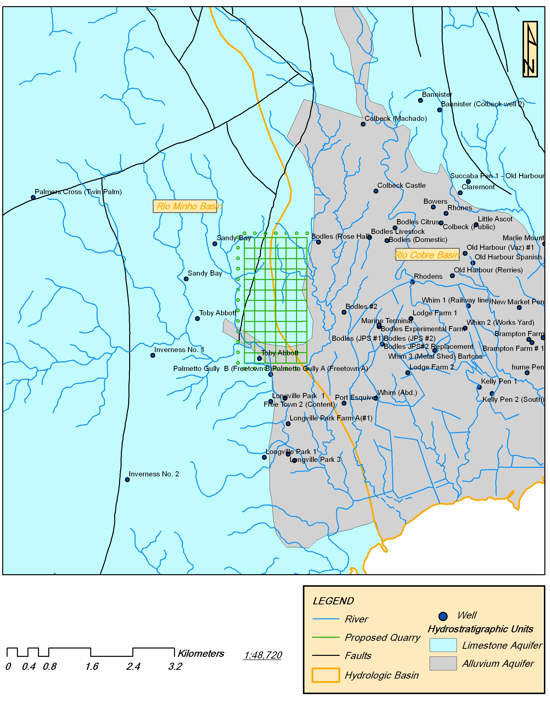
Figure 2: Hydrostratigraphic Units across Project Area and environs.

Surface Hydrology
Drainage
The site can be divided into three major catchments, eastern catchment, western catchment and southern catchment. Figure 3 shows the three major catchment areas. The eastern catchment encompasses an area of approximately 99.7 hectares (996 938 m2) and drains via overland flow to the Clarendon gully located east of the quarry site (See Figure 3). The western catchment has an area of approximately 71.8 hectares (718,336 m2) and drains through three earth swales to the Mammee gully which runs parallel to the western boundary of the property before crossing the Old Harbour main road and discharging into the Palmetto Gully. The Southern catchment has an area of 53.8 hectares (538,660 m2) drained in a southerly direction via overland sheet flow. There were no noticeable drainage features draining this catchment which suggests that the land is drained by the existing roads as overland sheet flows to the Palmetto Gully.

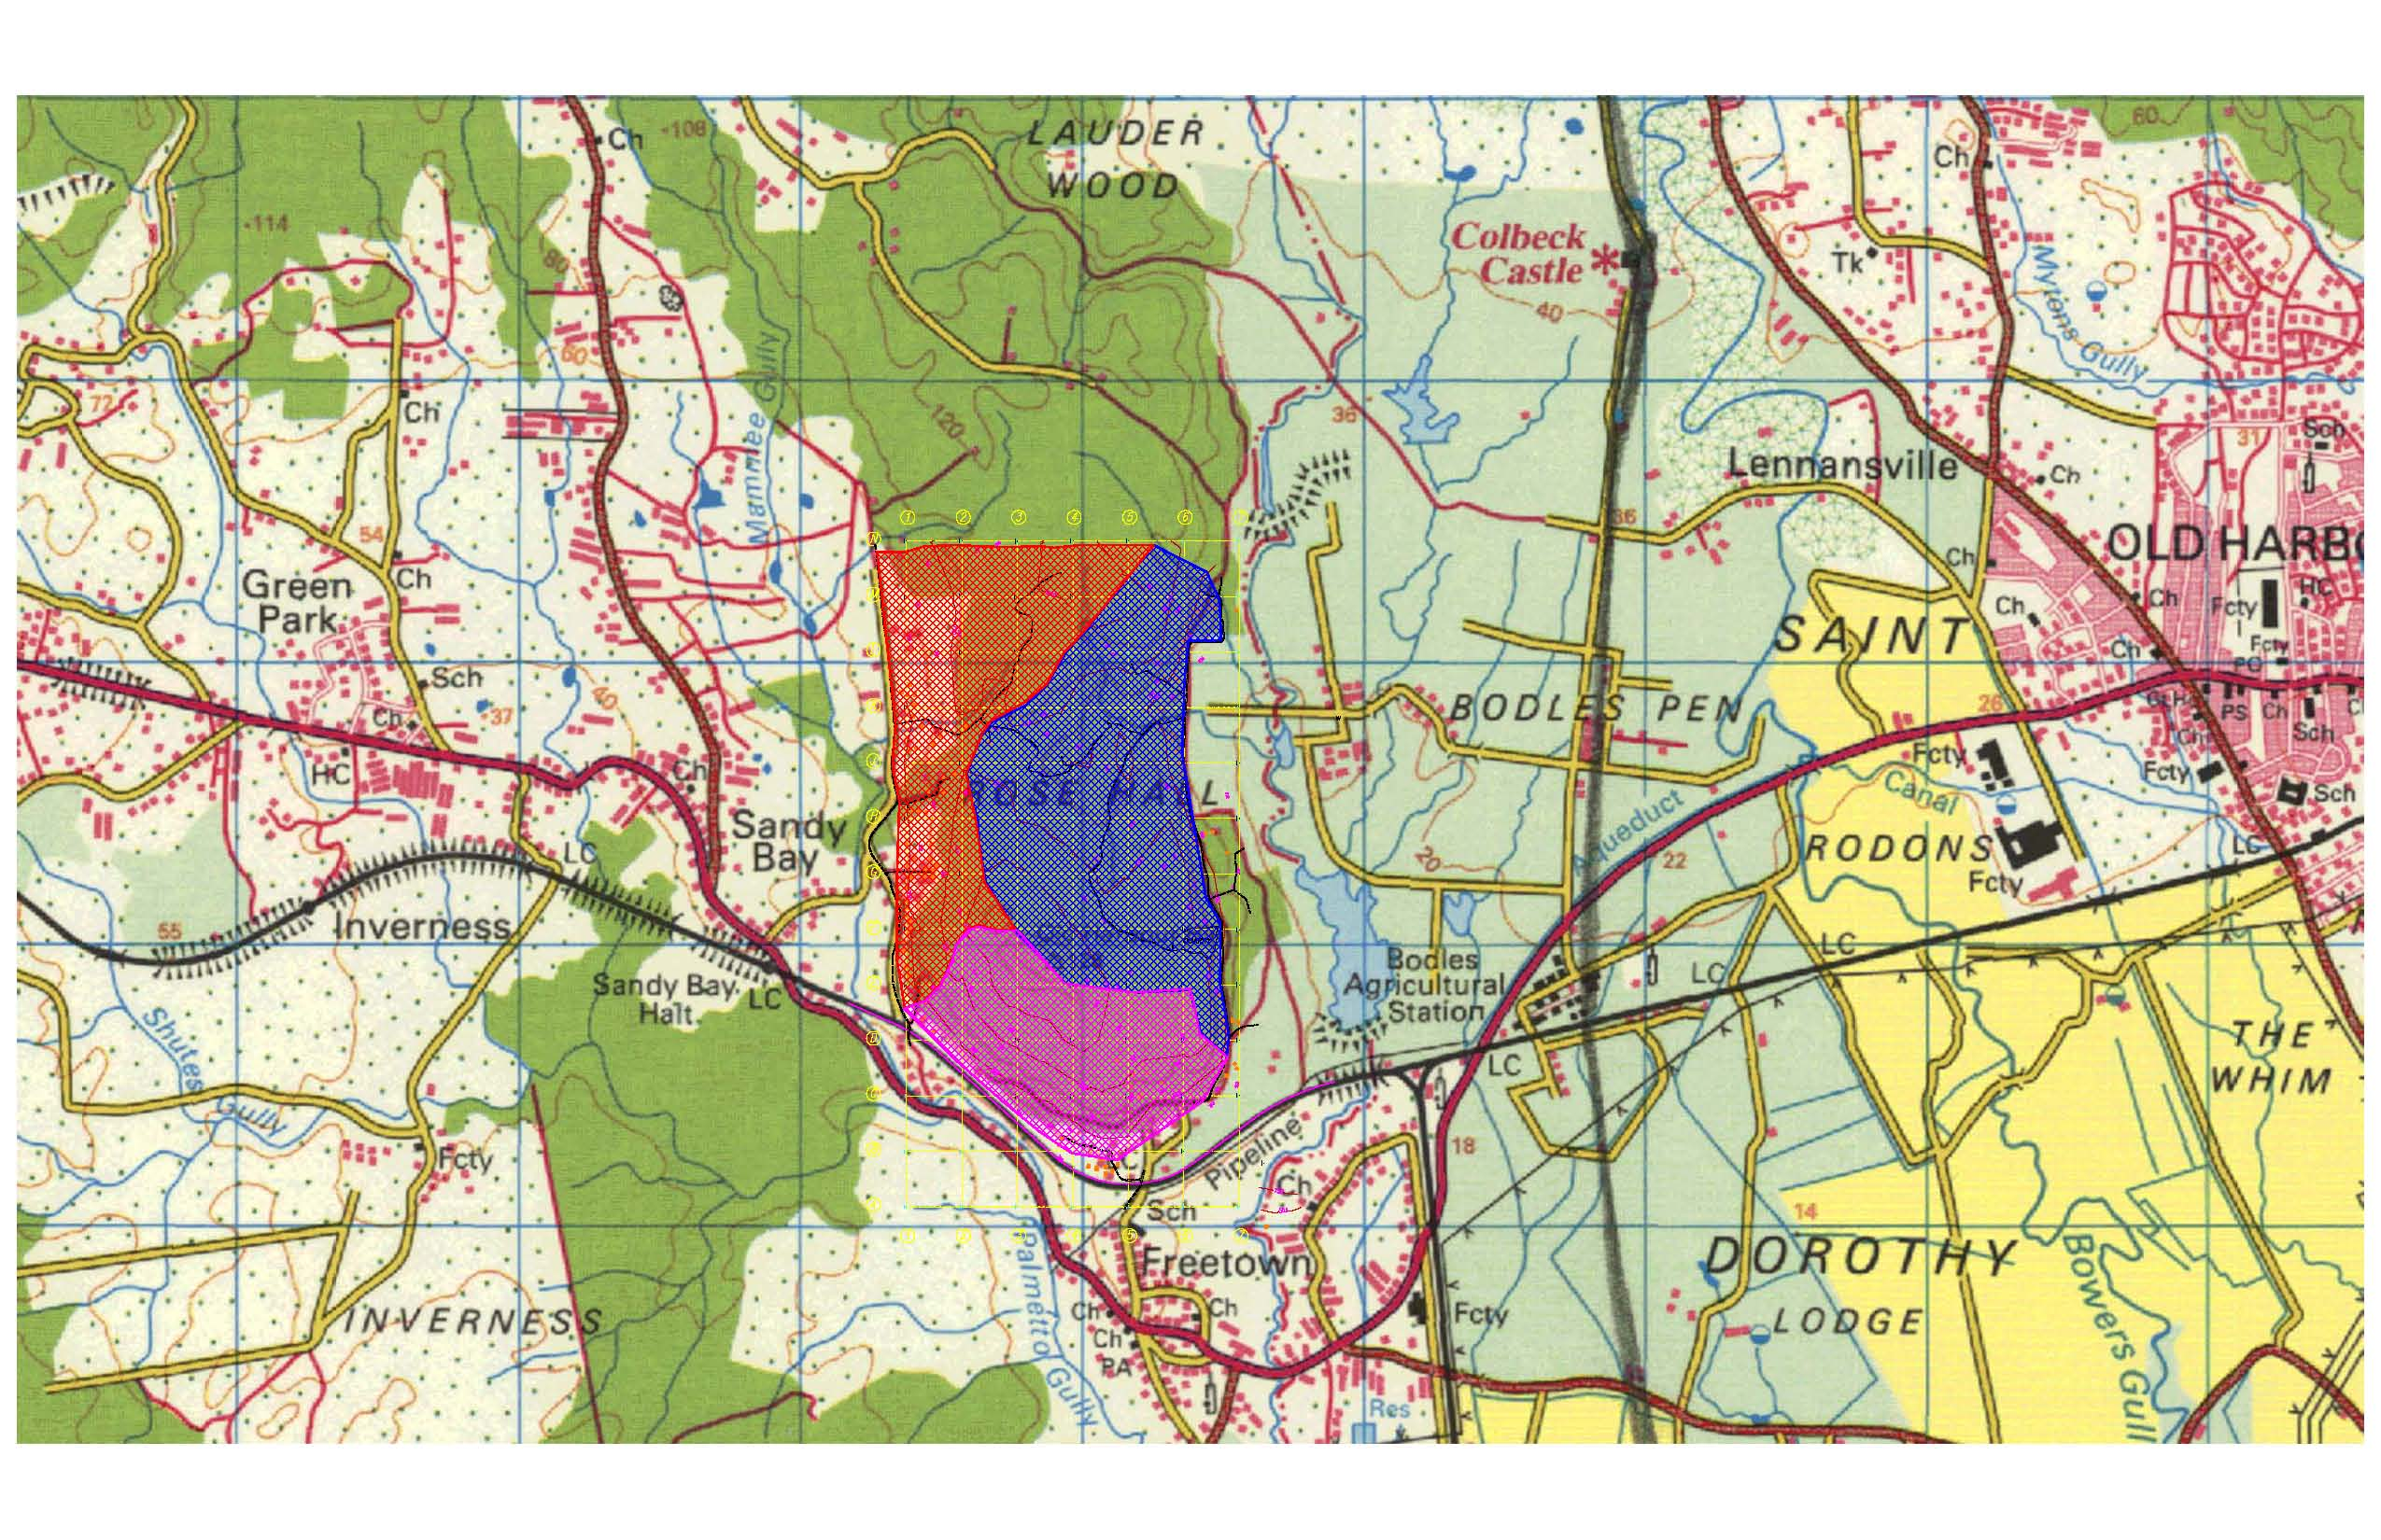
Figure 3: Map showing catchments associated with the site.

