Terms of Reference for Conducting an Environmental Impact Assessment (EIA) of the Proposed Cement Plant and Quarry Operation by Cement Jamaica Limited at Port Esquivel Industrial Complex and Rose Hall District St Catherine/Clarendon

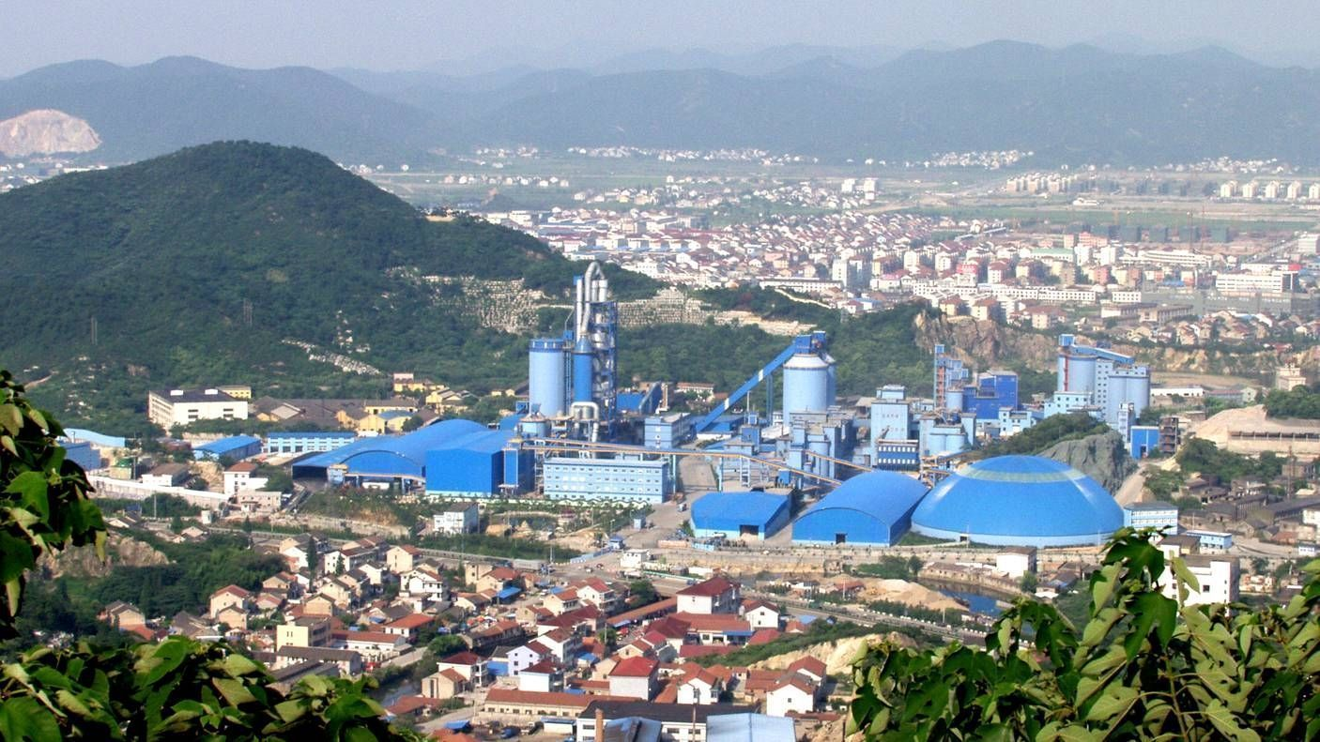

PROJECT PROPOSED BY: Cement Jamaica Limited
P.O. Box 506
Kingston 10.

PREPARED BY: EnviroPlanners Limited
17 Monroe Road
Kingston 6

DATE: December 30, 2009

TABLE OF CONTENT

1.0 INTRODUCTION 3

3.0 PROJECT DESCRIPTION 3

4.0 PROJECT LOCATION 7

5.0 TERMS OF REFERENCE 8

- INTRODUCTION
EnviroPlanners Limited has been contracted by Cement Jamaica Limited to conduct an Environmental Impact Assessment for the development of a Cement Plant and Quarry operation at Port Esquivel Industrial Complex and Rose Hall District in the parish of St. Catherine/Clarendon. In keeping with the requirements of the National Environment & Planning Agency (NEPA), EnviroPlanners limited is proposing the following Terms of Reference. This is based on NEPA’s draft Terms of Reference issued to Cement Jamaica Limited.

2.0 PROJECT DESCRIPTION

Project Concept
The Project involves two main components; namely a limestone quarry and a cement production plant. The operations will essentially produce two products, namely Portland cement and dolomitic materials, 1.5 million metric tones of Portland cement annually and approximately 5.0 million metric tones of limestone

The Project is being developed by Cemcorp Cement, Inc., Ontario, Canada; through its local subsidiary, Cement Jamaica Limited. The cement plant will be constructed by Sinoma International Engineering Company out of China. Sinoma is the world’s leading designers of cement plant and have designed and constructed well over 100 cement plants in more than 25 countries.

The Project site consists of two parcels of land in relatively close proximity to each other and is strategically located within a region rich with limestone and zone for mining with easy access to major roads and the rail network and the port at Port Esquivel.

Location of Project Site
The proposed project site for the quarrying operation is on lands located at Rose Hall in Clarendon near the border of St. Catherine adjacent to the communities of Freetown and the Bodles Agricultural facilities. Valuation Reference No. 20702007003.
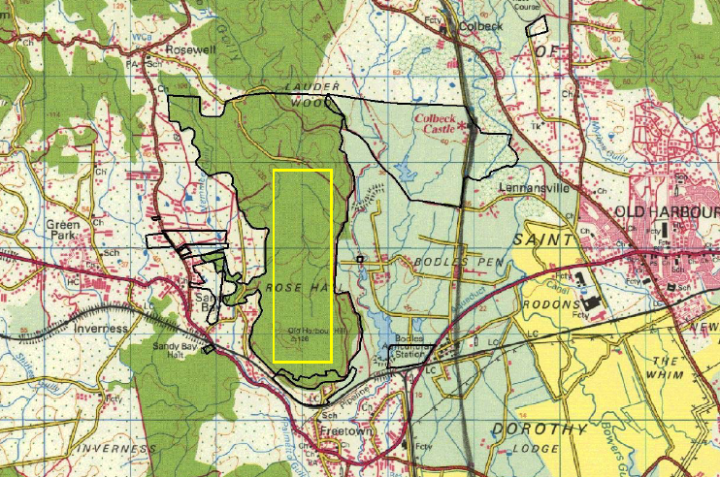
QUARRY LOCATION MAP
Project Process Description
Limestone Quarry
The quarry will be mined for limestone which will be crushed and fed to the cement plant. The method for quarrying is subsurface open cast mining.
a) Subsurface Open Cast Mining
Overburden or waste materials will be removed prior to exposing the limestone bedrock which is approximately 2 to 5 m below surface. During the quarry operation, mining of limestone will be carried out in a staggered pattern on the quarry face slope. Strict adherence to the blasting parameters and blasting procedures will be observed, and the loosened limestone blocks will be hauled to the crushing plant which will be located within the mining area.
b) Crusher Plant
A crusher plant will crush the limestone rocks to smaller sizes before being conveyed to the cement plant. The crusher plant is able to crush up to 1,000 t/hr of rock. A single-stage hammer crusher will be used to produce crushed stones of approximately 70 mm in size. The crushed limestone will then be transported into the Limestone Storage Yard at the plant by means of a conveyor belt which will run alongside the existing railway.

Production of Cement
The operations are being designed by the foremost factory fabricator in China, SINOMA International Engineering Co., Ltd.; they will be employing the most modern and efficient production technologies being used worldwide.

The modern dry process of manufacturing cement will be adopted where the raw materials are ground dry prior to the sintering process. The main steps in the production of cement are:
- raw material procurement,
- preparation of raw materials,
- pyro-processing for clinker production,
- grinding for cement production, and
- cement packing and delivery.

Cement Plant Location
The proposed site for the cement plant is on approximately 100 acres of land on the eastern side of the Longville Park main road.

CEMENT PLANT LOCATION MAP

PROCESS FLOW DIAGRAM; CEMENT PRODUCTION AND ASSOCIATED ACTIVITIES

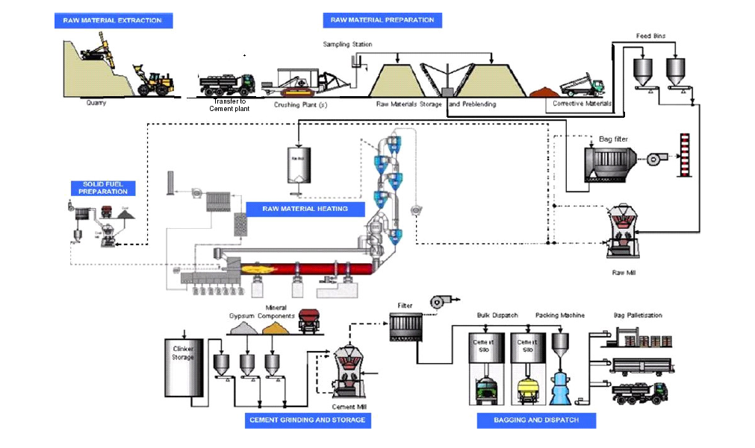

a) Raw Material Procurement
The principal raw materials used in the manufacture of cement are limestone, clay, sand, gypsum and ore. Limestone (mostly containing calcium carbonate) which makes up approximately 87% of the raw materials will be obtained from the project quarry site. All the other materials will be procured from sources within 10 km from the Project site. Coal will be imported from overseas at the Port Esquivel port and utilized as fuel during clinker burning.
Raw materials will be stored in covered storage sheds. Buildings with minimal open passages for dust dispersion control are provided adjacent to the crusher and raw meal feed bins for the storage of primary raw materials.

b) Preparation of Raw Material
This operation combines the blending of raw materials based on chemical composition in the raw material batching plant or also referred to as the Pre-blending Bed prior to their use. For the preparation, the pre-set weighed proportions of the raw materials will be extracted from their respective bins via weigh feeders onto conveyor belts and fed into the raw mill for grinding.

c) Pyro-processing for Clinker Production
The pyro-processing system to produce clinker involves three major steps: (i) drying or preheating; (ii) calcining; and (iii) burning or sintering. The clinker burning system consists of a rotary kiln (temperature up to 1,450 °C) with double string, five-stage cyclone preheater with a precalciner.
Clinkers produced are grey-coloured, typically of 3 to 25mm in diameter. The principal chemical compounds in the clinker are Tricalcium silicate, C₃S (40-60%), Dicalcium silicate, C₂S (16-30%), Tricalcium aluminate, C₃A (7-15%) and Tetracalcium aluminoferrite, C₄AF (7-12%).

d) Cement Production
The final step is the grinding of clinker to a fine powder. Up to 5 parts of gypsum and 5 parts of limestone are added to 90 parts of clinker for grinding. In the cement mill, grinding is carried out in a closed circuit arrangement. The system consists of two roller presses and two tube mills. Collected finished product (cement) will be transported to the cement storage silos.

e) Cement Delivery
Semi-automatic bag applicator will be used for packing of the final product into bags. Approximately two thirds of the cement produced will be exported, and the remainder sold to the local construction industry. All the dolomitic material will be exported, mainly to Canada.

Process and Quality Control
The cement plant will be controlled by a Distributed Control System (DCS) from the Central Control Room. Process variables in all manufacturing departments are continuously monitored in order to regulate and optimize clinker and cement production, i.e. from raw material storage to cement storage, or packing and loading. However, manual intervention is possible during process upsets, equipment malfunction or emergency conditions.
Flame profiles in the kiln are closely monitored for abnormal flame conditions, to ensure that any abnormalities can be detected and rectified. Operation of the pyro-processing system receives close attention since product quality will be largely determined in the kiln. If proper process conditions and kiln temperatures are not maintained, the complex chemical reactions in the kiln will be incomplete rendering the clinker produced unacceptable.
At every stage of the cement manufacturing, the raw and intermediate materials as well as the end products will be analyzed at the plant's laboratory to ensure that they conform to set quality standards on a consistent basis. The laboratory is equipped for testing of major process related materials, sample preparation, chemical analysis and physical testing.

Energy Source:
The plant will use coal that will be imported from Columbia for generating power. Excess power generation will be sold into the Jamaica Public Service power grid. This will contribute to the reduction in demand and use of expensive and escalating cost of oil.

Pollution Control
Pollution control measures and safeguards are key features in the operation of any industrial plant. The pollution control measures for the Project were selected after identifying emissions of various pollutants, particularly air pollutants from the different stages of cement manufacturing.
a) Air Pollution Control
Air pollutants generated during the operation of the Project consist primarily of particulates from quarrying, raw and finished materials as well as fuel combustion by-products.
Pulse jet type bag filters and a bag house will be employed as de-dusting equipment to control major emissions in the Kiln, Raw Mill, Grate Cooler, Coal Mill and the Cement Mill. For other emissions, a sufficient number of standardized bag filters will be installed at all transfer points at hopper, bins or silos as well as dust producing machinery (crushers, loading equipment, conveyors etc.) for de-dusting purposes.

Modern technology burners, dosing systems for fuel and kiln feed, and kiln control systems are used for the plant processes to control emissions (NO_{x}, SO_{x}, CO).
Cyclones will also be installed within the Raw Mill to capture materials entrained in airflows, which are routed through principal process units (e.g. milling and pyro-processing stages). They are considered as pre-treatment recovery and recycling device, and assists in enhancing the efficiency of both bag house and bag filter systems.

b) Water Pollution Control
The Project adopts a dry process of manufacturing. As such the volume of production wastewater for treatment and disposal is minimal and estimated at 250 m³/d. The principal effluent released from the clinker production and cement manufacturing process is principally equipment cooling water.
Domestic wastewater generated from toilets and the canteen is estimated to be at 225 m³/d. All wastewater is routed to the wastewater treatment plant prior to disposal. The treated effluent will comply with NEPA Standard for sewage effluent
Overflow cooling waters, tanker washings and floor washings will be collected and conveyed by open drains. These process wastewaters will be channeled into a solids 'gravity' separator then to the wastewater treatment plant prior to discharge.

c) Noise Control
The Project is likely to generate significant noise levels during blasting and from operation of the cement plant. The principal noise emission sources are impulsive noise during blasting and those associated with motors, fans, blowers, crushers, air compressor and tube mills in the cement plant. In-plant shielding of noise emissions will be adopted to ensure that noise levels at the boundaries are within the regulatory limits.
All equipment to be employed for the plant will be designed to operate with low noise levels, and will not exceed the maximum allowable noise level for the surrounding receiving land use.

- Drainage from quarry to avert flooding
Drainage will be provided to take storm water into nearby river course to avert flooding arising from changes to the topography of areas being quarried.

e) Access location to the plant and quarry
Access will be sought along the local road from the most western end from the Bodles facilities. This access point will prevent any disruption of the adjoining local residential communities, while providing easy access to the public at large traversing from either ends of the country along the Highway 2000.

Manpower
The Project will require manpower in both of its project components: the quarry component and the cement plant component during the construction and operational phases. Approximately 600 workers will be involved for the construction of the project whilst the total manpower for the operation of the project is estimated at 400.
All recruited staff will be given appropriate training in order to educate them on the specific job tasks to be performed; safety procedures; and the concepts of quarrying, blasting and cement manufacturing.

Project Economics
The total project value is estimated at just under US$300 million. Development of the project is planned to be completed in 24 months .Employment emanating from the operations will be in three phases, namely:
- Pre-construction phase: Various and required professional services for technical advise
- Construction phase: Over 600 persons will be employed over a 24 month period
- Production: Approximately 400-450 persons comprising administrative, technical and non-technical persons will be employed permanently and immediately after completion of the plant. These include engineers, chemists, computer operators, accountants, administrative assistances, secretaries, etc.
4.0 TERMS OF REFERENCE

The Environmental Impact Assessment to be completed by EnviroPlanners Limited will provide a comprehensive evaluation of the site, in terms of predicted environmental impacts, needed mitigation strategies, potentially viable alternatives to the development proposed and all related legislation.

The following issues related to the specific project site will be identified and given special consideration:

Sites located within, adjacent to or in the vicinity of areas listed as protected (e.g. under the Wild Life Protection, Forest, Natural Resources Conservation Authority, Fishing Industry or Jamaica National Heritage Trust Acts or designated Ramsar Sites) or having protected species: The main issue(s) to be considered are determined by the statutes of the legislation or convention in question and what the convention speaks to. The impact of the development on the specific sensitivities of the protected area will be identified and be highlighted as is applicable (e.g. diversion of water flows, extraction of water, pollution)

The Environmental Impact Assessment will include but not limited to the following:
1) Provide a comprehensive description of the existing site proposed for mining operations and for the establishment of the Cement Plant. Detail the elements of the project, highlighting areas to be mined and the areas which are to be preserved in their existing state.
2) Identify the major environmental issues of concern through the presentation of baseline data which should include social and cultural considerations. Assess public perception of the proposed development.
3) Outline the Legislations and Regulations relevant to the project.
4) Predict the likely impacts of the development on the environment, including direct, indirect and cumulative impacts, and indicate their relative importance to the design of the development’s facilities.
5) Identify mitigation action to be taken to minimize adverse impacts and quantify associated costs.
6) Design a Monitoring Plan which should ensure that the mitigation plan is adhered to.
7) Describe the alternatives to the project that could be considered at that site

EnviroPlanners Limited will ensure that a thorough and comprehensive environmental impact is carried out by executing the following tasks:

Task # 1: Description of the Project.
Provide a comprehensive description of the project, noting areas proposed for mining operations, mineral processing and construction of the Cement Plant. Detail the elements of the project, highlighting areas to be reserved for construction, areas to be preserved in their existing state as well as activities and features which will introduce risks or generate impact (negative and positive) on the environment. This will involve the use of maps, site plans, aerial photographs and other graphic aids and images, as appropriate, and include information on location, general layout and size, as well as pre-construction, construction, and post construction plans. All phases be clearly defined, the relevant time schedules provided and phased maps, diagrams and appropriate visual aids. A review of the impacts caused by operation will be done

Task # 2: Description of the Environment
This task involves the generation of baseline data which is used to describe the study area as follows:
i) Physical environment
ii) Biological environment
iii) Socio-economic and cultural constraints.
the methodologies employed to obtain baseline and other data will be clearly detailed.

Baseline data will include:
(A) Physical
i) a detailed description of the existing geology, geomorphology, topography and hydrology of the quarry and cement plant sites. Special emphasis will be placed on storm water run-off, drainage patterns, effect on groundwater and availability of potable water. Any slope stability issues that could arise will be thoroughly explored and mitigation measures identified.
ii) Water quality of any existing wells, rivers, ponds, streams or coastal waters in the vicinity of mining activities and the proposed cement plant. Quality Indicators will include but not necessarily be limited to nitrates, phosphates, faecal coliform, and suspended solids.
iii) Climatic and Airshed conditions (air quality studies) in the area of influence, including particulate emissions from stationary or mobile sources, NO_{x}, SO_{x}, wind speed and direction, precipitation, relative humidity and ambient temperatures,
iv) Noise levels of undeveloped site and the ambient noise in the area of influence.
v) Obvious sources of pollution existing and extent of contamination.
vi) Availability of solid waste management facilities.

(B) Biological
Present a detailed description of the flora and fauna (terrestrial and aquatic) of the areas, with special emphasis on rare, endemic, protected or endangered species. Migratory species will also be considered. There may be the need to incorporate micro-organisms and the existence of micro-habitats to obtain an accurate baseline assessment. Species dependence, niche specificity, community structure, population dynamics, carrying capacity, species richness and evenness (a measure of diversity) will to be evaluated.

(C) Socio-economic & cultural
Present and projected population; present and proposed land use; planned development activities, issues relating to squatting and relocation, community structure, employment, distribution of income, goods and services, recreation, public health and safety; cultural peculiarities, aspirations and attitudes will be explored. The historical importance of the area will also be examined. While this analysis is being conducted, an assessment of public perception of the proposed development will be conducted. This assessment may vary with community structure and may take multiple forms such as public meetings or questionnaires.

Task # 3. Legislative & Regulatory Considerations
Outline the pertinent regulations, policies and standards governing environmental quality, safety and health, protection of sensitive areas, protection of endangered species, siting and land use control at the national and local levels. The examination of the legislation will include at minimum, legislation such as the NRCA Act, the Wildlife Protection Act, The Mining Act, legislation from the Solid Waste Management Authority (SWMA), and the appropriate international convention/protocol/treaty where applicable.

Task # 4. Identification of Potential Impacts
Identify the major environmental and public health issues of concern and indicate their relative importance to the design of the project and the intended activities. Identify potential impacts as they relate to, (but are not restricted by) the following:
- change in drainage pattern
- flooding potential
- landscape impacts of excavation and construction
- loss of natural features, habitats, niches and species by
construction and operation
- pollution of potable, coastal, surface and ground water
- Air pollution
- socio-economic and cultural impacts.
- risk assessment
- noise
- change in soil pH
- waste disposal
- possible improper or accidental waste disposal via discharge into
sewers and water bodies, creation of mud lakes
- capacity and design parameters of waste treatment facility.
- impact of leachate.

Distinguish between significant positive and negative impacts, direct and indirect, long term and immediate impacts. Identify avoidable as well as irreversible impacts. Characterize the extent and quality of the available data, explaining significant information deficiencies and any uncertainties associated with the predictions of impacts. A major environmental issue is determined after examining the impact (positive and negative) on the environment and having the negative impact significantly outweigh the positive. It is also determined by the number and magnitude of mitigation strategies which need to be employed to reduce the risk(s) introduced to the environment. Project activities and impacts will be represented in matrix form with separate matrices for pre and post mitigation scenarios.

Task # 5. Mitigation Measures
Prepare guidelines for avoiding, as far as possible, any adverse impacts due to proposed usage of the site and utilizing of existing environmental attributes for optimum development. Quantify and assign financial and economic values to mitigating methods.

Task #6 Monitoring
Design a plan to monitor implementation of mitigatory or compensatory measures and project impacts during construction and operation. An Environmental Management Plan for the long term operations of the site will also be prepared.

An outline monitoring programme should be included in the EIA, and a detailed version submitted to NEPA for approval after the granting of the permit and prior to the commencement of the development. At the minimum the monitoring programme and report will include:
- Introduction outlining the need for a monitoring programme and the relevant specific provisions of the permit license(s) granted.
- The activity being monitored and the parameters chosen to effectively carry out the exercise.
- The methodology to be employed and the frequency of monitoring.
- The sites being monitored. These may in instances, be pre-determined by the local authority and should incorporate a control site where no impact from the development is expected.
- Frequency of reporting to NEPA
The Monitoring report will also include, at minimum:
- Raw data collected. Tables and graphs are to be used where appropriate
- Discussion of results with respect to the development in progress, highlighting any parameter(s) which exceeds the expected standard(s).
- Recommendations
- Appendices of data and photographs if necessary.

Task #7 Project Alternatives
Examine alternatives to the project including the no-action alternative. This examination of project alternatives will incorporate the use history of the overall area in which the site is located and previous uses of the site itself. Refer to NEPA guidelines for EIA preparation.

All Findings will be presented in the EIA report and will reflect the headings in the body of the TORs, as well as references. Eight hard copies and an electronic copy of the report will be submitted. The report will include an appendix with items such as maps, site plans, the study team, photographs, and other relevant information.

OTHER PERTINIENT and SPECIFIC INFORMATION TO BE COVERED/INCLUDED IN THE EIA

In addition to the above the following information will be included in the Environmental Impact Assessment Study:

- Revised maps showing the areas proposed for quarry operation and the construction of the cement plant with the relevant setback from adjoining proposed residential and residential areas.
- A Species Management Plan to reflect the temporary handling of any endangered or endemic species identified during the study.
- An Archaeological study/assessment of the Rose Hall Quarry site
- Public Health and safety concerns for the quarry and cement plant- (Health Impact Study) facilities on the adjoining communities
- Preparation of a cumulative impact report of the new developments on the existing environment.
- Provision of a conceptual reclamation and restoration plan for both facilities especially for the new quarry
- Development of a closure plan for both facilities

- Statements on Energy Conservation should be incorporated
- Quarry Restoration and After Care Analysis
- Outline of the transportation corridor for the conveyor belt and any other means of transportation of aggregates and finish products.
- Traffic Studies for both facilities
- The disposal of and management of solid, liquid and any hazardous waste during the construction and operational phases.

