New Harbour Village

Water Distribution & Sewage Design

Engineering Report

Prepared for: Gore Development Limited

July 2005

Gore Developments Limited New Harbour Village water distribution and sewerage design report

Overview

Mr. Christopher Gore of Gore Developments Limited retained Foreman Chung & Sykes Consultants Limited to prepare Civil Engineering designs for the proposed New Harbour Village Housing Development located on lands called New Market in Old Harbour Saint Catherine.

The National Water Commission indicated that they could supply the project with water if their present system was upgraded however the Water Resources Authority stated that the NWC does not have adequate supply at present and instructed the developer to seek an alternative source of water.

An operating well exists on the site and it has been tested for both quantity and quality of water available. Preliminary investigations show that the quantity exists and that the quality will be improved by treatment if necessary. Applications for a replacement well and for the license to abstract water are now with the WRA for approval. The well design and treatment works if required was done by another consultant.

The sewerage designs include the street main collection system only as the treatment plant supplier will design the sewage lift station to be located on that plant site.

The proposed subdivision will have 840 housing units.

Estimate of the development’s potable water use

The present average number of person per household based on the 2001 census is 3.6 however 4.5 is used to give a conservative population and estimate of water demand.

The peak factors used were taken from the Jamaica Institution of Engineers recommended guidelines for design and construction of housing infrastructure volume 3 water supply systems.

Water losses on the distribution network will be taken as 20% of the total demand as recommended by the NWC.

Estimate of water use
Table 1
Error! Not a valid link.

Water distribution design

Water distribution network
The service delivery standards for water distribution systems in Jamaica are set by the Office of Utilities Regulation. The recommended minimum pressure at the service connection during peak demand is 20psi (14m of water or 138kP). The Jamaica Institution of Engineers (JIE) Guidelines for Design and Construction of Housing Infrastructure recommend that the residual pressure at the hydrant during fire events be 5psi.

The subdivision is designed with 200mm, 150mm, 100mm diameter PVC mains and 50mm supply pipes serving a maximum of 16 lots. The network was modeled to ensure that the minimum pressure will be 14m of water (20psi) during peak demand (without fire flows).The network was also checked to ensure that a minimum pressure of 5psi (34kPa or 3.5m of water) is maintained at hydrants when fire flows are drawn off the system while peak day demand flows are drawn off the system.

EPANET, a water distribution network analysis programme developed by the Water Supply and Water Resources Division (formerly the Drinking Water Research Division) of the U.S. Environmental Protection Agency's National Risk Management Research Laboratory, was used to size the distribution system. The Hazen-Williams method was used to determine the flows and pressures in the pipe network.

The layout of the distribution network is shown in figure 1.

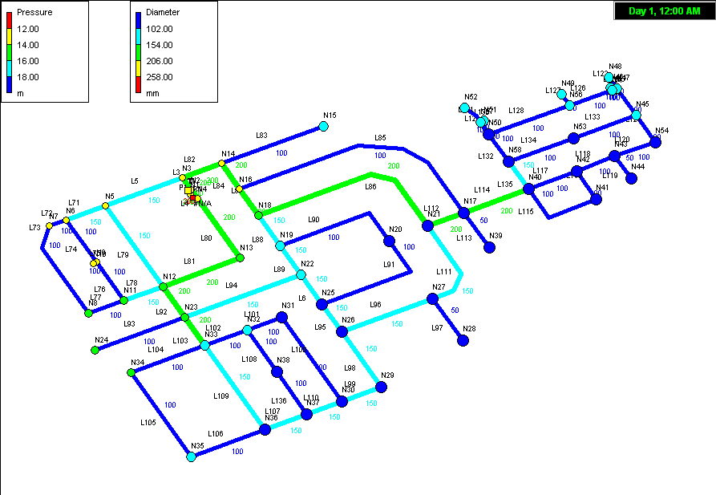
Figure 1 - Layout of New Harbour Village pipe distribution network

A seventy two hour extended period analysis was run for the network. This analysis varies the demand throughout the day from 0.6 times the average demand between 5am and 6am to 1.6 times the average demand between 7pm and 8pm. The daily variation in demand is satisfied by the flow into the tank from the well and from the volume stored in the tank.

The main components of the system are the inflow to the storage tank the outflow and rate of outflow from the tank and head losses in the system. The variation of head in the tank is shown in figure 2 below which sets the head on the distribution system and the resulting system pressure at peak flow with a hydrant delivering 30Lps (400UK gpm) at junction N46 is shown in table 2. The pressures on the system are shown to be adequate during this fire event.

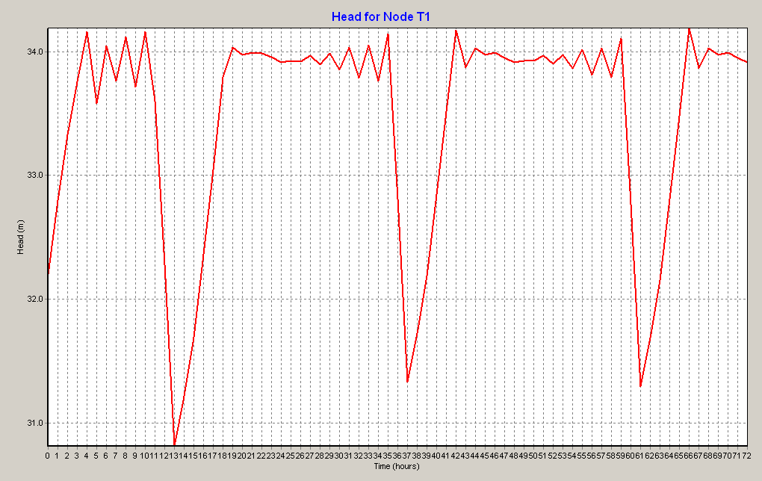
Figure 1 - Head variation in storage tank

Table 2 Pressures in the distribution system at peak hour demand.
Error! Not a valid link.

Fire Flow Requirements

The fire flow requirements were guided by the AWWA Manual M31 Distribution system requirements for fire protection. The Jamaica Institution of Engineers recommended guidelines for design and construction of housing infrastructure volume 3 water supply systems allow the minimum pressure on the network during a fire to be 5psi (34.5kPa or 3.5m of water). The required fire flow as defined in the manual is the rate of water flow, at a residual pressure of and for a specified duration, that is necessary to control a major fire in a specific structure. The residual pressure used in this report is 5psi (34.5kPa or 3.5m of water) in the vicinity of the hydrant as allowed in the JIE guidelines.

The manual outlines a number of methods to assess the Needed Fire Flow (NFF) and duration. The values used in this report conform to the Insurance Services Office method.

The fire flow used for this project is two streams from a hydrant anywhere in the subdivision.

Needed Fire Flow (NFF) for a dwelling in Spanish Village Housing Development

The Insurance Services Office Method defines the NFF as the rate of flow considered necessary to control a major fire in a specific building. The calculation of a NFF, in US gallons per minute considers the construction (C_{i}), occupancy (O_{i}), exposure (X_{i}) and communication (P_{i}) factors of that building.

NFF = (C_{i}) (O_{i}) (X + P) _{i}

C_{i} = 18 F (A_{i}) ^{0.5}

Where F = 1.0 for construction class 2 (jointed masonry)

A_{i} = effective area, where the effective area is the total square footage of the largest floor plus 50% of all other floors for class 2 construction

The effective area will be taken as 60% of a standard lot for a ground and a suspended floor. This is because the houses being sold can be expanded to this maximum.

A_{i} = 3,600 sq ft x 0.6 x 1.5 = 3,240 sq ft.

C_{i} = 18 x 1.0 x (3,240)^{0.5} = 1,024 US gpm

O_{i} = 0.82 (From table 1-2 AWWA M31 limited combustible C-2)

X_{i} = 0.21 (From table 1-3 AWWA M31)

P_{i} = 0.3 (From table 1-4 AWWA M31)

Therefore NFF = 1,024 x 0.82 x (0.21 + 0.3) = 428.34 US gpm or 1,621Lpm of 27Lps

Two streams from a single hydrant can supply 30.4 Lps which will be adequate to suppress a fire from the building considered.

The fire flow used to check the distribution network is 30 Lps at selected hydrants.

Water storage

Distribution storage can be economically justified if it takes care of normal daily variation and provide needed reserve for fire protection and minor emergencies.

The tank should be constructed at an elevation that will supply peak demands at the minimum required pressure. The commercial demands will not be included in the tank storage as the commercial facility will have to provide their own storage.

The flow into the tank is from the well is expected to be 25 Lps that is much greater than the peak day demand.

Table 5
Error! Not a valid link.

The minimum storage volume is 761 cu m above 31m elevation.

Construction

Pipeline construction details have been prepared and are shown on the design drawings. Cover should be 750mm generally. The minimum cover to the PCV pipe should be 600mm without encasing in concrete. Thrust blocks will be constructed wherever the line changes direction and dead ends.

Air valve will be included at the high points where the Engineer deems necessary in the subdivision.
Pipelines will be tested using a pump and pressure gauge to at least 150 psi. The pressure will be maintained for at least an hour, during which joints and thrust blocks will be inspected for joint leakage and movement of thrust blocks. Any leakages will have to be corrected immediately. After the initial test a pressure test will be carried out for the inspection by the approving body.

All pipelines will be flushed to remove debris from the pipeline and cleaned. The mains to the disinfected must be isolated from existing supply mains before the disinfection process is started. After disinfection the pipeline must be flushed with potable water. It will then be filled with potable water and bacteriological tests carried out and when acceptable results are achieved and approved the pipeline will be connected for service.

Sewerage design

Design References
The sewer collection design was prepared with reference to the Jamaica Institution of Engineers (JIE) Guidelines for Design and Construction of Housing Infrastructure Vol. 2 1984 sewerage systems and the British Standard European Union Code, BS EN 752-4 1998.

Design Criteria
The JIE guideline requires that sewers be designed and constructed to attain velocities when flowing full of not less than 2.0 ft. per second (approximately 0.6 m/s). Based on the JIE guideline the minimum pipe size is 8” with minimum slope of 0.4%. The British Standard requires either “velocity of 0.7m/s daily, or a gradient of at least 1: DN is specified.
Where self cleaning velocities cannot be achieved, provision should be made for adequate maintenance activities.”

Flow Calculations
The sewer flow rates were checked using the British Standard European Union Code, Drain and Sewer systems outside buildings BS EN 752-4: 1998, Part 4: Hydraulic design and environmental considerations, section 10 Wastewater design flows. The empirical approach in Annex C was adopted.

Calculation of wastewater flows for sewer systems is shown below:

Where Q = Lps
k_{DU} = frequency factor
DU = discharge unit

The peak flow rates are given by Q = k_{DU} $\sqrt{\sum{\text{DU}}}$

The frequency factor (k_{DU}) for dwellings and offices is 0.5.

The following table details the discharge unit for the sanitary appliances considered.

Table 2.0
Sanitary fixture | Discharge unit | DU used
Bath and kitchen sink  Shower and washbasin  Water closet (4.0L to 9.0L)  Washing machine | 0.8 to 1.3  0.3 to 0.6  1.2 to 2.5  0.5 to 0.8 | 1.0  0.4  1.8  0

The discharge units for each dwelling was calculated assuming that the average dwelling will consist of a shower, sink, water closet, kitchen sink, wash basin, giving a total of 3.8 discharge units per house.

Hydraulic Design
The Manning’s equation was used to determine the velocities in the pipes.

Manning’s equation in SI units v = 1/n R^{2/3} S^{1/2}

v = velocity of flow
n = manning’s friction coefficient
R = hydraulic radius
S = slope

The manning coefficient for the pipe specified is shown below.

Table 2.1
Material |  | Manning n
Polyvinyl Chloride (PVC) with smooth inner walls ^{d,e} | 0.009-0.011
^{d} Neale, L.C. and R.E. Price. Flow characteristics of PVC sewer pipe. Journal of the Sanitary Engineering Division, Div. Proc 90SA3, ASCE. pp. 109-129. 1964.
^{e} Bishop, R.R. and R.W. Jeppson. Hydraulic characteristics of PVC sewer pipe in sanitary sewers. Utah State University. Logan, Utah. September 1975.

The "n" value for minimum slope design of PVC sewer pipe is 0.009 as stated in the Uni-Bell PVC industry publication Handbook of PVC Pipe: Design and Construction.

Based on the preceding specifications the following table was developed

Table 2.2 200mm diameter PVC pipe minimum slopes
No of lots on pipe leg | Flow  Lps | Slope % | Velocity m/s
2  4  6  10  12  32  56 | 1.4  1.94  2.37  3.06  3.35  5.48  7.25 | 1.4  1.2  1.0  0.80  0.75  0.50  0.40 | 0.656  0.682  0.685  0.683  0.686  0.682  0.678

The pipe slopes shown on the sewer profile drawings conform to the above table.

The attached table outlines the sewerage calculations.

Pipe bedding and installation details are shown and described in the design drawings.

The 90% of water used is assumed to enter the sewerage system however an infiltration rate of 10% of the sewage flow is added to that flow.

Error! Not a valid link.

A 200mm diameter PVC sewer pipe with 0.4% slope is capable of conveying 21Lps at a velocity of 1.05m/s and is 65% full.

The construction details are shown in the drawings submitted.

Prepared By

Ivan Foreman, PEng.
Director

