ENVIRONMENTAL IMPACT ASSESSMENT FOR THE NEW HARBOUR VILLAGE HOUSING SUBDIVISION
ENVIRONMENTAL IMPACT ASSESSMENT
FOR THE NEW HARBOUR VILLAGE HOUSING SUBDIVISION

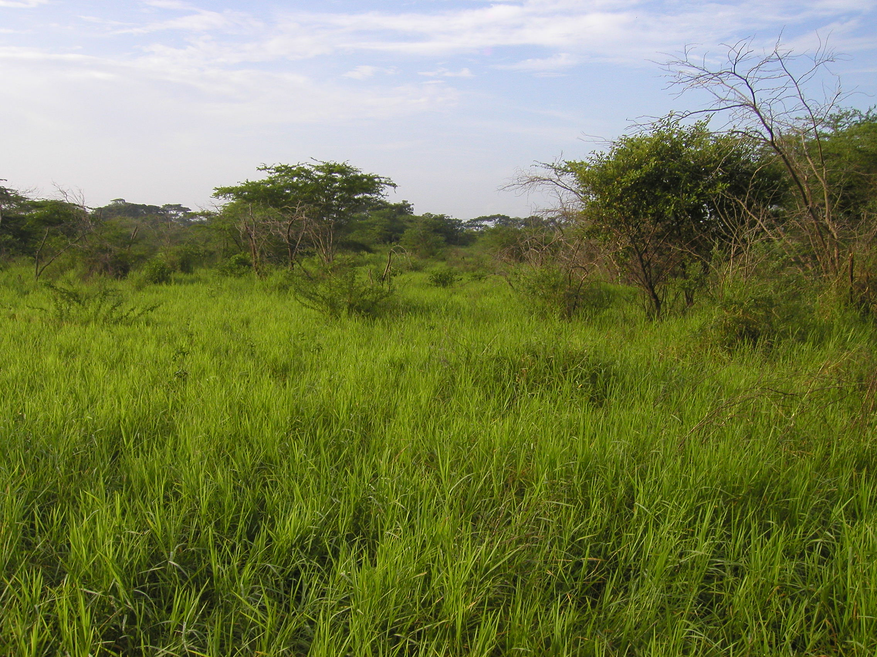
September 2006
Environmental Solutions Ltd.
Submitted to:
Gore Developments Ltd.
2c Braemar Avenue, Kingston 10
APPENDICES – Volume II

