ENVIRONMENTAL IMPACT ASSESSMENT
Highway 2000 – Segment I
Phase 1A – Portmore Causeway
Section: Ch 188+000 to 200+000

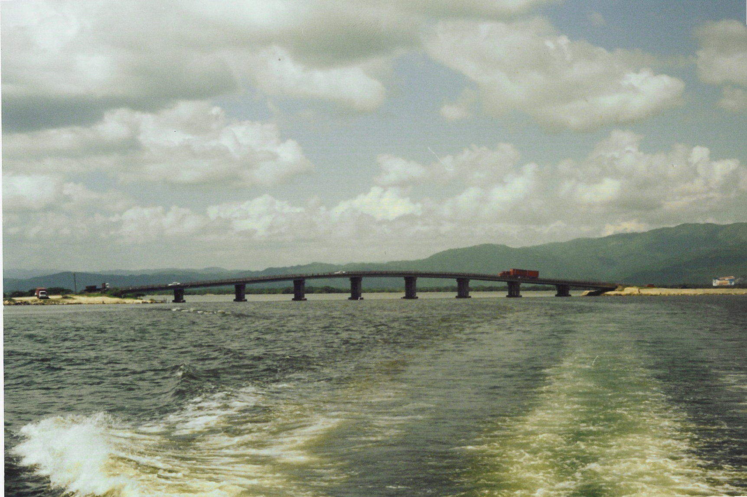

Report # 04

Submitted to:

TransJamaican Highway Ltd.
50 Knutsford Boulevard
Second Floor
Kingston 5

Prepared by:

Environmental Solutions Ltd.
20 West Kings House Road
Kingston 10

December 2003


