Report # 03

ENVIRONMENTAL IMPACT ASSESSMENT
Highway 2000 – Segment I
Phase 1A – Kingston to Bushy Park
Section: Ch 0+000 to 22+000

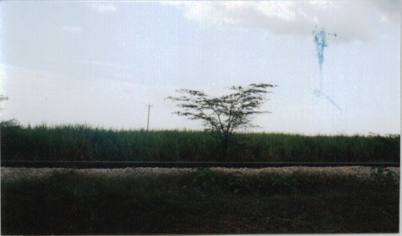

Submitted to:

TransJamaican Highway Ltd.
50 Knutsford Boulevard
Second Floor
Kingston 5

Prepared by:

Environmental Solutions Ltd.
20 West Kings House Road
Kingston 10

June 2002


