ENVIRONMENTAL IMPACT STATEMENT
AND SOLIDWASTE MANAGEMENT PLAN

OF THE

PROPOSED SOLIDWASTE DUMP AT WINCHESTER ESTATES
IN
HANOVER, JAMAICA

Submitted to
RIU HOTEL INTERNATIONAL
Hanover, Jamaica



JULY 2002

ENVIRONMENTAL IMPACT STATEMENT
AND SOLIDWASTE MANAGEMENT PLAN

OF THE

PROPOSED SOLIDWASTE DUMP AT WINCHESTER ESTATES
IN
HANOVER, JAMAICA

Submitted to
RIU HOTEL INTERNATIONAL
Hanover, Jamaica

Prepared by
C.L. ENVIRONMENTAL
Apartment 7
117 Constant Spring Road
Kingston 10

JULY 2002

TABLE OF CONTENTS

TABLE OF CONTENTS iii
1.0 INTRODUCTION 1
1.1 BACKGROUND 1
2.0 STUDY TEAM 1
3.0 DESCRIPTION OF THE EXISTING ENVIRONMENT 2
3.1 LOCATION 2
3.2 CLIMATE 3
3.3 TOPOGRAPHY AND DRAINAGE 3
3.4 SOILS 4
3.5 HYDROGEOLOGY 4
4.0 SOCIAL SETTING 5
4.1 POPULATION 5
4.2 EDUCATION 6
4.3 EMPLOYMENT 6
4.4 LAND USE 6
4.5 LAND TENURE 7
4.6 INFRASTRUCTURE 7
4.6.1 Roads 7
4.6.2 Transportation & Traffic 7
4.6.3 Water Supply 8
4.6.4 Lighting 8
5.0 BIOLOGICAL SETTING 9
5.1 FAUNA & FLORA 9
6.0 DESCRIPTION OF PROPOSED ACTIVITY 10
6.1 SOURCES OF WASTE 10
6.1.1 Site Clearance 10
6.1.2 Construction Activities 12
6.2 QUANTITIES OF SOLID WASTE GENERATED 12
6.2.1 Food Wastes 13
6.2.2 Commercial Waste 13
6.2.3 Construction Debris (Rubble) 13
7.0 SOLID WASTE MANAGEMENT PLAN 14
7.1 SITE EVALUATION AND SELECTION 14
7.1.1 Screening Process 14
Leachate Generation 14
Life Span of Site 15
7.2 OPERATIONS 15
7.2.1 The Plan 15
❑ Pre-dumping 15
❑ Construction 15
Dumping 17
Transportation 17
The Route 17
At the Dumpsite 18
Post dumping 18
9.0 MONITORING PROGRAMME 20

LIST OF TABLES

Table 1 30-Year Mean Monthly Rainfall 3
Table 2 Species seen and Identified 9
Table 3 Species seen but only classified to Family 9
Table 4 Waste Disposal Site Evaluation 14

LIST OF FIGURES

Figure 1 The Social Impact Area (SIA) 5
Figure 2 Flow chart of site clearance solid waste disposal at RIU II. 11
Figure 3 Sources of solid waste from construction activities 12
Figure 4 Flow chart of construction solid waste disposal at RIU II. 16
Figure 5 Proposed route from RIU II construction site to proposed dump at Winchester farms. 18
Figure 6 Over simplified flow chart of the disposal of RIU II construction solid waste. 19

LIST OF PLATES

Plate 1 Aerial depicting the proposed dump area. 2
Plate 2 Evidence of illegal dumping occurring on the proposed site. 7
Plate 3 Marl access road on the proposed site. 7
Plate 4 Pre-existing garbage illegally dumped on the site. 10

1.0 INTRODUCTION

This document seeks to obtain an approval for RIU Hotel chain to use an alternative to the Retirement dump in St. James.

1.1 BACKGROUND

RIU International is a Spanish-owned international hotel chain with properties throughout the world, including the Caribbean and one in Jamaica. RIU now proposes to develop their second resort in Bloody Bay, Negril in Hanover, Jamaica. The proposed site for this second hotel is approximately 1000 yards away from the present RIU hotel (RIU Tropical Bay).

It is proposed that the new hotel will have four hundred and twenty (420) habitable rooms with a floor area of 32,874 square metres (m²). Four (4) blocks of rooms, each of three (3) storeys high are planned for the site of the approximately nine (9) hectares (22 acre).

The original plan for the disposal of the solid waste during construction was to carry it to the Retirement dump in St. James. However, upon reviewing the plan, it was found that the cost to transport that volume of waste material to Retirement would be prohibitive.

A closer alternative dumpsite was explored and permission was obtained from Mr. Lloyd Dennis of Winchester Limited, Green Island, Hanover, to use a section of his 406 ha (100 acres) Winchester Estate (Appendix I).

2.0 STUDY TEAM

Carlton Campbell, M.Phil., CIE Environmental Scientist - Team Leader

Earl Wright, M.Sc. Hydrogeologist

Janet Manning, B.Sc., M.Phil (pending) Botanist

3.0 DESCRIPTION OF THE EXISTING ENVIRONMENT

3.1 LOCATION

The area is a part of Winchester Estate located in the parish of Hanover. It is found approximately 3.5 km (2 miles) south southwest of Green Island. The proposed site is approximately 16 km (10 miles) from RIU II construction site in Bloody Bay (Plate 1). This is closer to the construction site than the Retirement dump. The Retirement dump is approximately 75 km (47 miles) from the construction site.
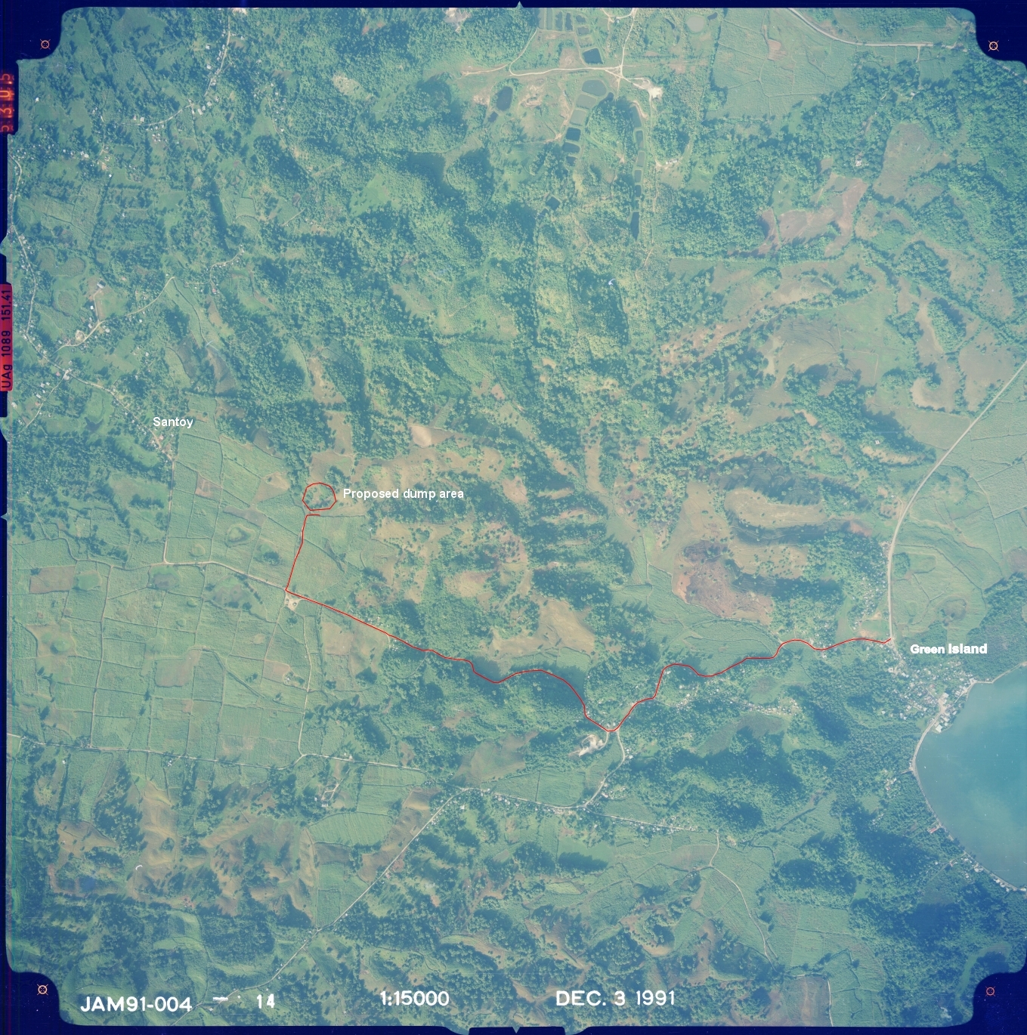
Plate 1 Aerial depicting the proposed dump area.

3.2 CLIMATE
The mean monthly rainfall for the two stations with long-term rainfall data is presented in Table 1. The mean monthly rainfall varies from 57 mm in January to 286 mm in June for the Green Island Station and the mean annual rainfall is 2117 mm. The site is at a higher elevation than the Green Island Station and therefore the rainfall depth is expected to be higher.

Table 1 30-Year Mean Monthly Rainfall
Station | J | F | M | A | M | J | J | A | S | O | N | D | TOTAL
Green Island | 57 | 79 | 76 | 156 | 257 | 286 | 248 | 297 | 248 | 243 | 90 | 80 | 2117
Logwood | 58 | 53 | 107 | 147 | 216 | 249 | 236 | 221 | 221 | 201 | 130 | 56 | 1895
Source: Meteorological Office
Wind and temperature data is not available for the site. Projecting from the meteorological station at Negril, the wind direction is predominantly from the north-east, occurring 37.2 percent of the time. Wind speeds of 40 knots have been reported, however the wind speed is typically between 7 -21 knots. The wind speed are on average at the maximum in the mid afternoon.

The average maximum temperature is 34.2 ºC and the average minimum temperature is 21.4 ºC.

3.3 TOPOGRAPHY AND DRAINAGE

The proposed waste disposal site (WDS) is located at Winchester Estates, Hanover in the Lucea River Watershed Management Unit. The site is approximately 3.0 km from the coastline at Orange Bay and 40 m above mean sea level. (Figure1). The area is characterized by undulating hills and internal depression. The base of the depressions is typically lined with clay, resulting in the formation of permanent and semi-permanent ponds.

The site is close to the watershed boundary between the Green Island River and the Orange Bay River. Drainage in the vicinity of the site is largely internal and to depressions mentioned above. Surface runoff exceeding the capacity of these depressions drains from this area and north towards the Green Island River system.

3.4 SOILS

The soil characteristic and the biological and chemical reactions that take place will influence the mobility of contaminants released from the waste disposal site.

The soils at the site are red-brown bauxitic clay and loam derived from the weathering of the shales in the area. No soil profiling was done but based on field observation the soil is relatively thick on majority of the site.

No measurements on the characteristic of the clay in the area were done. However reported values for the characteristics of similar clays in Jamaica are as follows: permeability 10⁻⁵ to 10⁻⁷ cm/sec, Wet density 110 to 120 pcf, moisture content 25 - 30 percent and cation exchange capacity (CEC) of 80 - 90meq/100g. The typically high cation exchange capacity of clays implies that positively charge ions that are potentially toxic such as ammonium, cadmium, nickel, zinc and copper are likely to be immobilized and retained by the clays.

3.5 HYDROGEOLOGY

The site is located in an area described as the Lucea Inlier and is underlain by the Hanover Shale. These rocks are classified as aquiclude (i.e. rocks with low permeability). Based on this classification there is no significant groundwater resource below the site and therefore the potential for groundwater development and/or contamination is negligible.

As expected, given the type of rock formations in the area, there are no wells on the site or in close proximity to the site.

4.0 SOCIAL SETTING

Social Impact Area (SIA) of the proposed dump is assumed to be two-kilometres in radius. It encompasses the communities of Santoy, Mount Pleasant, Phoenix Town, Haughton Hall and parts of Winchester, Salt Spring and Logwood (Figure 1).

Figure 1 The Social Impact Area (SIA)

4.1 POPULATION

The resident population within a two (2)-kilometre radius of the proposed dump in 1991 was approximately 5,949 persons. If the population growth rate within the area remains constant from 1982 –1991 (1.3% per annum), then the population at the time of this investigation is estimated to be 8,323 persons. This population is expected to grow to 9,504 persons in the next twenty-five years.

In 1991, the population within the SIA was relatively young with approximately 80%  45 years of age. Of this, the majority (49%) of the male population and the majority (44%) of the female population were in the 15-45 years category. Males out numbered females within the population with a sex ratio of 103.8.

4.2 EDUCATION

Most persons (46%) within the SIA attained a primary education. Thirty one percent had attained a secondary education, while 11% had no formal education. Those attaining a nursery or infant school education accounted for 4% of the population, 7% did not state to what level they attained and less than 1% each attained a university or other forms of education.

4.3 EMPLOYMENT

Approximately 54 % of the working age population within the SIA was economically active. Unemployment within the SIA in 1991 stood at approximately 54%.

4.4 LAND USE

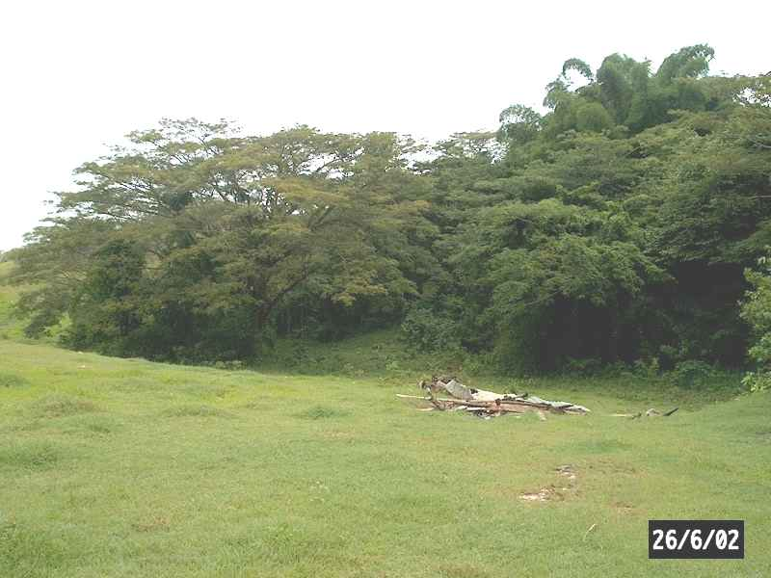
In 1991, the area was used for cane cultivation (Plate 1) but subsequently has fell into disuse. When the site was visited, the fields laid fallow. There was some evidence of illegal dumping occurring (Plate 2) and the area was also used limitedly for grazing cattle.

Plate 2 Evidence of illegal dumping occurring on the proposed site.

4.5 LAND TENURE

The Winchester Estate property is privately owned by Winchester Limited, Green Island, Hanover.

4.6 INFRASTRUCTURE

4.6.1 Roads

Roads within the area are generally in a good state of repair. Most of them having an asphalted surface. The access roads to the proposed site however, is constructed of marl and dirt in places and has no surface (Plate 3). Sections of this road have the marl eroded and the earthen base exposed.

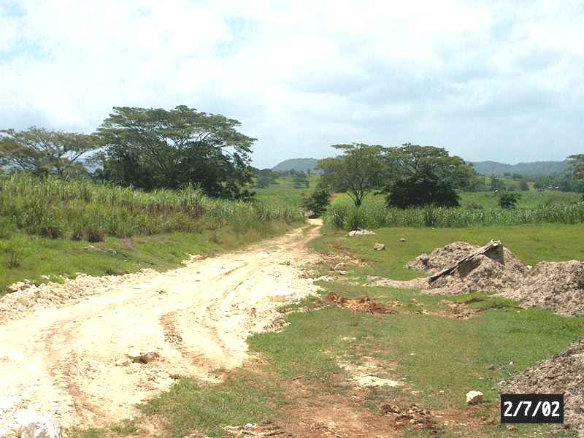

Plate 3 Marl access road on the proposed site.

If this proposed site is approved then there will be need for the access road surface to be paved so as to reduce the potential of trucks becoming stuck during rains.

4.6.2 Transportation & Traffic

Taxis, private cars, motorbikes and bicycles provide transportation within the area. There is a marl quarry approximately 2 km from the proposed site. While no actual traffic counts were conducted, cursory visits to the proposed site indicated that the volume of traffic along the Green Island to Santoy road was not large.
Three (3) potential problems are identified as it relates traffic and transportation along the proposed route.

- The entrance of the heavy trucks from the RIU construction site unto the Negril to Green Island main road.
- While the frequency will be relatively low (approximately 4 trucks per day), the turning of these trucks across oncoming vehicular traffic at the Green Island turn (just before the Green Island Police Station) and unto the access road to the proposed site.

Both of which increases the potential for accidents. The third is mainly aesthetics. The transportation of debris if not done correctly may entail the release of some of it along the roadway used. In addition to aesthetics, there is the danger that debris can hit a pedestrian or another vehicle causing damage and in extreme cases death.

4.6.3 Water Supply

Within the SIA, 92% of the households received water from a public source (National Water Commission). Of this, 59% received their water supply from public standpipes. This is in keeping with the parish figures as the majority of the households in Hanover received this precious commodity from public standpipes.

Five percent of the households in the SIA had private means of getting their water supply, 2% had other means and 1% collected their water from a spring or river. There is no water supply on the proposed site.

4.6.4 Lighting

The main method of lighting for households within the SIA is by electricity (49%). An almost equal amount (48%) of households uses kerosene to provide lighting.
There is no electricity supply on the proposed site.

5.0 BIOLOGICAL SETTING

5.1 FAUNA & FLORA

Apart from the cattle on the proposed property, there are no other important faunal species.

The following is a list of plant types encountered at the proposed dumpsite (Tables 2 and 3) for solid waste from the RIU Jamaicotel Ltd. during the construction of their second hotel in Bloody Bay Negril.

Table 2 Species seen and identified
Species Name | Common Name
Albizia lebbeck | Woman’s Tongue Tree
Mimosa pudica | Shame ol’ lady
Solanum torvum | Gully Bean, Susumber, Turkey Berry
Blighia sapida | Ackee
Bambusa vulgaris | Common Bamboo
Terminalia catappa | West Indian Almond
Wedelia trilobata | Marigold, Creeping Ox-eye
?Caesalpinia bonduc | Nicker, Gray Nikal
Psidium guajava | Guava
Cirtus aurantifolia | Lime
Saccharum officinarum | Sugar Cane
Haematoxylum campechianum | Logwood

Table 3 Species seen but only classified to Family
Graminae ( grasses) – 3 species
Papillionaceae – 3 species
Malvaceae – ?Abutilon sp.
Zingiberaceae – ornamental ginger plants

The species seen in a rapid assessment of the area proposed for the location of the dumpsite are not endemic to Jamaica. In addition, none of these species has been listed as rare. The area is relatively disturbed seemingly by the presence of grazing animals and previous farming activities.

6.0 DESCRIPTION OF PROPOSED ACTIVITY

6.1 SOURCES OF WASTE

6.1.1 Site Clearance

During site clearance, the main forms of solid waste that will be generated are vegetation cuttings from the brush (organic), earthen material (inorganic) and pre-existing garbage (inorganic) that were dumped illegally on the site prior to RIU II occupying (Plate 4).

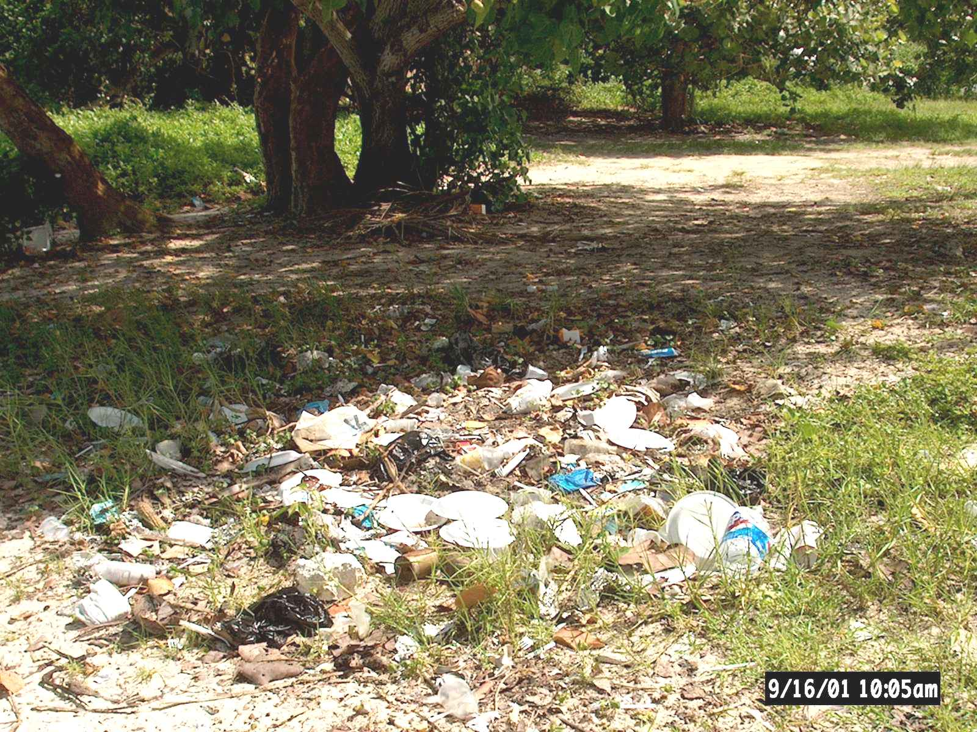

Plate 4 Pre-existing garbage illegally dumped on the site.

Vegetation cuttings will be shredded or burned and will be combined with the topsoil onsite to improve the soil structure. This soil mix will be re-spread over the entire site after completion of the building foundations. Pre-existing garbage consists of plastics, cans, Styrofoam and other household solid wastes. The quantity of this is unknown. These will be collected and trucked to the Retirement solid waste dump in Montego Bay, St. James (Figure 2).
SITE CLEARANCE

“Onsite” Disposal Transportation to Retirement dump (Montego Bay)

Vegetation Cuttings Earthen Materials Pre-existing Garbage “onsite”

Combined and Spread Plastics Cans Styrofoam
On Property to improve
Soil properties

Figure 2 Flow chart of site clearance solid waste disposal at RIU II.

6.1.2 Construction Activities

During construction, three (3) main wastes will be generated. These are food waste, construction debris and commercial waste. It is anticipated that construction workers will generate some food waste. The main form is expected to be disposal containers such as Styrofoam or boxes.

The construction of the hotel will generate two types of solid waste. These are construction debris (rubble), which are mainly marl, hardened waste cement, damaged tiles and damaged concrete blocks. These are inert materials. The other is commercial waste, which can be characterised by woodcuttings, tins, metal cuttings, wire, plastics and paper (Figure 3).

CONSTRUCTION ACTIVITIES

Food waste Construction debris Commercial waste
(plastics, organics etc.) (marl, damaged tiles, paper etc.) (wood, tins wires etc.)

Figure 3 Sources of solid waste from construction activities

6.2 QUANTITIES OF SOLID WASTE GENERATED

Based on the construction of a previous RIU hotel of similar size, it is anticipated that approximately 19,114 m³ (25,000 cubic yards) or 17,000 tonnes of construction waste will be generated. It is estimated that there will be approximately four (4) truck trips per day over a ten (10) month period. The anticipated breakdown of this total is given below.

6.2.1 Food Wastes

The estimate of food waste to be generated over the ten (10) months of construction is calculated as approximately 16 tonnes (36,000 lbs). This is based on 600 workers generating ¼ lb of waste per day, 6 days per week, 4 weeks per month over 10 months (600 workers x 0.25 lb x 6 days x 4 weeks x 10 months).

6.2.2 Commercial Waste

It is estimated that approximately 10% of the solid waste generated during construction is commercial waste. Based on that assumption, approximately 1,700 tonnes will be generated.

6.2.3 Construction Debris (Rubble)

The rest of the solid waste is assumed to be construction debris. These amounts to approximately 15,284 tonnes of waste will be generated.

7.0 SOLID WASTE MANAGEMENT PLAN

7.1 SITE EVALUATION AND SELECTION

7.1.1 Screening Process

The suitability of the site for use as a waste disposal facility was evaluated using the Guidelines for the Selection and Siting of Hazardous and Solid Waste Disposal Facilities in Jamaica (WRA 1991). The results of the evaluation is presented in Appendix III and summarized in Table 4.

There were seven (7) acceptable location factors compared to one (1) unacceptable factor for Level 1 Screening. There were twelve acceptable factors for community and environmental impacts in comparison to two (2) unacceptable factors. At all levels of screening, the acceptable factors exceed the unacceptable factors. Based on the guidelines, the site is suitable for use as a waste disposal facility with minimal environmental and community impact.
Table 4 Waste Disposal Site Evaluation
 | Level I Factors  Location | Level II Factors  Accessibility/  Landuse | Level III Factors  Community/  Environmental Impact | Level IV Factors  Specific Impacts
Acceptable Factors | 7 | 2 | 12 | 22
Unacceptable Factors | 1 | 2 | 2 | 1

Leachate Generation

Given the nature of the waste to be disposed at the site, no significant amount of leachate will be generated at the site.

Life Span of Site

The site will only be operated during the construction phase of the project and therefore the life span of the site is approximately twelve (12) months.

7.2 OPERATIONS

7.2.1 The Plan

Pre-dumping

Approximately 2 acres ( 0.8 ha) of the Winchester Estate will be prepared for dumping. The road leading off the Salt Spring to Santoy road leading unto the property will be paved to prevent trucks from being stuck in the case of heavy rains.

The area identified is a depression located at 190,787.89 North, 114,236.34 East – Jamaica Grid . It is approximately 8 m deep and has a surface area of approximately 6,800 m² (0.7 ha). It is estimated that the area can hold a volume of 54,400 m³ ( 70,720 cu. yds.) or 47,000 tonnes. The area is more than adequate to hold the estimated 15,284 tonnes of construction debris that is expected to be deposited there. The area will be prepared, fenced off to provide limited access and an office is to be placed at its gate.

Construction

It is proposed that solid waste generated during construction activities will be sorted into two categories, food and commercial wastes and the construction debris. Rollouts will be used for food and commercial wastes, while skips will be provided onsite for the construction debris. When the rollouts are filled (anticipated by a week), a commercial solid waste contractor (Garbage Disposal and Sanitation Systems Limited) will collect the rollout and transport it to the Retirement dump for disposal. The skips when filled will be collected by private haulers and transported to the Winchester Estate and deposited at the proposed area (Figure 4).

CONSTRUCTION
Rollouts
Skips

Transportation to Retirement Transportation to Winchester Estate

Paint, Paint Thinner Cans and Plastics Paper Marl Hardened Damaged Tiles
Metal Cuttings Waste Cement Damaged Concrete
Blocks
Figure 4 Flow chart of construction solid waste disposal at RIU II.

Dumping

For the period during which the area will be an active dumpsite, access will be limited to only to authorized persons. An identification card will readily identify these persons. No sorting (“scavenging”) will be allowed.

In addition to the use of identification cards, fencing and closing the gates after normal work hours to prevent illegal dumping, security will be put in place after work hours.

Dumping will occur within the depression, which will necessitate the filling of the depression.

Transportation

It is anticipated that approximately 1,200 truck trips will be made to the proposed site. These trucks will be covered. A logbook system will be in place where upon departure the license number, time of departure and drivers name will be logged. An authorized RIU agent before departure of each truck trip will sign this book.

The Route

Upon leaving the construction site, truck will turn left and travel along the Negril to Green Island main road following the depicted route (Figure 5). This route was chosen because of two main factors, (i) less densely populated when compared to alternative routes and (ii) the roadway is more suited for the heavy-duty trucks (wider, less winding and better road surface).

Figure 5 Proposed route from RIU II construction site to proposed dump at Winchester farms.

At the Dumpsite

The drivers of trucks entering the dumpsite must have a valid identification card and the logbook must be given to the RIU agent located at the site. The time of arrival must be entered and the logbook signed. The driver will receive a voucher as prove that the cargo he was carrying was delivered to the dumpsite.

Trucks will be driven to the northern part of the dumpsite where it will be tipped. A front-end loader will be used to push the contents of each load to the required area, where some compaction will be done occasionally (Figure 6).

Post dumping

The dumped materials will be covered with topsoil and re-grassed or trees planted on the site.
Turned
Away

Logbook procedure

Rejected

Verification
Of drivers ID
And Logbook

Approved

RIU CONSTRUCTION PROPOSED
SITE Trucked DUMPSITE Tipping

Appropriate
Area

Front end Loader
Figure 6 Over simplified flow chart of the disposal of RIU II construction solid waste.

9.0 MONITORING PROGRAMME

Pre-Dumping

- Inspection of the preparation of the proposed area for dumping on the Winchester Estate.

This should be done by a qualified person. NEPA and/or Local Planning agencies (e.g. Hanover Parish Council) could conduct these inspections.

It is not anticipated that this exercise will incur additional costs.

Dumping

- Inspections at the construction site and the proposed dump area should be conducted daily.

This should be dome by a RIU appointed agent. Spot checks should be conducted by the NEPA and/or the Local Planning agencies.

It is not anticipated that this exercise will incur additional costs.

- Monitoring the transportation of solid waste from the construction site in Bloody Bay to the proposed dump at Winchester Estate for example checking that no debris being transported is falling unto the roadway along the route.

This should be done by a RIU appointed agent. Spot checks should be conducted by the NEPA and/or the Local Planning agencies.

It is not anticipated that this exercise will incur additional costs.

Post Dumping

- Inspection of the sealing and re-grassing of the proposed area for dumping on the Winchester Estate.

A qualified person should do this. This should be done by a RIU appointed agent, NEPA and/or Local Planning agencies (e.g. Hanover Parish Council).

It is not anticipated that this exercise will incur additional costs.

REFERENCE

C. D. Adams 1972. Flowering Plants of Jamaica.

Statistical Institute of Jamaica. 1991. Population Census 1991, Parish of Hanover, Vol 1 Part 9.

Statistical Institute of Jamaica. 1991. Population Census 1991, Parish of Hanover, Vol X1 Part 9.

APPENDICES

Appendix I Letter Authorizing the Use of Winchester Estates for Landfill
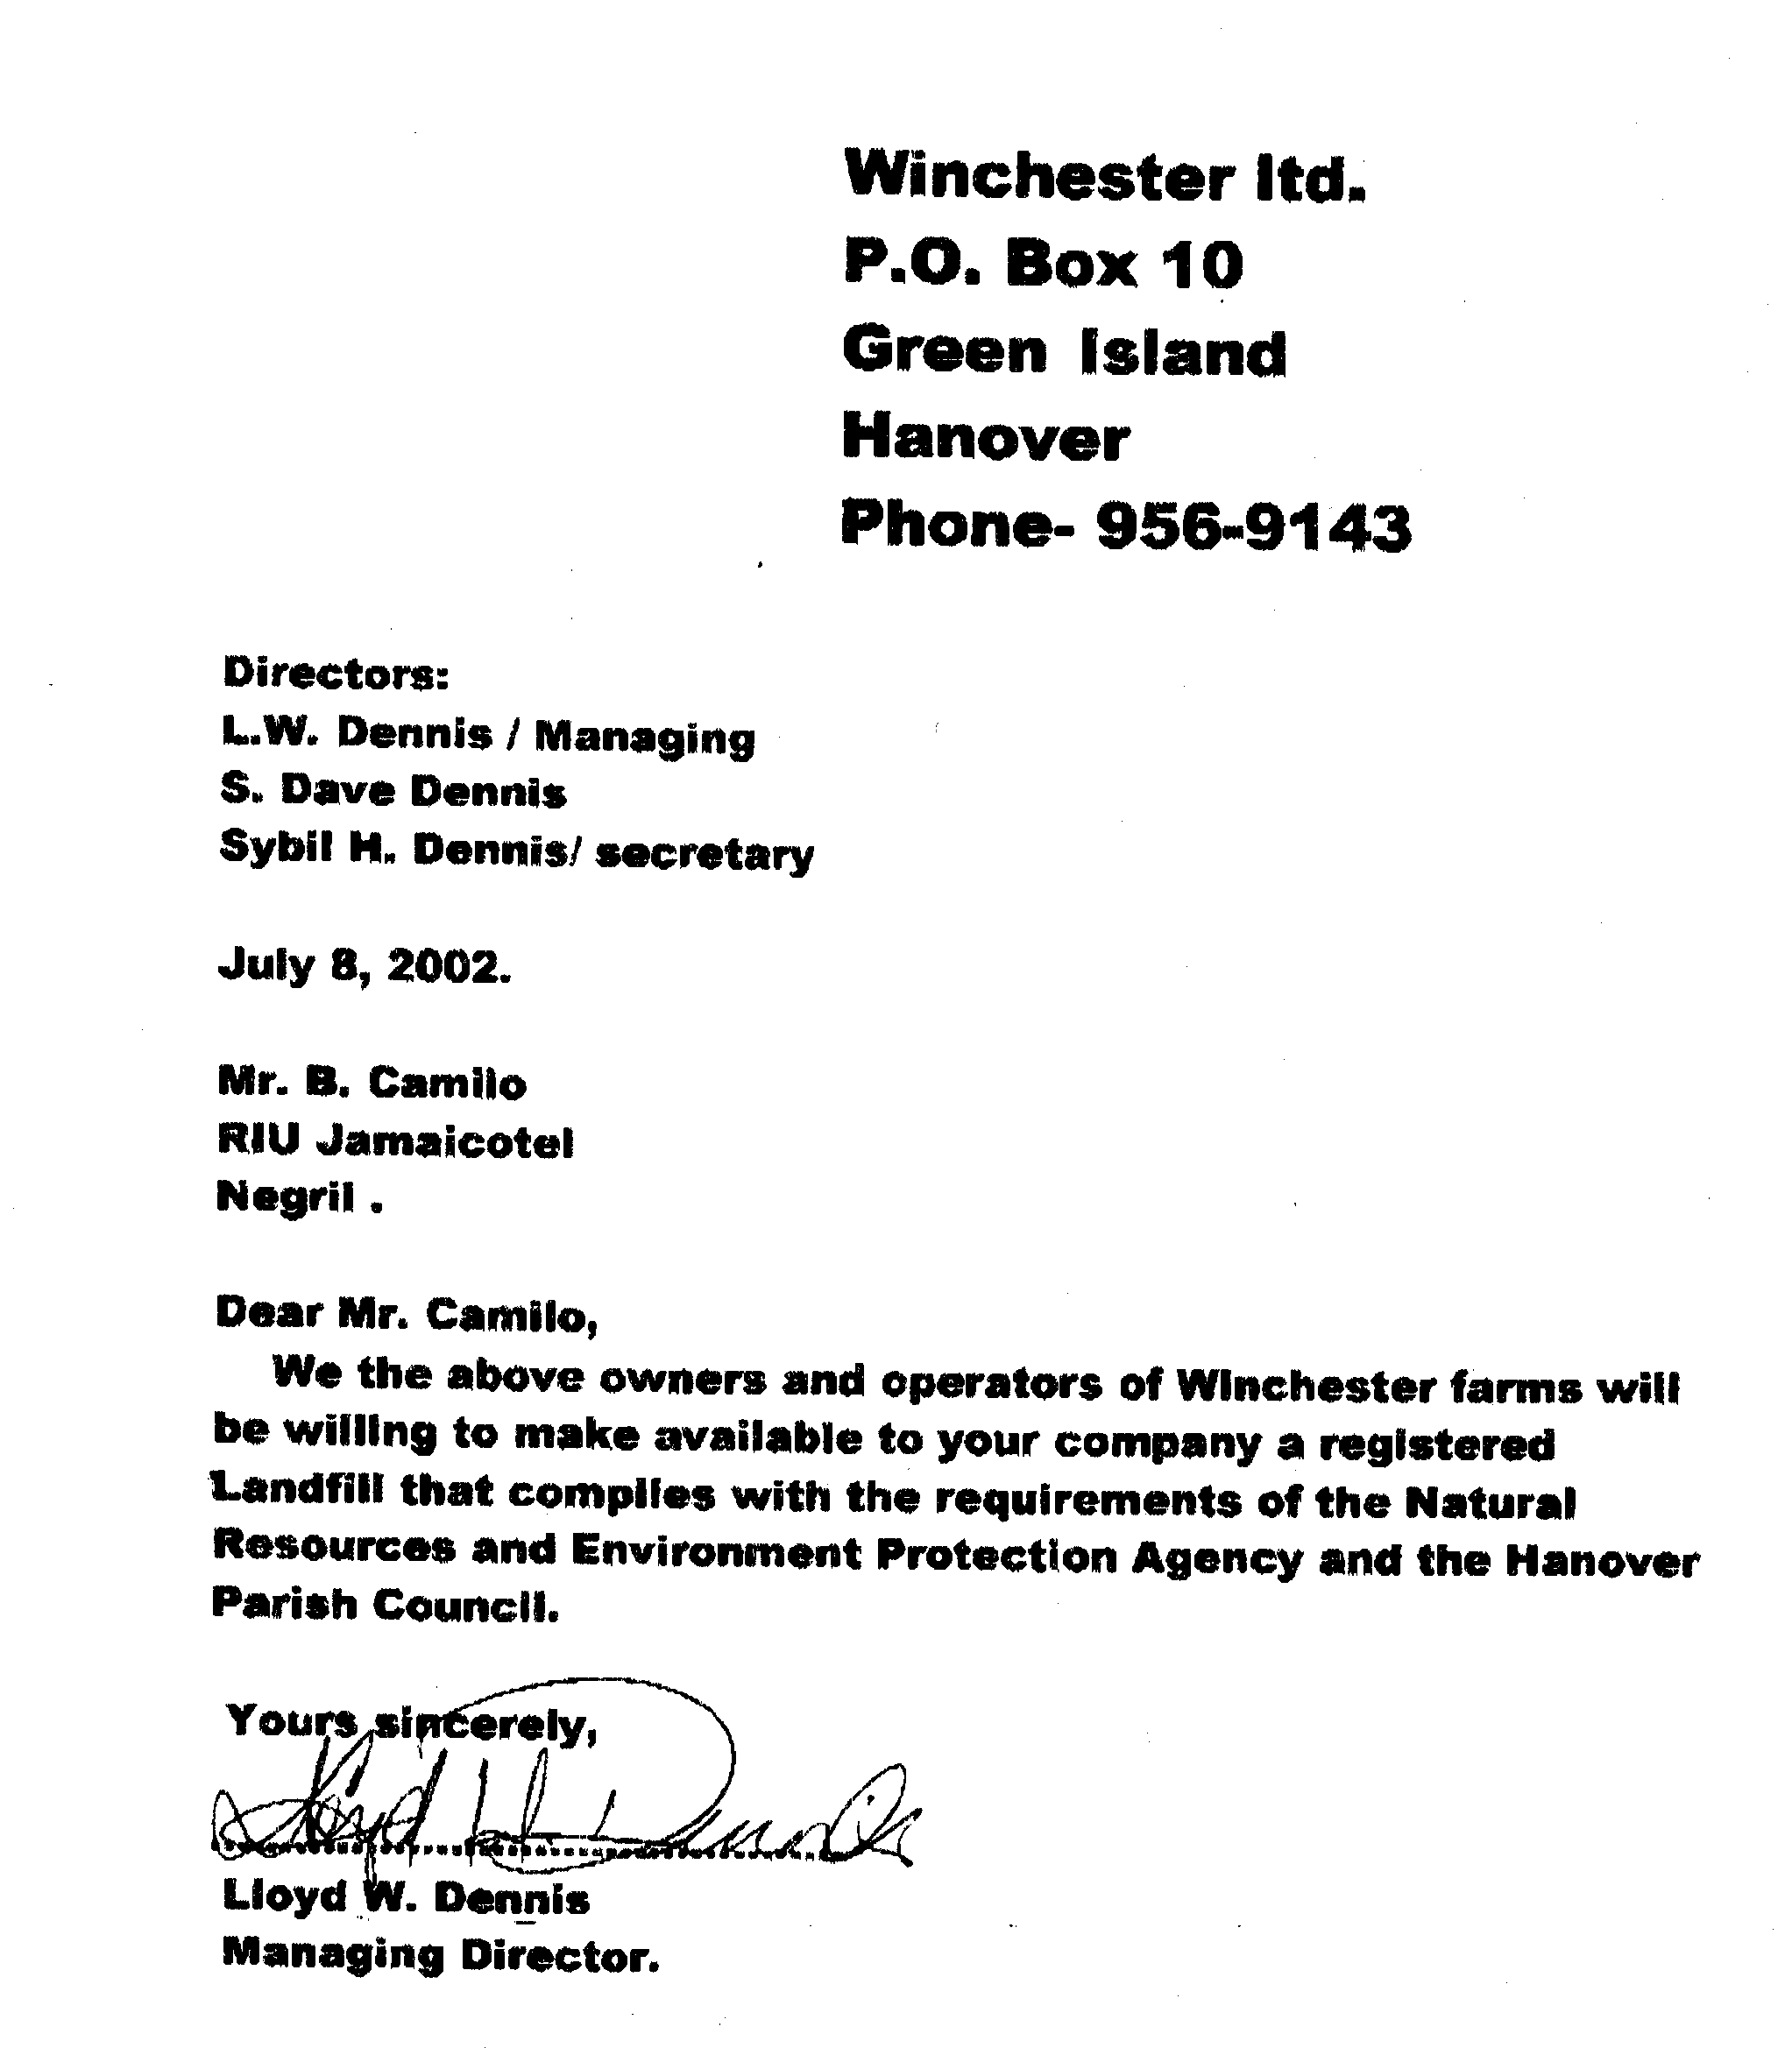

Appendix II Site Inspection Check List
Appendix II

Site Inspection Checklist
- Existing Plans/SOPs
- Operations Plan ……………………
- Grading Plan ……………………
- Closure Plan ……………………
- Property Boundary Survey ……………………
- Responsibilities ……………………
2. Presence of Signs: Yes………No……..
If Yes:
- Visible? ………………………
- Restrict types of waste? ……………………….
- Direct haulers to weigh station? ……………………….
- Direct haulers to active area? …………………………
- Restrict Speeding? …………………………
- Restrict smoking? …………………………
- Other? …………………………

3. Is there adequate inspection of incoming waster: Yes……. No…………
If Yes:
- Site entrance? …………………………..
- Weigh station? ………………………….
- Active area? ………………………….
4. Access Roads: Main Road On Disposal Site
- Length Paved? ……………. …………………
- Gravel? ……………. …………………
- Dust Control? ……………. …………………
- Drainage? ……………. ………………….

- Stormwater Runoff Controls:
- Along Access Road? …………………………
- Active Areas? …………………………
- Closed Areas? …………………………
- Sedimentation Basin? …………………………
- Discharge Point? ………………………….
- Leachate Seeps? ………………………….
- Water Quality Standards …………………………….

- Scrap Metal/White Goods/Yires:
- Accepted? Yes……. No……..
- If yes.
- Quantity …………………………..
- Segregated? …………………………..
- Location? ………………………….
- Environmental Controls ………………………….
- Active Area:
- Size/Location …………………………...
- Equipment/Personnel ……………………………
- Procedures ……………………………
- Daily/Intermediate Covers ……………………………
- Control of Blowing Paper ……………………………
- Inspection of incoming waster ……………………………
- Closed Area(s):
- Size/Location …………………………….
- Final Cover …………………………….
- Grading ……………………………
- Vegetation ……………………………

- Access Restrictions:
- Fence? ………………………….
- Security? ………………………….
- Topography? ………………………….
- Presence of Fires:
- Smoke/Fires? ………………………….
- Location ………………………….
- Surficial/Deep ………………………….
- Fire Protection Equipment ………………………….
- Disposal Outside Landfill:
- Location …………………………
- Quantity/Area ………………………….
- Leachate Seeps:
- Location ………………………….
- Chemical Data ………………………….
- Flow …………………………...
- Discharge Point ………………………….
- Nearby Drinking water source …………………………...
- Equipment:
- Type …………………………..
- Number …………………………..
- Maintenance ………………………….

- Vectors:
- Type ……………………………
- Control Programmes …………………………….

- Cover Materials: Daily Intermediate Final
- Source ……………………………………………….
- Quantity ………………………………………………
Quality ……………………………………………….

Appendix III Guidelines for the Selection and Siting of Hazardous and Solid Waste Disposal Facilities in Jamaica (WRA 1991).
Appendix III Jamaica Landfill Screening Process

Level I Screening

NATURAL ENVIRONMENT | YES | NO
Is the site located in a 100-year flood plain? |  | N
Does the site contain coastal wetlands? |  | N
Is the site located on or near public recreational areas or conservation areas? |  | N
Is the site located in a watershed that feeds a public water supply on-stream reservoir? |  | N
Is the site in an area where the first bedrock stratum is soluble limestone or dolomite rock encountered at shallow depth below the land surface? |  | N
Is the site located on an aquifer that is not separated from the land surface by an aquiclude of at least 10 ft in thickness? |  | N
Is the site located in an area where an earthquake intensity of Modified Mercalli VII has occurred? | Y
Is the site overlying an aquifer with a yield greater than 50 igpm? |  | N

- Total Number of Acceptable Factors (No Answers) = 6
- Total Number of Unacceptable Factors (Yes Answers) = 2
- Pass on to Level II Screening? YES

Level II Screening

LAND USE AND INFRASTRUCTURE | YES | NO
Is the site located within two miles radius of principal or secondary road or rail access? | Y
Is the site located on or adjacent to lands which has previously been used for waste disposal activities? |  | N
Is the site located on government-owned lands with large acreage having no residential population or in government-owned areas with additional buffer acreages where there is a residential population? |  | N
Is the site located on an abandoned property of appropriate area in a non-residential area? | Y

- Total Number of Acceptable factors (Yes Answers) = 2
- Total Number of Unacceptable Factors (No Answers) = 2
- Pass on to Level III Screening? YES

Level III Screening

SOCIO-ECONOMIC AND ENVIRONMENTAL FACTORS | YES | NO
Is the site in an area containing existing concentration of residential, commercial, industrial or community activities? |  | N
Is the site located in an area designated as agricultural land? | Y
Is the site located on or adjacent to developments of substantial community significance? |  | N
Is the site located in a 100-Year flood plain or a fluvial area capable of significant influent flow during flood events that may cause abnormal fluctuations in groundwater levels? |  | N
Does the site contain freshwater wetlands? |  | N
Is the site located in a dam-related flood hazard area (danger reach by flood pool)? |  | N
Is the site located within 500 ft of a stream or pond of economic importance to shellfish harvesting and fish farming? |  | N
Is the site located within 1000ft of stream segments on which there is a water supply intake, within 5 miles upstream of the public water supply intakes, or within o.1 mile downstream of such intakes? |  | N
Is the site located on a land area potentially visible from any portion of designated rivers or streams that provides scenic, touristic or recreational value? |  | N
Does the site overlay an aquifer less than 100 feet in thickness? |  | N
Is the aquifer beneath the site separated from the land surface by an aquiclude less than 20 feet in thickness? |  | N
Is the site located in an area where the first bedrock stratum encountered is soluble limestone or dolomite? |  | N
Is the site located in an area where residents down-gradient of the site use groundwater for drinking water and have no alternative water supply? |  | N
Is the soil/saprolite thickness at the site less than 30 ft? | Y

- Total Number of acceptable Factors (No Answers) = 12
- Total Number of Unacceptable Factors (Yes Answers) = 2
- Pass on the Level IV Screening? YES

Level IV Screening

COMMUNITY & ENVIRONMENTAL IMPACTS | RESPONSE | NEGATIVE | NEUTRAL | POSITIVE
Distance from site to sewage treatment facility (ft) |  |  |  | *
Distance from occupied structures within 0.5 miles of site to public water hook-ups | none |  |  | *
Number of dwelling units, schools, hospitals and shopping centers having primary access from the transportation route between the site and the nearest primary or secondary roads. | none |  |  | *
How does the road connecting the site with the nearest primary or secondary roads meet relevant standards? | N/A |  |  | *
Can effective visual buffers be created at the site? | Yes |  |  | *
Number of dwellings units within 500 feet of the site | none |  |  | *
Number of commercial centers within 500 - 1000 ft of site | none |  |  | *
Number of churches and schools within 1- 2000 ft of site | none |  |  | *
Number of airports and hazardous facilities within 2500 - 3500 ft of site | none |  |  | *
Number of immobile resident facility within 0.5 mile of site | none |  |  | *
How many parcels of land comprise the site | one |  |  | *
Distance to emergency services |  | *
Would the site occupy over 10 % of the area of known habitat of an endangered species? | no |  |  | *
Depth to regional aquifer | No aquifer |  |  | *
Depth to groundwater | N/A |  |  | *
Groundwater Velocity (ft/yr) | N/A |  |  | *
Is groundwater flow direction in the direction of a water supply | N/A |  |  | *
Number of groundwater parameters at the site exceeding establish criteria and standard | No data |  |  | *
Soil pH | No data |  | *
Soil Cation Exchange Capacity | High/LOW |  |  | *
Soil Permeability | Low/low |  |  | *
Is the site located in an area of potential mineral development? | Not Sure |  | *
Thickness of confining clay layer | N/A |  |  | *
Site Slope | Gentle Sloping | * |  | *

Is the site suitable for use as a waste disposal site? YES

