SANGSTER INTERNATIONAL AIRPORT INCINERATOR
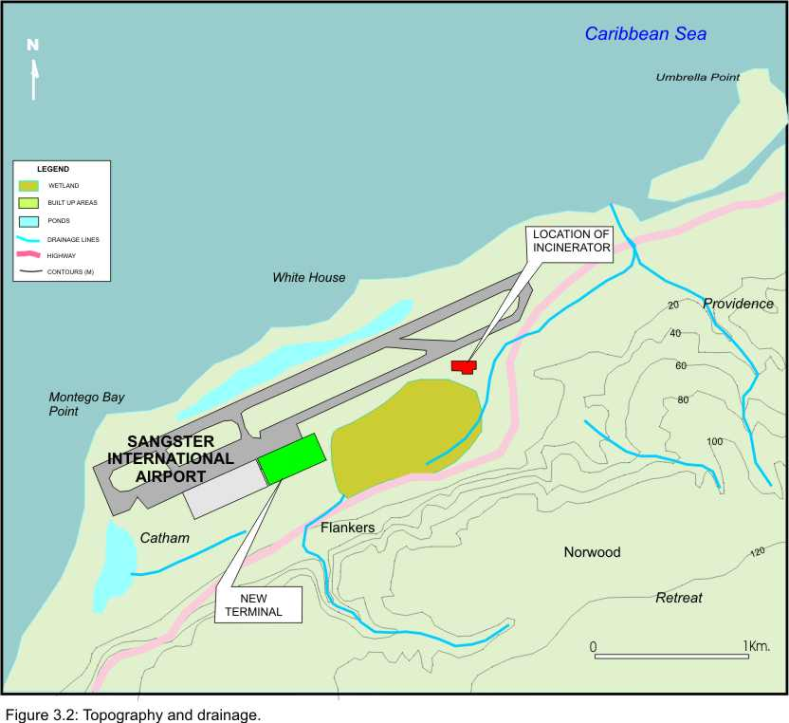
ENVIRONMENTAL IMPACT ASSESSMENT

Prepared on behalf:

Airports Authority of Jamaica
53 Knutsford Boulevard
Kingston 5

By:


Environmental Solutions Limited
20 West Kings House Road
Kingston 10

June 2004

