ENVIRONMENTAL IMPACT ASSESSMENT

GREENFIELD, TRELAWNY
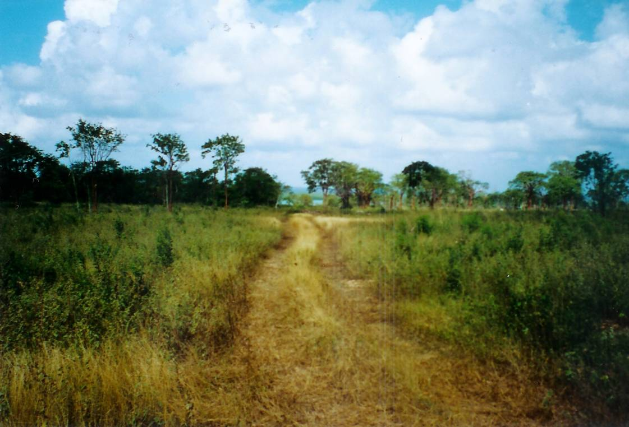

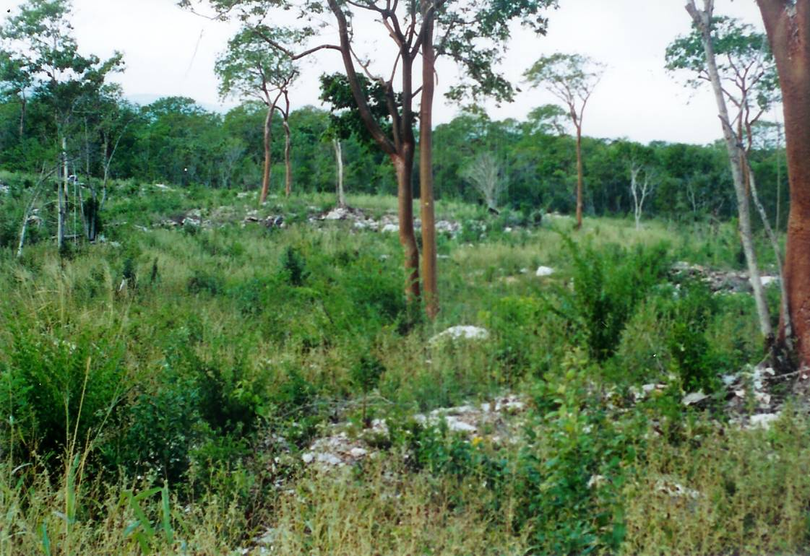

Submitted to:

Jamaica Cricket 2007 Ltd.
11a Oxford Road
Kingston 5

Prepared by:

ENVIRONMENTAL SOLUTIONS LIMITED
20 West Kings House Road
Kingston 10



June 2005

