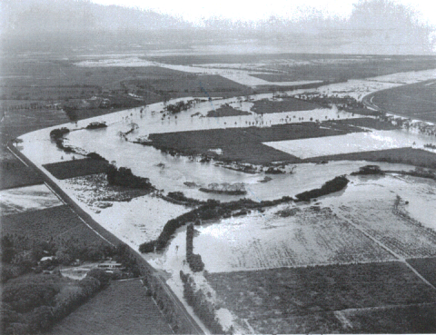
Plate 16: Rio Cobre flood event in June 1969, 1 km downstream the proposed crossing site.
(Source: Government of Jamaica – 2000: Highway 200 Drainage & Hydrology Report7)

