Goshen Social Facilities and Services
Introduction

A community’s social facilities are essential for providing basic support services which its population rely on within or close to the residential area. The Goshen community has established several facilities which meet the basic needs of the community including education, religious, recreational and entertainment facilities. The current situation of social services in the community has been highlighted below along with proposals to improve these from a planning perspective, incorporating local sustainable indicators to ensure sustainable use of facilities over time.

Existing Situation

Education
There are three (3) public educational facilities in the study area, namely:
- Goshen Basic School (Early Childhood Institution) – Goshen Main Road
- Bennett’s Basic School (Early Childhood Institution) – off Bennett Street
- Goshen All Age School – School Road

Early Childhood Education
Bennett’s Basic School was established in 1972 and is located on Bennett Street which is in the southern section of the study boundary. (See map x).

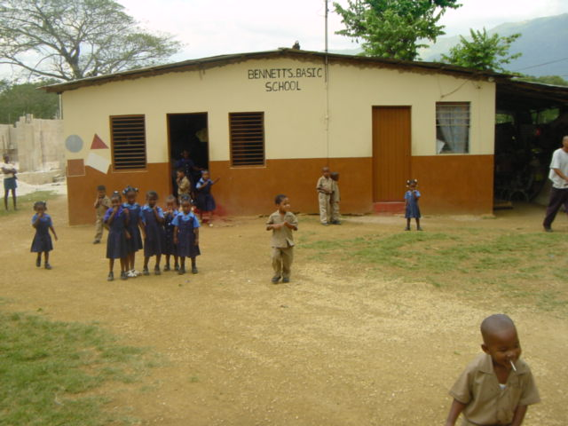
The school currently has forty five (45) Boys and thirty eight (38) Girls ranging in age from 3-6 years enrolled at the school. All four (4) teachers, (two (2) male, two (2) female) and the principal are trained teachers from teachers college. This indicates a teacher-pupil ratio of 1:17 which is one half of the minimum students per teacher. The percentage daily attendance for the current academic year 2002- March 2003 stands at 84% which can be considered excellent.

The children attending the school come from the surrounding districts of Wilton, Content, Pepper, Phanti Land, Gutters and Goshen (See map x) which are within a 5km or less radius. The school provides transportation for its students who do not live within the immediate vicinity of the school which is a mechanism used to ensure attendance.

Presently the cost for school fees is $1000.00 per term.

Enrolment at Bennett’s Basic School by Sex, 1993-2003
Academic Year | Male | Female | Total
1993-1994 | 38 | 20 | 58
1994-1995 | 24 | 24 | 48
1995-1996 | 33 | 25 | 58
1996-1997 | 34 | 29 | 63
1997-1998 | 44 | 28 | 72
1998-1999 | 40 | 34 | 74
1999-2000 | 45 | 41 | 86
2000-2001 | 44 | 39 | 83
2001-2002 | 40 | 39 | 79
March 2002-2003 | 45 | 38 | 83
Table 1 Source: Bennett’s Basic School

Analysis
- Compare with 3-6 population of the study area
- Compare with other basic school
- Projection of school going population and compare with existing facilities
- More boys than girls between the years 1993-2003. (Ask teacher why) Teacher don’t know why
- Enrolment in 1993-1994 stood at 58 students. By the following academic year a decrease of 10 was noted. This was caused by ? Over subsequent years enrolment has increased from 58 students in 1995-1996 to 86 students in 1999-2000 the highest it has been over the analysis period. It fell slightly in 2000-2001 to 83 and again in 2001-2002 to 79. The decrease in enrolment was primarily due to out migration over the academic periods as stated by the Principal. By the following academic year enrolment increased by 4 for a total of 83 students.

The building structure is in good condition and has three (3) class rooms with an average of twenty six (26) students per classroom which is below the required number of 30 students per classroom based on Ministry of Education, Youth and Cultures, Early Childhood Unit requirements.

The school has an out door kitchen from which students can purchase meals. The toilet facilities require upgrading as three (3) pit latrines are used one each for boys, girls and teachers. A large field/pasture is located to the east of the school property and is used for sports activities. The schools front yard is also used for recreational activities.

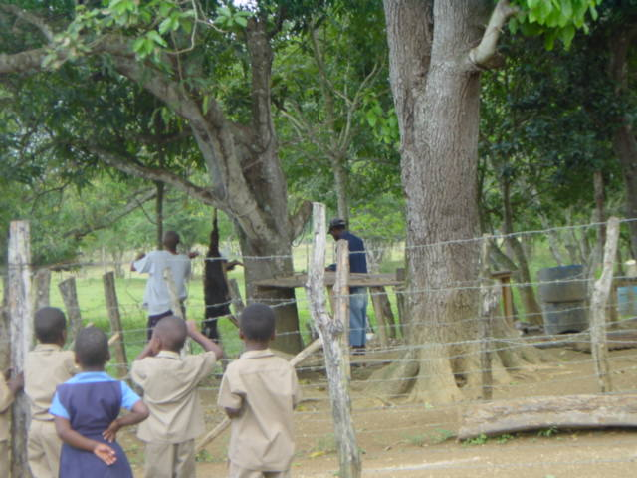
From time to time animals are slaughtered on the property adjacent to the school to provide meat for student’s lunches. The area is not enclosed and students could be seen watching a goat being slaughtered in full view at a visit to the school.

The school is growing and requires a larger facility to house its students. The Ministry of Education, Youth and Culture has proposed to extend the school at a future date.

Goshen Basic School (See map x) was established in the 1970’s by Mrs. Scott a resident of Goshen, who operated the school from her home. Over the years the school relocated several times as it grew; it was housed at the Community Centre and later when the building was being refurbished in 1997 by the Sports Development Foundation (SDF), it was housed at the Goshen Shiloh Apostolic Church on Saw Mill Road. It was finally relocated in 2000 to its present location on the Goshen Main Road when the Member of Parliament for the area donated funds to construct the school. The school is operated by a Sponsoring Body made up of community persons including persons from the Citizen Association and the All Age School.

A total of thirty one (31) students between the ages of 3-6 attend the school which has one (1) head teacher (trained) and one trained teacher both of which are female. This indicates a teacher-pupil ratio of 1:16 allowing for adequate attention to be paid to students.

The percentage daily attendance currently stands at 84% which is excellent. One problem with attendance is that some children do not attend school on a Friday. Why?

Majority of children are from the area with the exception of two (2) students who reside in Pepper.

Presently the cost for school fees is $1,500.00 or $2,000.00 per term.

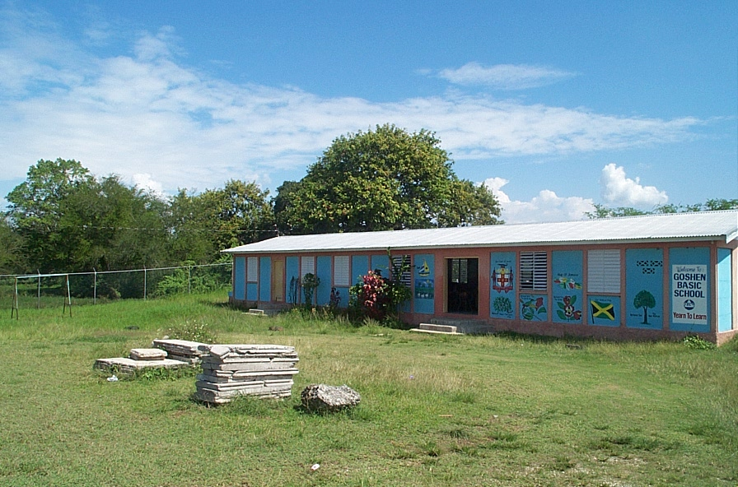

Enrolment at Goshen Basic School by Sex, 1993-2003
Academic Year | Male | Female | Total
1993-1994 | 10 | 12 | 22
1994-1995 | 14 | 7 | 21
1995-1996 | 11 | 8 | 19
1996-1997 | 10 | 8 | 18
1997-1998 | 12 | 8 | 20
1998-1999 | 8 | 10 | 18
1999-2000 | 5 | 7 | 12
2000-2001 | 11 | 14 | 25
2001-2002 | 9 | 21 | 30
March 2002-2003 | 10 | 21 | 31
Table 2 Source: Goshen Basic School

Analysis
- Compare with 3-6 age group for Goshen
- Compare with other basic school
- Projection…..
- More boys that girls between the years 1993-1998. Girls dominate to present. (Ask teacher why)
- Since 1993 overall enrolment steadily dropped every year until 1998 when enrolment stood at 20 students then fell again to its lowest during the 1999- 2000 academic year with 12. It has steadily increased since then and has reached its highest of 31 in the academic year 2002-2003.

It has been reported that parents are reluctant to send their children to the school due to its close proximity to the cemetery.

The school is in very good condition and is well kept. It has one large room that is partitioned to accommodate two classrooms which indicates an average of 15 students per class room which is one half of the required number of students per classroom. Other facilities at the school include a sick bay area in one of the classrooms, a kitchen that provides meals at a cost to students and a total of three (3) water closets, one (1) each for boys, girls and teachers.

The school does not have a playfield on its compound but has a play area in the front yard which regularly suffers from flooding during periods of heavy rain. Some garbage and metal refuse was found to the front of the school which could pose some risk to children at play. The school utilises the adjacent Goshen Play Field for major events such as sports day.

The school is currently experiencing a security problem as there is no fence to separate the community centre from the school. Often persons attending functions at the community centre trespass on school property and litter the grounds.

Secondary Education
Goshen All Age School was established in 1963 and is located on School Road off the Goshen Main Road. It currently has one hundred and ninety four (194) Boys and two hundred and nineteen (219) Girls enrolled at the Primary level (Grade 1-6) and forty seven (47) Boys and twenty three (23) Girls at the secondary level (7-9).
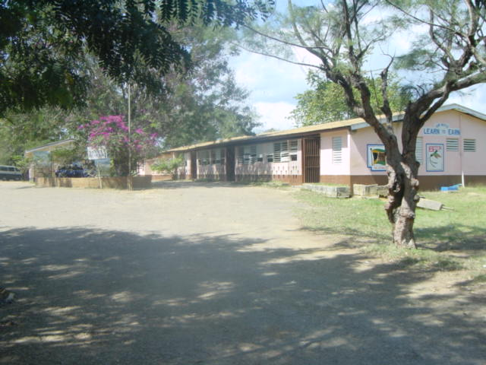
The school has in it’s employ a total of thirteen (13) trained teachers with eight (8) teachers for Grades 1-6, two (2) teachers for Grades 7-9, one (1) Information Technology teacher, 1 Physical Education teacher and one (1) Guidance Councillor.

Majority of students come from Goshen, Pepper, Phanti Land, Brae’s River and Content.

Enrolment at Goshen All Age School, 1998 - 2003
Academic Year | Male | Female | Total
1998-1999 | 242 | 211 | 453
1999-2000 | 233 | 193 | 426
2000-2001 | 225 | 202 | 427
2001-2002 | 215 | 214 | 429
March 2002-2003 | 241 | 240 | 481
Table 3 Source: Goshen All Age School

Analysis
- Compare with age group for Goshen
- More boys than girls over the five academic years
- Why more boys that girls? (Ask principal)
- Enrolment declined since 1998 then increased in the 2000-2001 academic year. It has increased to its highest in the 2003 – 2003 academic years to 481.
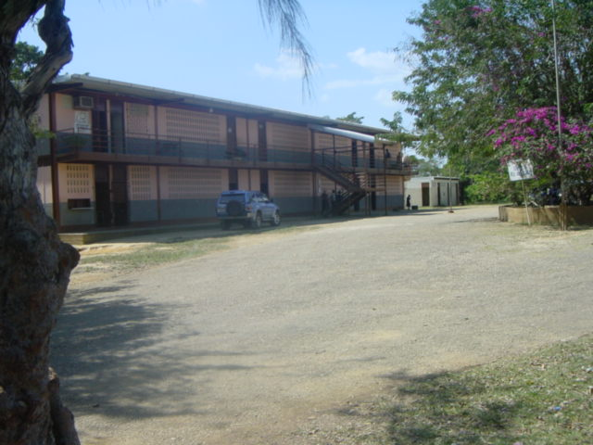

Goshen All Age School Passes for the Grade Six Achievement Test (GSAT)
2001-2002
Subject | Male (24) | Female (23) | Average
Mathematics | 34.02 | 47.77 | 40.75
Science | 36.94 | 53.99 | 45.28
Social Studies | 34.79 | 50.71 | 42.58
Language Arts | 35.76 | 53.00 | 44.20
Communication Task | 4.54 | 7.48 | 5.98

- Overall the girls did better than the boys in every subject.
- Fifty percent (50%) and over of girls passed all subjects except in Mathematics and Communication Tasks.
- Averages for majority of subjects fall within the 40’s. This is not good

Cemetery
The study area is served mainly by a public cemetery, which lands were donated by the Government through the Land Settlement Commission in the 1950’s. The cemetery is located on Centre Road directly behind the Goshen Basic School. The land was original assigned to bury those persons who did not complete payment on their personal property. As a result those persons were not afforded the luxury of being buried on their own property.

The land is owned by the Local Authority and operated by the Citizens Association who charges a fee for the purchase of plots to maintain the facility. The President of the Citizens Association estimates the cemetery to be three (3) acres (1.21406 hectares) and an estimated ½ acre (0.202343 hectares) utilized.

The cemetery is not landscaped and poorly maintained as seen by the overgrowth of shrubs and bushes on the grounds. (See figure x). Signage is poor as only a weathered metal sign on the main road instructs persons interested in the cemetery to make inquiries to the Citizens Association.
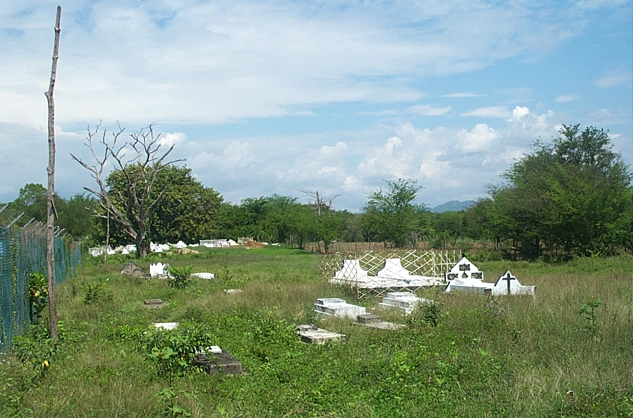
Burial seems to take place in a haphazard way as graves are located in several sections of the property. (See figure x).

The road to the cemetery is in good condition. Parking is not provided but persons often utilise the cemetery grounds and the road to park when attending funerals.

The cemetery is located in an area with a high water table and water is visible on the grounds as well as on the adjacent property. This can have implications for underground water as embalming fluids pose a threat to residents if water is polluted. Water table data from Bea

The Citizens Association has proposed to construct a shelter on the cemetery grounds to provide cover against the elements for visitors.

Other Sites

Other burial options for residents include burial in church plots such as the one located at Goshen Moravian Church for its members as well as the age old practise of family plots, several of which are seen through out the study area, even with the Parish Council discouraging the practise for many years.

Postal Agency
The Goshen Postal Agency (PA) building was originally constructed as an office for the collection of monies for the payment of land under the Land Settlement Programme. After all monies were collected the building was vacated and left for several years. It was then handed over to the Community Council by the Lands Department who had responsibility for collection under the Land Settlement Programme. It was then refurbished and donated to the community by the Goshen Community Council in 1979.

The PA is currently managed by the Citizens Association and provides general services such as sale of postage stamps and serves several districts and communities outside of Goshen including Content, Mitcham, Phanti Land, Long Hill, Wilton and New Castle. House to house delivery is not offered by the PA. (See figure x on page x).

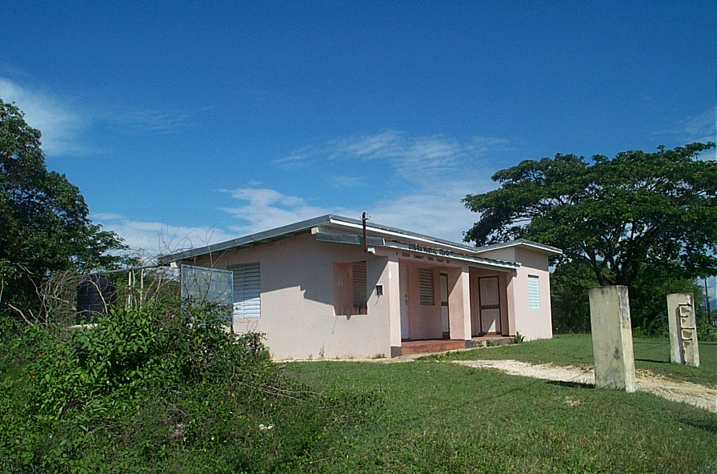
The facility is centrally located on the Goshen Main Road and is in good condition as it is frequently maintained. There is no light in the building and water is provided through a water tank which is piped into the building. The property adjacent to the facility is poorly maintained with shrubs and overgrowth contrasting to the manicured lawns of the PA.

The PA employs one Post Mistress and should soon be commercialising its operations so that it may generate income and become self sustaining.

Churches
The study area has five (5) churches of varying denominations which are centrally located within the community. (See figure x on page x).

- Kingdom Hall of Jehovah Witness – Myers Street
- Goshen Seventh Day Adventist – Goshen Main Road
- The Power of Faith Ministry – Goshen Main Road
- Goshen Moravian Church – Goshen Main Road
- Goshen Shiloh Apostolic – Saw Mill Road
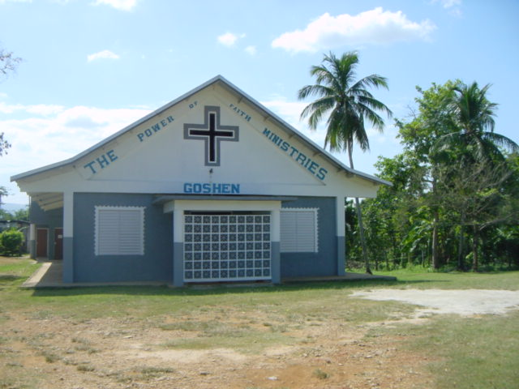

All the churches are in good condition and are regularly maintained.

They are all involved in out-reach programmes in the community including assisting schools in the area with various activities and visiting shut-ins.

Leisure and Recreation
The Goshen Community Centre and Sports Complex is the major recreational space in the community and can be found just off the main road. The building is in good condition and has three (3) water closets inside and two (2) pit latrines outside.

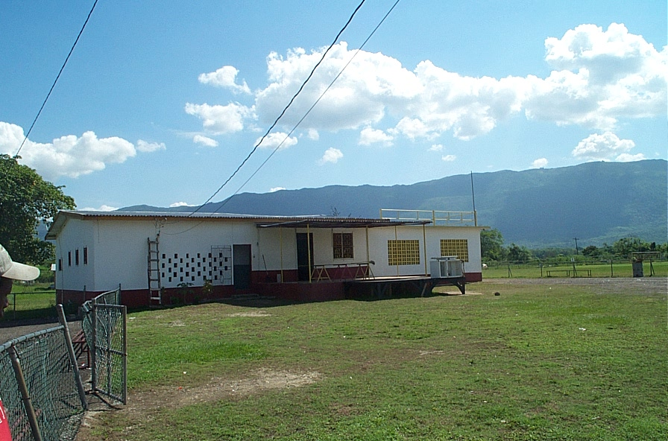
The centre lands were donated by the Government in the 1950’s under the Land Settlement Programme. It was an important part of the Government’s social programmes to construct community centres for residents to have a central meeting place to discuss common concerns and implement plans to improve their situation as well as focusing on training in social, economic, cultural, recreation and education activities and so in 1955 the centre was constructed through the Lands Department. It was then donated to the community and later improved by the Jamaica Welfare Limited.

In 1997 the Sports Development Foundation further developed the grounds by fencing around the football field and providing a multi-purpose court for netball, basketball and volleyball. They also refurbished the centre and provided running water into the property for the maintenance of the field.

The training programmes have long ceased but other activities have been undertaken such as hosting community meetings and community dances as well as the facilities being rented for weddings and other functions that generate revenue for the maintenance of the building and grounds. The field is used for hosting football matches, school sports day and stage shows.

Even with the efficient running of the centre by the Goshen Sports Club, several residents have expressed concern about the red tape that exists in accessing the property for community based recreational activities.

Community Integration

Several community based organisations (CBO’s) have been established in the community which are listed below along with their current status.

- Goshen Citizens Association – Active
- Goshen Basic School PTA – Active
- Bennetts Basic School PTA – Active
- Goshen All Age PTA – Active
- Goshen Sports Club – Partially Active

The Goshen Citizen Association is the most central group in the community and was original known as the Goshen Community Council. The organisation holds meetings once a month at the Goshen All Age School and has a central executive of eight (8) persons with a general membership of sixty (60) persons from various backgrounds and organisations in the community. The association is involved in several activities such as the management of the cemetery and postal agency as well as sitting on the board of the Goshen Basic School. The organisation is involved in several projects, such as their annual Christmas treat for shut-ins and the elderly in the community, as well as the issuing, each year, of the Hurdley Mitchell Scholarship to a child from Goshen attending secondary school.

The major issue affecting the organisation is the lack of interest from the youth and would like to see an increase in membership from the younger members of the community.

The Goshen All Age School PTA is a very active community organisation and has an average membership of twenty two (22) persons. The PTA, over the years has assisted the school with projects such as establishing the National Health Scheme (Blue Cross), renovating a section of the school, planning annual school fairs and sports days etc. They are currently planning the School’s 40th Anniversary Celebrations which should be held in ?.

For a school with almost five hundred (500) students the membership is very low and the PTA would like to see more parents taking a more active interest in the affairs of their children.

The Goshen Sports Club was formed in the 1970’s. The club manages the Goshen Community Centre and Sports Complex. It has a small executive consisting of six (6) persons and is partially functional with a fluctuating general membership. The Club mainly focuses on the rental of the facilities to generate revenue to maintain the facilities.

The executive of the Club have been charged with being bureaucratic and not involving the community in their decision making process.

The Club faces several problems ranging from lack of community support, and maintaining the Sports Complex facilities as rain often destroys some of their equipment. Most persons that utilise the facilities come from outside of the community. The Club is now trying to rejuvenate its “Sports Sunday” activities, which encourage community persons to come out on a Sunday and play several sports such as Cricket, Football and Netball.

Community integration is important for the sustainable development of the community. This involves participation by all groups affected in the decision making process, as it relates to land-use issues, recreation, culture, leisure etc. The community emits a high level of participation shown by their willingness to get involved in activities beneficial to the community, but similar to most communities across Jamaica, Goshen lacks a high level of cohesiveness.

Other Services

Police Station
The closest police station to the study area is the Santa Cruz Police Station. It serves Goshen along with seventeen (17) other communities. The station is roughly 6km from Goshen with an estimated travel time of thirteen (13) minutes.

Fire Station
In case of fire, units from the Santa Cruz Fire Station would be on call to serve the area, coming from 6km away taking an estimated twelve (12) minutes to arrive. Other stations that could provide assistance would include Junction and Black River Fire Stations. The community has also called on the services of Alpart who have in the past arrived before the fire trucks and extinguished fires in the community.

Health Care
No health care facility exists in the study area. Persons utilise the following facilities for health care services.

Health Facility | Type | Area | Est. Travel Distance (km)
Santa Cruz HC | 3 | Santa Cruz | 6
Pepper HC | 2 | Pepper | 5
St. Elizabeth Technical School HC | 8 | Santa Cruz | 6
Black River Hospital | C | Black River | 21
Mandeville Hospital | B | Mandeville | 16
Hargreaves Memorial Hospital | Private/Specialist | Mandeville | 16

HC – Health Centre

Recommendations and Conclusion
Can’s make no good ones need population, and info from Visioning Workshop
Education
- Play equipment for Early Childhood Schools
- Proper sanitary facilities for teachers and students
- Discourage institutional and commercial land uses adjacent to each other (slaughter house)

Leisure and Recreation
- Construct proper seating area with covering for persons attending football matches and other functions for the football field.

Sustainability Indicators

Source:

- Scott, C. Rowledd. (December 1967) Master Plan Report: Junior Secondary Programme. Houston Texas
- Ms. Peart, Secretary – Goshen All Age School
- Mr. Bennett, Principal – Bennett’s Basic School
- Mrs. Elaine Bryan, Teacher – Goshen Basic School
- Mr. Rhoden, Principal - Goshen All Age School
- Mrs. McLean, President – Goshen Citizens Association
- Mr. Chung, Acting President – Goshen Sports Club
- Ms. Daphne Holmes, Mayor – St. Elizabeth Parish Council
- Mr. Everton Levy, Caretaker – Goshen Community Centre and Sports Complex
- Ministry of Education, Youth and Culture – Early Childhood Department
- Mr. Andrew Pearson, Project Officer – Sports Development Foundation
- Mrs. Merna Palmer, Postmistress – Goshen Postal Agency

