Ridge to Reef Watershed Project

USAID Contract No. 532-C-00-00-00235-00

Consulting Trip to Jamaica

To Collaborate in Identifying the Wood-boring Insects Infesting the

Honduras Mahogany and the Blue Mahoe Plantations in Jamaica, and to

Recommend Remedial Actions to Mitigate the Infestation

December 2003

Prepared for the

Government of Jamaica’s

National Environment and Planning Agency

and the

United States Agency for International Development

Implemented by:

ARD, Inc.
P.O. Box 1397
Burlington, Vermont 05402

Prepared by:

Luko Hilje
Department of Agriculture and Agro-forestry
Tropical Agriculture and Higher Education Center (CATIE)
Turrialba, Costa Rica

Table of Contents

Introduction 5

Objectives 5

Activities 5

Results 6

Conclusions 7

Hypotheses 7

Recommendations 8

Additional comments 8

Acknowledgements 9

Appendix 1 Locations Sampled for Wood Borers in Jamaica 10

Appendix 2 Presentation - Are Insect Borers the Problem to Mahogany
and Blue Mahoe in Jamaica 11

Introduction

The Ridge to Reef Watershed Project (R2RW), an initiative between the Government of Jamaica’s National Environment and Planning Agency (NEPA) and the United States Agency for International Development (AID), focuses on improving and sustaining the management of natural resources in targeted watershed areas that are both environmentally and economically significant, such as the Great River and Rio Grande watersheds. In such watersheds, the blue Mahoe (Hibiscus elatus) (Malvaceae) and Honduras Mahogany (Swietenia macrophylla) (Meliaceae) are among the most important timber species promoted by the Forestry Department for the establishment of forest cover.

Some of these plantations were established in the 1960s and 1970s (see rationale in the Scope of Work –SOW- for this consultancy) and almost no silvicultural management has been practiced on them. In recent years, as licenses for exploting these valuable tree species have been issued, it has been noted that felled trees show extensive “tunneling” in the pith and heartwood. Wood-boring insects have been blamed for such damage, but specimens have not been collected so far to prove they are the primary cause for the damage.

It becomes necessary, then, to identify these wood-boring insects and appraise the extent of their damage, in order to recommend remedial actions to curb the infestation, while training personnel to deal with it, within an integrated pest management (IPM) perspective.

This is of utmost importance to Jamaica. As stated in the SOW for this consultancy, there are over 1,700 ha of Honduras mahogany and over 1,500 ha of blue mahoe in Jamaica, representing a marketable volume of approximately 550,000 m³, with a stumpage value of over US$50,000,000. Moreover, these precious timber species are aimed at improving tree cover in watersheds, thus reducing soil erosion and, when selectively harvested, helping to alleviate rural poverty by providing sustainable livelihoods for local communities.

Objective

To identify the wood-boring insects infesting Honduras mahogany and blue mahoe plantations in Jamaica, and to recommend remedial actions to mitigate the infestation.

Activities

November 30 Arrival in Kingston, Jamaica.

December 1st Briefing and procurement of available information pertaining to the problem, as well as securing the equipment and materials needed for performing our task in the field: R2RW personnel (Mr. Hugh Graham and Mr. Mark Nolan) and Forestry Department (Ms. Marilyn Headley, Mr. Keith Porter, Mr. Charles Dunkley, and Mr. Alli Morgan).

December 2 Field trip to Honduras mahogany plantations in Duffus Run and Barrett Pen (Central Jamaica), along with Mr. Keith Porter and his collaborators (Mr. Kevin Boswell), plus the support of regional contacts from the Forestry Department (Mr. York Reid and his field crew). Activities included the location of possibly affected spots; recording geographic coordinates with a GPS device; and cutting and slicing of trees possibly injured by borers.

December 3 Field trip to Honduras mahogany and blue mahoe plantations in Mosely Hall (Central Jamaica), together with Mr. Keith Porter and his collaborators (Mr. Kevin Boswell), plus the support of regional contacts from the Forestry Department (Mr. Stephen Martin and his field crew). Same activities as above.

December 4 Field trip to Honduras mahogany and blue mahoe plantations in Caenwood and Cambridge (Northeastern Jamaica), together with Mr. Charles Dunkley and his collaborators (Mr. Lascelles Fearon), plus the support of regional contacts from the Forestry Department (Mr. Danny Simpson and his field crew). Same activities as above.

December 5 Field trip to Honduras mahogany plantations in Spring Bank (Southeastern Jamaica), together with Mr. Fred Dias and his collaborators (Mr. Lascelles Fearon), plus the support of regional contacts from the Forestry Department (Mr. Alton Henry and collaborators). Same activities as above.

December 6 Analysis of gathered information, as well as searching for further information in the Internet at the hotel in Kingston.

December 7 Analysis of gathered information, as well as searching for further information in the Internet at the hotel in Kingston.

December 8 Field trip to a Honduras mahogany plantation in Quickstep (Western Jamaica), together with Mr. Lascelles Fearon, plus the support of regional contacts from the Forestry Department. Same activities as in the previous week.

December 9 Field trip to Honduras mahogany plantations in Retirement, Deans Valley and Burnt Ground (Western Jamaica), together with Mr. Michael Barrett and his collaborators, plus the support of regional contacts from the Forestry Department (Mr. Dexter Lewis and collaborators). Same activities as above.

December 10 Field trip to Honduras mahogany and blue mahoe plantations in Duanvale and Hyde Mountain (Western Jamaica), together with Mr. Patrick Barrett and his collaborators, plus the support of regional contacts from the Forestry Department (Mr. Ian Gordon and collaborators). Same activities as above. Return to Kingston.

December 11 Analysis of gathered information and preparation of a Power Point presentation at the hotel, in Kingston.

December 12 Debriefing.with 16 people, including R2RW (Mr. Hugh Graham) and Forestry Department leaders (Ms. Marilyn Headley, Mr. Keith Porter and Mr. Charles Dunkley) and other staff members, as well as Mr. John Latham (Trees for Tomorrow Project), Ms. Karyll Johnston (USAID Office), and representatives from other Jamaican institutions.

December 13 Departure from Jamaica.

Results

We visited 12 locations, which allowed us to cover three large regions (Central, Eastern and Western) and six Parrishes (Saint Ann, Portland, Saint Thomas, Trelawny, Saint James, and Westmorland) in Jamaica (Appendix 1), and inspecting 43 either Honduras mahogany (38) or blue mahoe (5) trees.

Methods used for field work included: 1) location of possibly affected spots, with the support of regional contacts from the Forestry Department, as well as local farmers; 2) recording standard geographic coordinates, with a GPS device; 3) cutting and slicing possibly injured trees; and 4) rearing found insects, from larvae to adults.

As a result of these activities and observations, the following statements can be safely made. The statements can also be found outlined in the Appendix 2 (as well as in a CD enclosed with this report, along with 104 labeled pictures taken during the field trips), which includes numerous colour pictures illustrating our points and was used for the debriefing meeting.

- Despite their good external aspect, mahogany and blue mahoe trees are often severely injured (rotten) internally (in their pith and heartwood).

- Sometimes, damage progresses from the bottom to the top, but other times it goes from top to bottom, starting at sites (bumps) where branches used to be.

2. In addition to a rotten heart, it is common to observe concentric and very symmetric cracks along some peripheral growth rings.

- There is evidence (galleries) of insects boring the wood, but we saw no exit holes. The only holes observed were probably caused by birds (woodpeckers) searching for insects to feed upon.

- Perhaps insects (subterranean termites and Cerambycidae beetle borers) are merely opportunistic, arriving after the tree has been affected by other factors. Termites were seen in only two occasions, and at very low levels. Some wood blocks of blue mahoe (from a blue mahoe tree that had been on the ground for about a year) were left in the Forestry Department, to rear a few Cerambycid larvae to the adult stage. In addition, four days after being collected in the field, a Cerambycid adult emerged from one of these blocks. I hope to identify it with the support of taxonomists at the Costa Rican National Institute of Biodiversity (INBio) as soon as possible. Unfortunately, they are on vacation until early January, 2004.

3. Interestingly enough, there was no evidence of attack by bark beetles (Scolytidae nor Platypodidae). They are opportunistic, commonly attacking trees with reduced resin pressure. But mahogany and blue mahoe trees had no problem in this regard, as rotten hart damage does not affect resin flow.

Conclusions

- Damage to both Honduras mahogany and blue mahoe plantations is very high (perhaps as high 75%), depending on their age and location, and is widespread all over Jamaica.

- Borers are not the cause of the observed damage to Honduras mahogany and blue mahoe.

- Damage seems to be due to one or more interacting biotic (tree age) and abiotic

- (Physical) factors, perhaps exacerbated by fungal pathogens which may cause tissue disintegration (rotting).

Hypotheses

The following four hypotheses, resulting from field observations as well as from discussions with Forestry Department field personnel and farmers, can be put forth: 1) Tree overmaturity; 2) site quality; 3) lack of stand management; and 4) strong winds and hurricanes.

- Tree overmaturity. Many of the observed Honduras mahogany and blue mahoe trees are very old (more than 25 years old), thus perhaps exceeding their standard commercial cycle. Younger Honduras mahogany trees, on the contrary, showed no problem at all, and especially when growing in very good soils. This was clearly illustrated in two locations of Quickstep, separated by only four miles, where old Honduras mahogany trees (more than 25 years old) were suffering from severe rotten heart damage, whereas 12-15 year old trees were completely healthy. As it would be gathered from a biological standpoint, overmature trees are expected to be affected by natural decaying processes associated with aging. Nevertheless, it cannot be ruled out that this phenomenon could be exacerbated by some fungal pathogens causing rotting, a factor that merits deeper analysis.

- Site quality. The majority of the observed trees showed a rather low growth in diameter (only 20-30 cm), despite being old enough to have attained much higher growth values. I recommend to comparing growth rates for Honduras mahogany and blue mahoe for Jamaica conditions, if such data is available, in order to gain insight into remedial measures that could be implemented. In this regard, two basic questions are in place: Are some soils too shallow for large and old trees to get enough nutrients and anchorage? Are some soils just too rocky or too compacted (clayish) to favor tree development?

- Lack of stand management. Two factors deserve to be considered on this matter. On the one hand, for old mahogany and blue mahoe trees, short planting distance and lack of thinnings would give rise to a strong intraspecific competition for light and nutrients (perhaps not for water, which seems to be abundant in the Forest Reserves studied). On the other hand, strong interspecific competition can result from spontaneous vegetation, including large shrubs and trees. In fact, the very dense forest cover observed in the Forest Reserves would be advisable for watershed protection, but not for timber production.

- Strong winds and hurricanes. Strong winds and hurricanes (like Gilbert, in 1988) are quite common in the Caribbean Basin. The concentric and very symmetric cracks observed along peripheral growth rings suggest that this is a mechanical injury caused by strong winds. Also, top-to-bottom rotting starting at bumps suggests that strong winds cause a punctual mechanical injury, and after branch breakage water gets into the trunk, promoting wood rotting.

Recommendations

- To develop a team approach (task force), with expertise of specialists from the Forestry Department and other local institutions, in order to clarify whether silvicultural factors (site quality, stand management, etc.) are indeed promoting the observed decaying processes in mahogany and blue mahoe plantations.

- To include in the team a plant pathologist, to determine the possible role of fungi in the observed decaying processes.

- In accordance to the resulting findings and recommendations from the Task Force, to consider alternatives such as:

  - To selectively harvest what can be saved, as soon as possible.

  - To plant both Honduras mahogany and blue mahoe using other silvicultural approaches.

  - To plant new timber species in the Forest Reserves.

  - To look for international experts on tropical silviculture if required.

Additional Comments

I took the opportunity to distribute several copies of my papers focusing on the mahogany shootborer (Hypsipyla grandella), which represents the main constraint to establishing both mahogany and cedar commercial plantations in Latin America. Also, I brought three copies (which were donated by ARD to Jamaican institutions) of the two-volume book (a handbook and a field guide) Forest pests in Central America.

In addition, despite the fact that wood-borers were not critical for Honduras mahogany or blue mahoe trees, it is important to keep in mind that they could become apparent in plantations sometime in the future.

In a literature search previous to my trip to Jamaica, I found no references for wood- borers as pests of these two tree species, not even in the classic book by Browne (1968), Pests and diseases of forest plantation trees, which focuses on the Commonwealth countries. Nonetheless, there are some reports from Cuba and Mexico. For Cuba, Hochmut and Manso (1982, Protección contra las plagas forestales en Cuba) reported that Acanthoderes circumflexa and Plectomerus dentipes (Cerambycidae) can attack weakened, moribund or felled West Indies mahogany (Swietenia mahagoni) and Hibiscus sp. Likewise, for Mexico, Cibrián et al. (1995, Insectos forestales de México) reported that Chrysobothris yucatanesis (Buprestidae) can bore into Spanish cedar (Cedrela odorata) trees.

Acknowledgements

I want to acknowledge the collaboration of the following persons, who helped me gather field data, and provided useful thoughts and information to accomplish my task: Mr. Michael Barrett, Mr. Patrick Barrett, Mr. Kevin Boswell, Mr. Fred Dias, Mr. Charles Dunkley, Mr.Owen Evelyn, Mr. Lascelles Fearon, Mr. Ian Gordon, Mr. Dowen Grant, Ms. Marilyn Headley, Mr. Alton Henry, Mr. Dexter Lewis, Mr.Stephen Martin, Mr. Alli Morgan, Mr. Keith Porter, Mr. York Reid, and Mr. Danny Simpson.

To Mr. Preston Hanson, Mr. Michael Barrett, and Mr. Hubert Samuels, who tirelessly guided me through so many winding and narrow roads almost all over the Jamaican countryside to reach forest plantations, while making me feel and taste the real essence of Jamaican culture.

Special thanks are due to Mr. Hugh Graham and Mr. Mark Nolan (R2RW Project), who contacted me to perform this consultancy and gave me constant support, as well as to Mr. Keith Porter and Mr. Charles Dunkley (Forestry Department), for his continuous help to carry out my activities.

And, last but not least, the remarkable performance and efficiency of Ms. Zyck Baggett and Ms. Teki Cass, from Associates in Rural Developmet, Inc. (ARD) in making this consultancy both feasible and enjoyable.
APPENDIX 1

Locations Sampled for Wood Borers in Jamaica

(Map drawn by Mr. Owen Evelyn, Forestry Department)

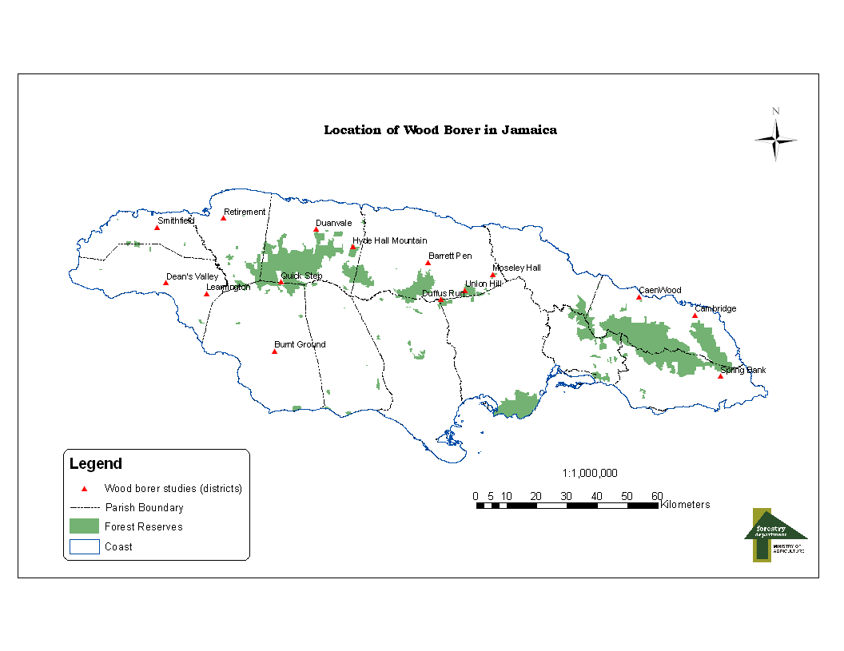

APPENDIX 2

Pictures Illustrating Field Findings

