Ridge to Reef Watershed Project

USAID Contract No. 532-C-00-00-00235-00

Western Jamaica Seminar on

Environmental Unity

Through Faith

May 20, 2004

Prepared for the

Government of Jamaica’s

National Environment and Planning Agency

and the

United States Agency for International Development

Implemented by:

ARD, Inc.
P.O. Box 1397
Burlington, Vermont 05402

Prepared by:

Carol Lawes
Seminar Coordinator

Table of Contents

Executive Summary 5

Introduction 8

Background 8
Mandate 8

Methodology 10

Planning Committee 10
Steering Committee 10

The Seminar 12

Design 12

Implementation 12
Arrival/Registration/Connection 12
Greetings and Reflection 12
Reconnection/Presentation I 13
Reaction and Exploration 13
Group Presentations 14
Presentation II/New Directions 18
Culmination? 18

Evaluation 23

Recommendations 24

Appendices

- Program 25
- Instructions to Participants 27
- Concept Paper 28
- Environmental Knowledge Questionnaire 37
- Environmental Pledge 39
- List of Exhibitors/Steering Committee Members 40
- Project Outlines presented by groups 41
- Songs/Poems created by groups 45
- Evaluation 49
- List of Participants 50

Executive Summary

Background

At the request of stakeholders from the Great River Watershed, this seminar was proposed to further encourage religious groups that are already promoting mainstream environmental stewardship practices and awareness to become more involved and catalyze the involvement of others by increasing their awareness and providing them with practical and meaningful access to resources.

Objectives

A one-day seminar was therefore planned for May 20, 2004, at the Holiday Inn, Montego Bay, with the following objectives:

- To bring together spiritual leaders (for example youth leaders and ministers of religion) to examine the connection between Faith and Environmental issues.

- To acknowledge each Jamaican as an environmental steward and a custodian of a unique part of the creation.

- To enhance overall awareness on environmental issues and foster stewardship of the environment.

- Identify opportunities for religious groups to become involved in environmental stewardship activities such as tree planting, nature walks, waste management, organic farming, among others.

- To demonstrate the link between the environment, every day life issues, and religion.

Planning and Participation

A consultant was engaged to coordinate the activity, with emphasis placed on stakeholder involvement in the process. The target set for participation was 150 persons from St. James, Hanover, Westmoreland and St. Elizabeth to represent the Baha'i, Buddhists, Christians, Hindus, Islam, Judaism and Rastafari.

There were four Planning Committee meetings and four Steering Committee meetings. All faith groups except the Jews were involved in the planning of the event. One hundred and seventy three persons registered, representing all seven faiths, but only 146 participated from the Baha'i, Christianity, Islam and Rastafari.

The Seminar

The Seminar included presentations from Leo Douglas of R2RW on the context and faiths; Mr. Franklin McDonald on The State of the Jamaican Environment; Dr. Peter Vogel on Inspiration from Birds; as well as intensive small group work and presentations to plenaries.

A brief opening ceremony included Greetings from USAID and NEPA.

Seven agencies active in environmental issues mounted exhibitions.

R2RW Chief of Party Mark Nolan made closing remarks in which he encouraged participants to conduct follow-up activity.
Next Steps

Participants proposed several ways of continuing the work of the seminar on Environmental Unity through Faith:

- Information from the seminar should be shared with the religious groups to which the participants belong.

- All issues discussed to be brought together in a paper for distribution to all attendees.

- Promotion of the ideas in church, mosque, school, youth club, citizens’ association.

- Along with home groups, participants should implement things learnt.

- Organize public programs/forums to communicate with the community on environmental issues, which affect them. Use meetings, workshops, seminars, flyers, bulletins, stickers T-shirts and posters.

- Convene community meetings and develop action plan with faith based organizations.

- Create clubs and groups which can mobilize tree planting activities.

- Invite environmental experts to religious activities to give talks.

- Lobby government agencies – Parish Councils/RADA/NEPA for environmental changes.

- Develop a database of community representatives/create a directory of all participants from this seminar.

- Liaise with other faith groups and maintain links to ensure continuity in sustainable environmental practices.

- Form a Western Faith and Environmental Committee to:

- Schedule monthly meetings

- Identify database of environmental issues and prioritize them

- Decide on calendar of activities

- Develop a secretariat

- Conduct annual environmental competitions

Evaluation

The predominant view expressed was that the seminar was extremely useful. Comments made in closing suggested that the faith groups worked very well together and that this presented a basis for further work on the environment. This was found to be particularly valuable by most respondents to the questionnaire, followed by the quality of the work done in small groups and the wealth of information and the forms in which it was presented.

Recommendations

- Sharing relevant sections of this report urgently with all participants is critical to maintain the momentum of the work. Contact may be made with the parish representatives and feedback sessions held in each parish.

- R2RW and NEPA representatives should attend these sessions, so that follow-up can continue beyond the life of the R2RW project.

- Parish groups should develop work plans, which should include fundraising activities to facilitate projects, as well as the formation of links with other civic and commercial entities.

- Representatives from the parish groups should come together periodically (maybe quarterly?) to share plans and ideas, and to support each other's initiatives, facilitated by R2RW and the Great River Watershed Management Committee.

- R2RW/NEPA should assist the groups to publicize their activities in the News media, both as a means of re-enforcing their importance, and encouraging similar action in other areas.

- The CDs of the Seminar presentations, as well as an edited feature from the video footage should be made available to the parish groups for use in their educational activities.

- A second seminar should be planned for 2005, to assess the progress made and to plan the next phase of organized faith-based environmental stewardship.

Introduction

"I love you my brother, I love you my sister,
whether you pray in your church,
kneel in your mosque or worship in your temple,
for the various bands of religion
are fingers on the hand of one loving God,
eager to receive all."

Haile Selassie

Background

The Ridge to Reef Watershed Project (R2RW) is a five-year bilateral initiative between the Government of Jamaica’s National Environment and Planning Agency (NEPA) and the United States Agency for International Development (USAID).

R2RW comprises three Components contributing to the achievement of the Intermediate Results under the USAID Strategic Objective 2 (SO2) – Improved quality of key natural resources in selected areas that are both environmentally and economically significant.

Component 1 sets out to work with local organizations to identify and promote sustainable environmental management practices.
R2RW strongly endorses an approach of working with existing organizations in watersheds as partners in solving local problems. In an effort to encourage stewardship values and to also enhance natural resources in the Great River Watershed, it had been articulated that the religious organizations continued to be an important social medium through which people of all ages and social classes are brought together at the local level. As such religious groups are major stakeholders of Jamaica’s watershed areas and an important partner in promoting environmental stewardship that falls within religious teaching.

At the request of stakeholders from the Great River Watershed, this seminar was proposed to further encourage religious groups that are already promoting mainstream environmental stewardship practices and awareness to become more involved and catalyze the involvement of others by increasing their awareness and providing them with practical and meaningful access to resources. It was also clearly stated as a recommendation from the Youth and Environment Conference of the Great River Watershed Management Committee, which was held in July 2003, that initiatives that promote religious youth organizations to care for the natural environmental be prioritized.

Mandate

The following objectives were therefore agreed:

1. To bring together spiritual leaders (for example youth leaders and ministers of religion) to examine the connection between Faith and Environmental issues.

2. To acknowledge each Jamaican as an environmental steward and a custodian of a unique part of the creation.

3. To enhance overall awareness on environmental issues and foster stewardship of the environment.
4. Identify opportunities for religious groups to become involved in environmental stewardship activities such as tree planting, nature walks, waste management, organic farming, among others.

5. To demonstrate the link between the environment, every day life issues, and religion.

Within that context, the consultant was therefore mandated to undertake the following activities:

- Develop a work plan for the overall approach to this assignment.

- Develop a 12-page concept paper on religion and the environment in Jamaica showing national, regional and international linkages between faith and the environment.

- Develop a work plan for the proposed Seminar including preparation of a detailed budget with implementing schedule.

- Develop and work with a Planning Committee to confirm the concept paper and develop and implement the logistics for the seminar on Faith and the Environment (including agenda, venue, invitation list, speakers, displays, participant packages, travel and meal arrangements)

- Design the most appropriate methodology for delivery of each theme/subject.

- Prepare the invitation list and send out invitations and follow-up.

- Call and facilitate all Planning Committee meetings.

- Coordinate media coverage in collaboration with Marline Stephenson and Sonja Harris of R2RW.

- On the day of the event coordinate and manage all activities.

- Coordinate the evaluation process and recommend next steps.

11. Any other duties that might be assigned by the Planning Committee/R2RW.

Methodology

Tried and tested Theatre for Development methodology was employed in conducting the Seminar. It required that participants work both in small groups and 'plenaries', alternatively developing and exploring ideas and sharing them with others. The exercises included games, recall of personal experiences, song/poem creation as well as individual work. Analysis and discussion was a constant feature of the day, serving to reinforce and clarify concepts and foster participation.

The tools with which the participants worked included information from formal interventions by carefully selected presenters, chosen as much for their ability to communicate as for their knowledge of their subjects, and from printed material, which was made available.

Preliminary exercises also provided tools - allowing them to relax with each other, learn from each other about their concepts of faith and the environment, develop the confidence to take bold steps while not being afraid to make mistakes, as well as to understand concepts which they needed throughout the process - cooperation, discipline and commitment.

The success of the activity also depended heavily on the setting of realistic targets and careful attention to detail. Care was also taken to sharply focus the theme and topics of the day's activities so as not to overload and overwhelm the participants. They had to end the day with clear understanding of tasks, which were manageable and sustainable both in terms of scope and resources.

Having their proposals evaluated with fellow participants would have given insight into what was workable and what was not, what approaches needed modification and where and how to find any additional resources which might be suggested. Time did not allow for this, but one of the presenters, Mr. Franklin McDonald was instead asked to comment on the proposals after they were presented.

In preparing for the day's activities, it was recognized that early involvement of stakeholder representation in the planning was critical. This would promote their buying into the program, and ensure that the process and content benefited from the valuable inputs from their vantage point, and from their experience on the ground.

Planning Committee

A Planning Committee was assembled from R2RW, Faith Groups, Government Social Agencies and Civil Society in Western Jamaica. Altogether there were some 40 persons involved at this level. There were four Meetings of the Planning Committee, with the largest attendance being about 20 persons. The Planning Committee looked at the broad issues concerning the logistics and content of the Seminar, and contributed to decisions such as those having to do with location and content.

Steering Committee

The Steering Committee began with six members who functioned as an executive body, overseeing the preparations between Planning Committee Meetings. It was, however, agreed that this should be expanded to include representatives of all Faith Groups in the process. Nominally, then, it included representatives from the Baha'i, Buddhists, Christians, Hindus, Islam, Judaism and Rastafari. Despite many attempts to get the participation of the Jews, this did not become a reality at this level, though the contact established indicated that a representative would have participated on the day of the Seminar.

Four Steering Committee meetings were held, with an average attendance of 6 persons. Both Planning and Steering Committees influenced the decisions made at all levels of the process.

The Seminar

Design

The seminar was designed to allow for the issues to be introduced in a relaxed setting, allowing for participants to informally meet each other and share personal/faith information, before getting down to exploration of environmental issues.

Care was taken to ensure that the atmosphere was non-confrontational, the activities encouraged broad participation, and that the event would point the way to concrete action.

This was achieved by scheduling formal presentations as well as small group discussions and feedback sessions with all participants.

A logical progression was established in which participants were first asked to identify the problems then work towards proposing solutions.

They were reminded of the context, presented with information, then asked to examine that information and its relationship to their faiths and communities. Having done that, they were then able to define the precise nature of the problems. In the afternoon, following an inspirational presentation, they were asked to apply their experience and creativity to developing possible solutions.

Implementation

Arrival/Registration/Connection

On arrival at 8:30 a.m., participants were handed a list of instructions and a registration form. On completion of the form, they were given a colour-coded nametag and a seminar kit.

Kits contained a Concept Paper, information on the Ridge to Reef Watershed Project, a Fact Sheet on the Seminar, notepaper, and several brochures on environmental issues and best practices.
Although representatives of six faith groups had been involved in the planning, and a seventh had indicated the intention to participate in the seminar, only four groups were included in the one hundred and forty six persons registered. There was one member of the Baha'i faith, 11 Moslems, 12 Rastafari, and as expected, Christians made up the largest group. Within this group, however, there were representatives of 15 denominations, including 1 Jehovah’s Witness.

On entering the seminar room, lush with plants, bird sounds and a simulated river, participants were asked to move around, meet six people and share personal information without disturbing the river.

This exercise did not have its full impact, as the snacks meant for the coffee break were already available when participants arrived. Most of the time was therefore spent on snacking outside of the room, rather than on getting to know each other in the designated space. However, to the extent that it was done, attention was paid to the river in the initial moments, after which many, taken for granted and “degraded”, as in life, forgot it. Facilitators made the point at the end of the exercise, and some efforts were made to "restore" the river to its original state.

Greetings and Reflection

At 9:00 a.m., the facilitators greeted the gathering, introduced themselves and called for a minute of silence during which participants were asked to either pray, meditate, or give thanks, and focus on the day ahead. This replaced the usual prayer, recognising that the concept held differing meanings for different faith groups.

Trevor Spence of Ridge to Reef was then introduced, and guided the formal proceedings, which included:

- A presentation by Leo Douglas of R2RW on the Context of the Seminar and the Faith groups involved;

- Greetings from

- Karen Turner, Head of the USAID Jamaica Office; and from

- Onyije Chigozili of the National Environmental Protection Agency;

- A performance of a poem "The Reptile's Lament" by Tasha Gay Brown, and

- Vote of Thanks by Paul Morris, Chairman of the Planning Committee.

Leo Douglas' power point presentation on the context of the seminar, with images of beautiful scenery juxtaposed with harsh conditions of degraded environment was very well received. His introduction to the environmental tenets of the various belief systems also served to emphasize that there were more similarities than differences between the faiths, and established the basis on which 'environmental unity' could be achieved. 'The Reptile's Lament' was charmingly presented and drew attention to the perspective of some of the other creatures with which humans shared the planet.

Reconnection/Presentation I

After a short Coffee Break, the participants were guided through "walk and talk", an activity designed to facilitate greater comfort levels amongst the participants and the introduction of environmental concerns into their conversation.

This was in preparation for a presentation on "The State of Sustainable Development and the Environment" by Franklin McDonald.

In his wide-ranging power point presentation, Mr. McDonald explained Sustainable Development, reviewed past initiatives on Faith and the environment, and examined the challenges to sustainability. He further outlined the Jamaican 'Hot Spots" in the context of global concerns, and presented specific areas for attention, including Tourism, agriculture and mining. He cited several possible approaches to addressing the problems including governance, cultural and individual action.

Reaction/Exploration

The participants were then divided into groups based on the colour of their nametags. Each group was instructed to elect a chairperson and rapporteur then react to the presentation by collectively examining the issues raised, connecting them to experiences in their own communities.

The following responses were recorded:

- Responsibility for environmental issues must be shared by all generations;

- There is need to educate people about environmental protection starting from the very young in Basic schools, and with special focus on parents and women;
- Creative means such as Music and DJs, Drama, Art, competitions etc., should be used in the educational process;

- Form groups to lobby Government towards action (more field officers with technical skills etc.);

- Target special groups in communities;

- Provide more resources to enable schools to better impart knowledge to students. Further,

- There was recognition of the impact of the traditional value system and cultural practices of a community on environmental issues;

- Care should be taken to unify words and deeds;

- There is need to acknowledge, respect and care for ourselves and for all living things and to appreciate the larger "community of life";

- A balance should be maintained between the demands of development and the needs of the environment such as:

  - Following development laws, and

  - Halting the development of informal settlements especially along rivers and gully banks, while

  - Planting/replacing trees and maintaining green areas and

  - Ensuring the proper disposal of garbage including household and industrial waste (compost/reduce/reuse/recycle)

  - Observing proper sanitation practices

  - Refraining from contamination of rivers and sea and from destruction of coral reefs for economic gain

  - Opposing the killing, capturing, and selling of endangered animals and plants

- Faith should be allowed to impact more on values so as to reduce the tendency towards materialism and a narrow focus on economics.

Next the six groups were each given a different environmental issue on which to focus within the context of the theme of World Bio-diversity day - Food Water and Health for all. The issues were garbage, sanitation/sewage, deforestation, coastal issues/water quality, agricultural practices and soil erosion.

Group Presentations

1. How do Agricultural Practices affect Food water and Health in our communities?

Food

Improper washing of agricultural products render products unsafe for consumption.
Premature ripening of fruits affects quality of product.

Water

Poor disposal of agricultural waste allows seepage into water supply particularly in limestone areas.

Chemicals pollute water supply
Killing of aquatic animals brings about improper balance
Clearing land by burning or using chemicals affects the watershed.

Health

Cancer-causing chemicals used in forcing the maturity of poultry and livestock.
By-products being used as feeds and fertilizers introduce slow poisoning into man's system.
Smoke inhalation from the burning of cane fields increases allergies, skin and internal problems.

Conclusion

Agricultural practices are not sustainable. Organic farming is a better alternative.

2. How does Soil Erosion affect Food water and Health in our communities?

In general - washes away topsoil – nutrients

Food

Poor food quality
Produce smaller in size and quantity
Low production/no production
Reduction of seafood

Water

Increased contamination
Reduction of water supply

Health

More water-borne diseases
Breeding of mosquitoes
More infants with poor birth weight/stillborn
Malnutrition
Skin diseases

3. How does Deforestation affect Food water and Health in our communities?

Food

Drought/low rainfall
Poor yields of crops
Increase in malnutrition
Soil erosion

Water

Low rainfall
Decreased water supply
Decreased sustenance for people and animals
Poor quality of water

Health

Increased risk of diseases e.g. cholera, typhoid and gastroenteritis
Increased risk of personal injury (in improper felling)
Increased bush and forest fires
Increased skin diseases (rashes/fungi)
Dehydration

4. How does Poor Sanitation/Sewage affect Food water and Health in our communities?

- Lack of proper sanitary facilities in restaurants and food stalls is potentially dangerous.

- The resultant Increases health risks are not only physical but also psychological effects such as depression etc.

- Dumping refuse in drains/gullies, river and sea creates breeding grounds for flies, mosquitoes and other harmful pests and contributes to disasters like flooding.

- Increased economic cost

- Destruction of Marine life

- Poor aesthetics

5. How do Water quality/Coastal issues affect Food water and Health in our communities?

- Affects marine life thus reducing food

- Causes diseases when not treated properly

- Excessive chemical treatment e.g. Chlorine

- Community activities (laundry, washing of cars, disposal of garbage etc)

- Rearing of animals near river banks

- Improper maintenance of sewage treatment plants

- Growth of Algae destroys coral reef

- Development of infrastructure - mining

- Sand mines

- Reduce salt supply we get from sea

6. How does Garbage affect Food water and Health in our communities?

Food

Contaminate food via flies, vermin

Water

Pollution affects marine and aquatic life
Reduces water quantity and quality
Blocks drain
Causes flooding (reduces food supplies)

Health

Gastroenteritis, typhoid, malaria, dengue
Foul odour (asthma etc.)
Breeding ground for rats and insects that spread disease such as leptospirosis
Affects people socially
Health issues lead to loss of production hindering economic development.

The final task before Lunch was to discuss the role of Religious Leaders relative to the environment, and propose ways in which religious groups could affect the treatment of the issues.

The groups agreed that Religious leaders/organizations should:

- Lead by example and practice on your own religious compound;

- Increase the level of unity among religious groups;

- Encourage a holistic way of life and teach the appreciation for all life forms;

- Foster a non-partisan approach to environmental issues;

- Promote inter-faith environmental initiatives;

- Encourage unity of religious groups and communities through social interaction programs;

- Sensitize the religious community to the effects of environmental degradation;

- Promote the use of pulpit exchanges to educate congregations and the wider community;

- Education in Sunday/Sabbath School, Youth Fellowship, Services, Camps;

- Use better communication practices to enhance education including the mass media and broadcasts;

- Ensure that church budgets allow for education activities such as the use of drama, workshops, seminars, etc.;

- Listening and empathizing in order to identify problems;

- Brainstorming to seek solutions to problems;
- Work with NGOs and CBOs;

- Establish cottage industries and agricultural projects as alternatives for harmful economic activities;

- Lobby for the engagement of environmental stewards/wardens and proper maintenance of water treatment plants;

- Observe Environmental Days and sponsor community clean-ups;

- Plant more trees and encourage reforestation in watershed areas;

- Donate garbage receptacles and promote improved sanitation methods;

- Adopt or sponsor specific projects.

During Lunch, participants were encouraged to view the exhibitions which had been mounted, complete the Environmental Knowledge Questionnaire and make any amendments they thought necessary to the draft Pledge of Environmental Unity for persons of All Faiths.

On resumption, the facilitators led the gathering through a warm-up exercise using two folk songs - 'Linstead Market' and 'Chi Chi Bud' as a means of re-energising participants, re-establishing the focus, and as preparation for the song-writing exercise which was to come.
This was followed by an inspirational presentation by Dr. Peter Vogel on The Wonder of Nature.

Presentation II/New Directions

Dr. Vogel's presentation looked at the artistry of nature, particularly as this was demonstrated through the movement and colours of birds, as well as the ways in which birds had inspired art through history.

This presentation encouraged participants to "think outside the box" in defining the new directions. The task was now:

- To prepare project outlines to address the problems identified,
- To prepare songs and poems to illustrate concerns and point to action, and
- To identify the 'next steps' which could be taken by faith groups.

Culmination?

The end, it was hoped, would be a new beginning. The project outlines presented showed thought and depth and offered real possibilities for further action. In commenting on them, Mr. Franklin McDonald identified some of the contextual and organizational issues with which they might have to contend, and later, there was some discussion on avenues, which might be pursued for financing of the projects.

The songs, composed to the tunes of 'Linstead Market' and 'Chi Chi Bud' and poems presented, demonstrated a wide range of concerns and offered options for spreading the message of environmental stewardship.

Several persons expressed the intention to maintain contact and to pursue inter-faith environmental activity within their parishes. Suggested parish Contacts are:

St. James Rev. Everald Galbraith
Hanover Rev. Lloyd Rose-Green
Westmoreland Ahmad Roy Golaub
St. Elizabeth Patricia Scarlett

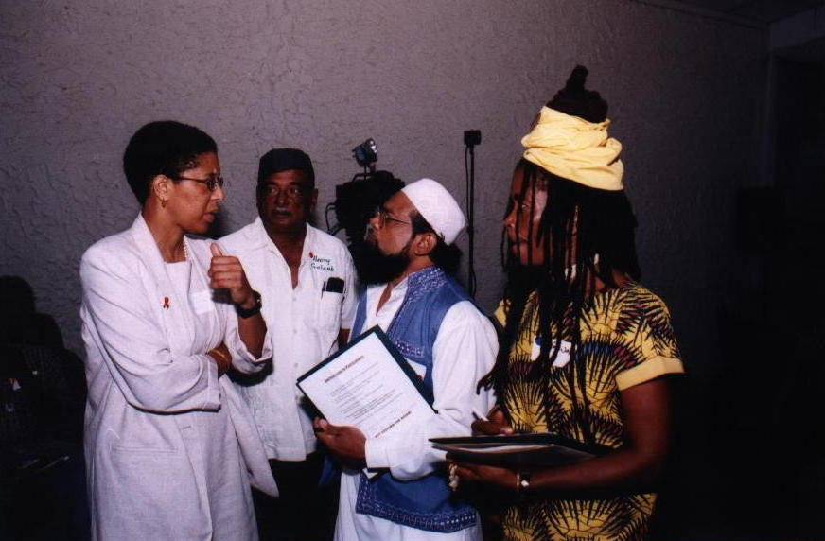

Karen Turner, Mission Director, USAID, speaks with seminar participants

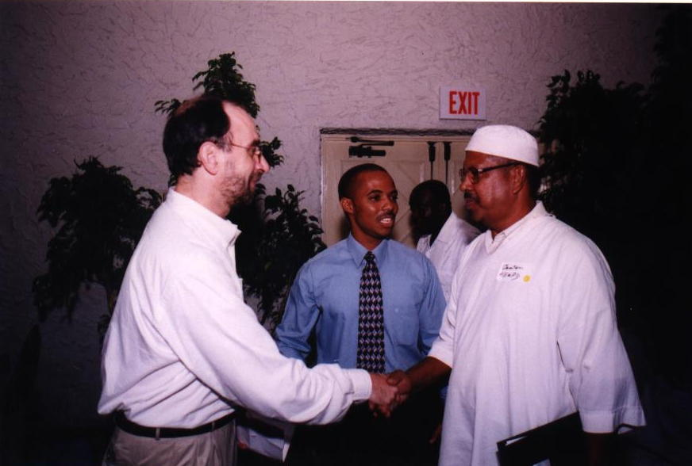

Mark Nolan, Chief of Party, and Leo Douglas of R2RW greet a Muslim participant
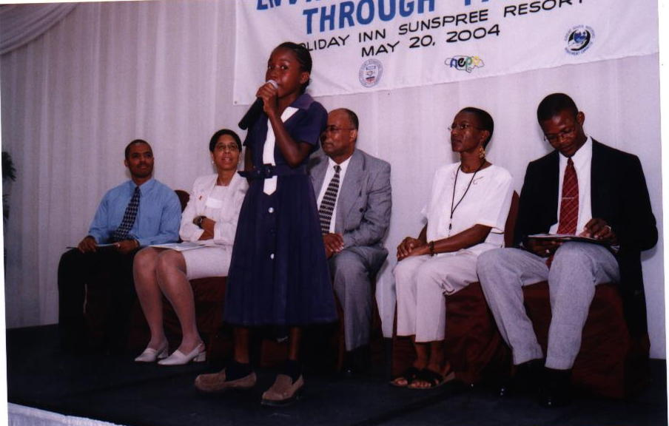

Tasha-Gaye Brown has the platform party spellbound as she performs “The Reptile’s Lament”. On the platform are (l-r) Leo Douglas, Karen Turner, Trevor Spence, Onyije Chigozili and Paul Morris

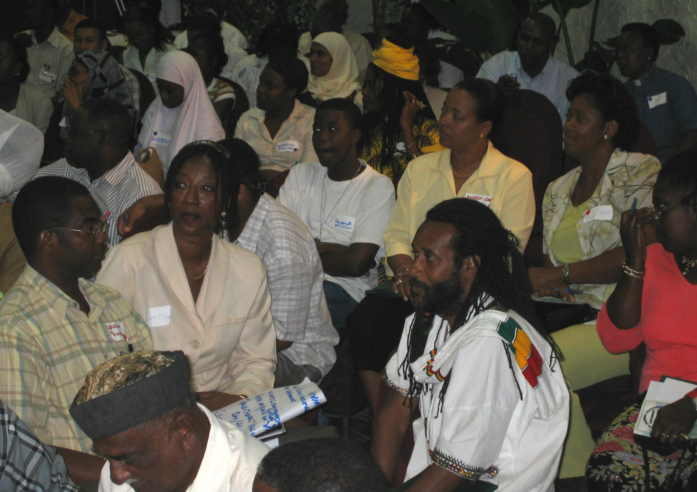

The seminar brought together Muslim, Christians, Baha’is and Rastafari

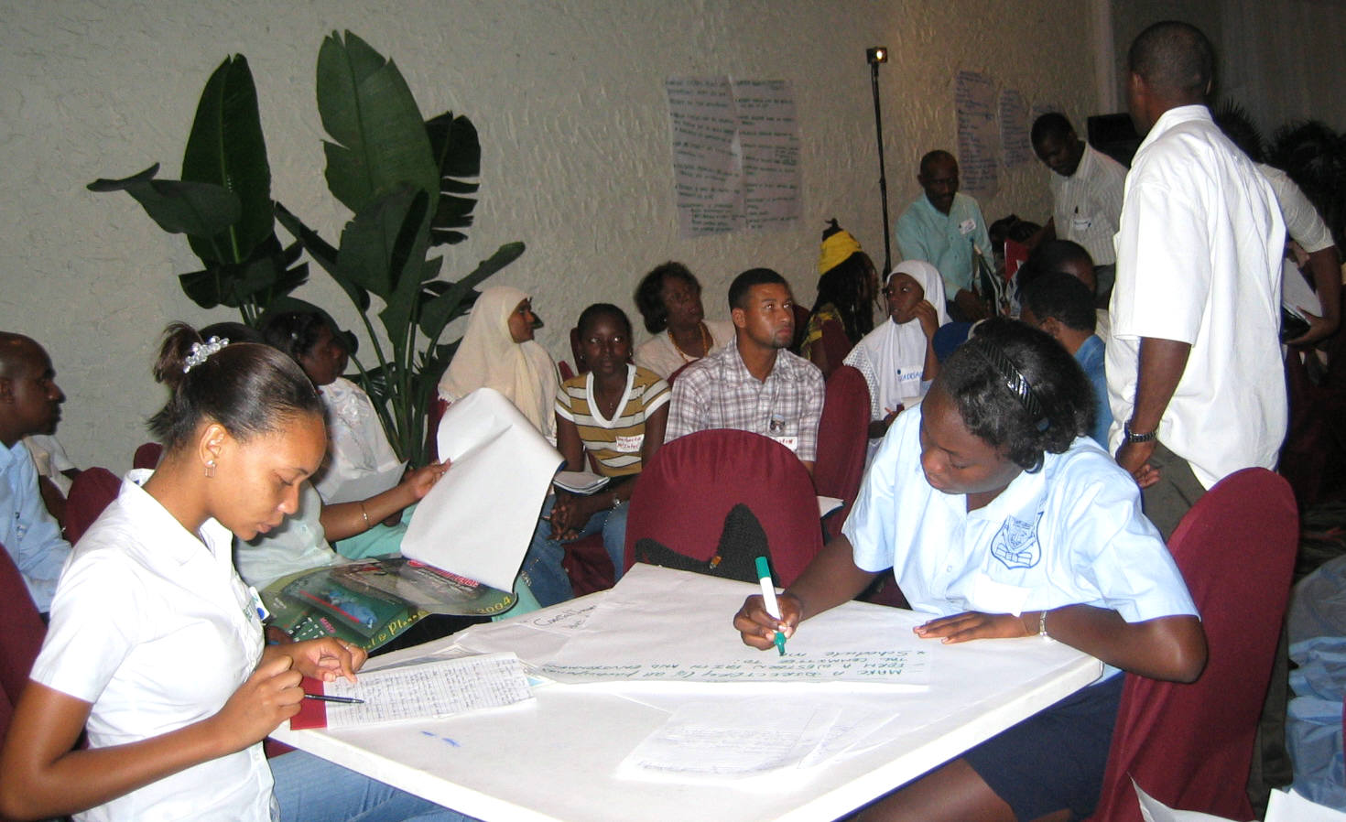

Young people were fully involved in the process

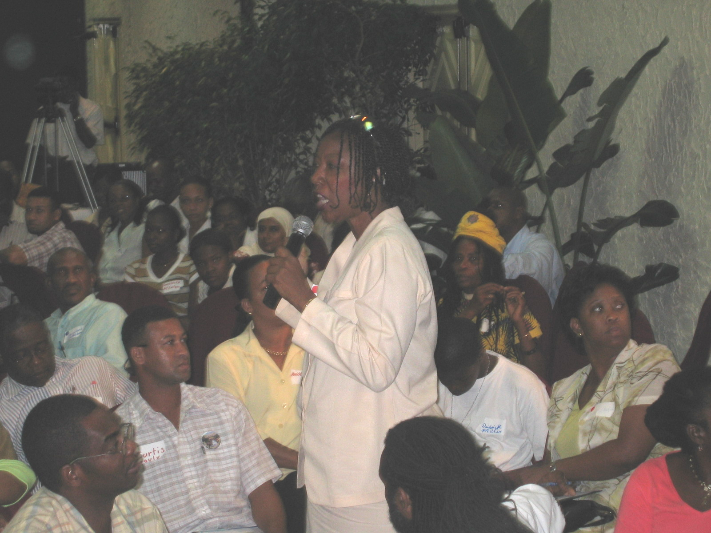

Valerie Lewis O’Bryan, a Baha’i and a Vice Chair of the planning committee presents the view of her working group

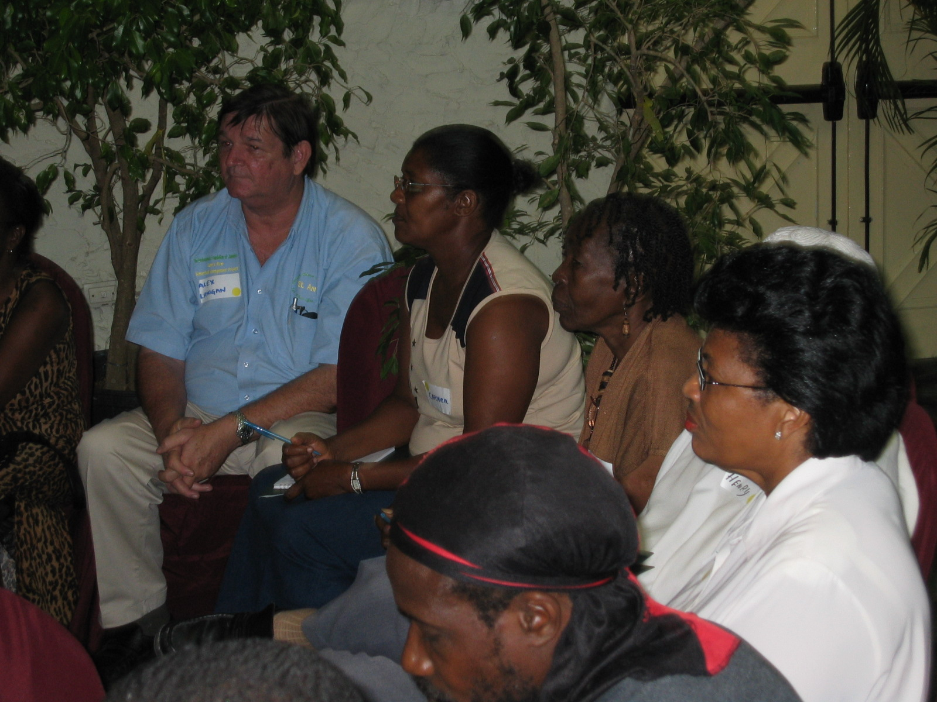

Participants listen attentively to a presentation

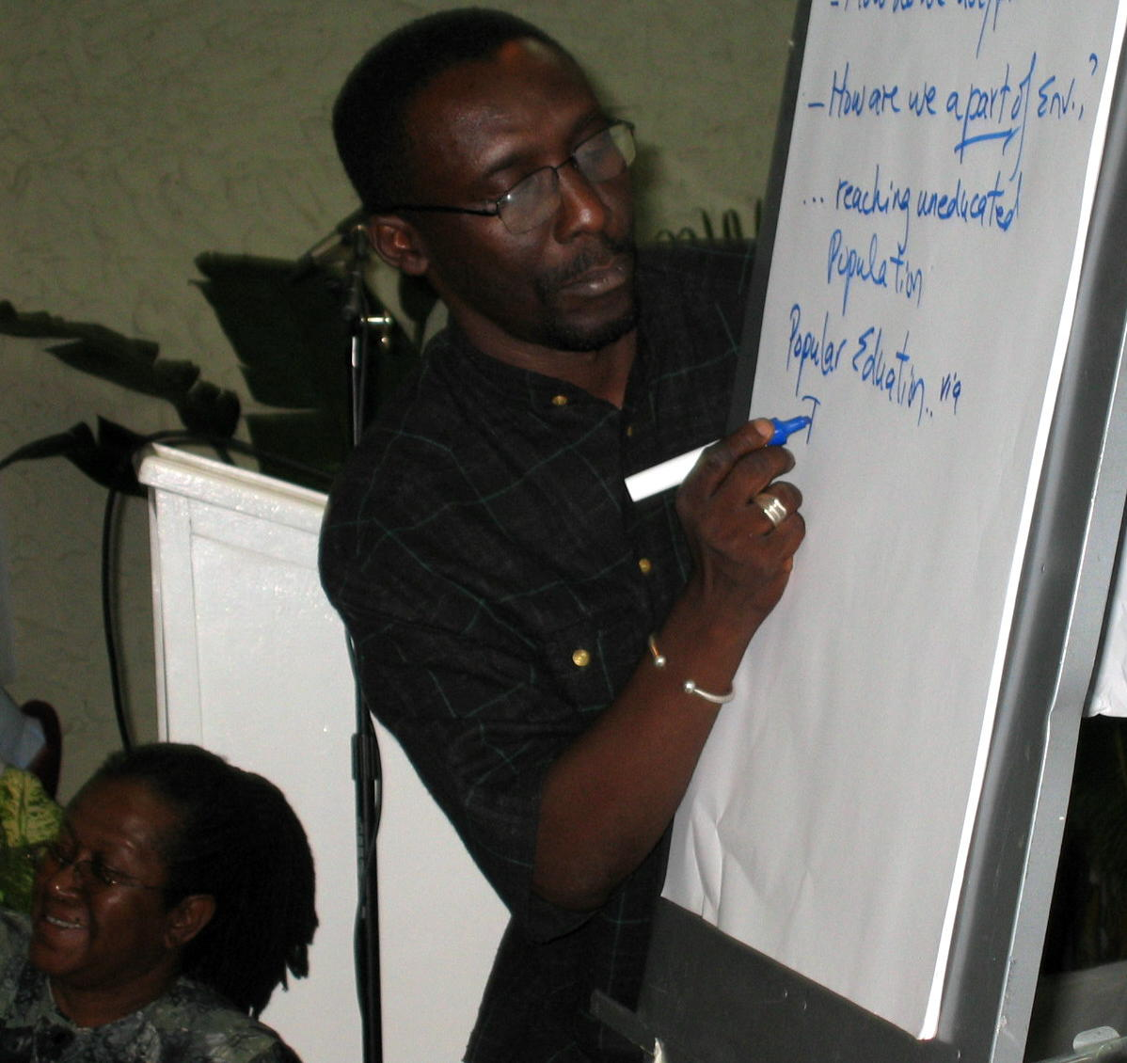

Facilitators, Owen Ellis (writing) and Carol Lawes (sitting) make sure nothing is left out

Evaluation

The predominant view expressed was that the seminar was extremely useful. Comments made in closing suggested that the faith groups worked very well together and that this presented a basis for further work on the environment. This was found to be particularly valuable by most respondents to the questionnaire, followed by the quality of the work done in small groups and the wealth of information and the forms in which it was presented.

On the forms provided, participants indicated their intentions to initiate action at the level of religious organization, community and club, and to spread the word on environmental stewardship amongst their contacts. They also expressed overwhelming willingness to be part of faith-based environmental initiatives.

On the whole, the exercise proved to be a useful one, both at the level of the environmental information made available, as well as the unique opportunity presented for sharing between faith groups.

The preparation process benefited from the stakeholder involvement, and was at the same time carefully managed by R2RW so as to avoid the many potential pitfalls. There were some hiccups experienced because of the change of intern at a critical point. However, once the changeover was finally effected, preparations once again ran smoothly.

The huge volume of work of the R2RW office also placed limitations on the support available from the staff there, and liaising with the intern in Montego Bay for the completion of certain mechanical tasks also proved challenging.

On the other hand, it was useful to be able to draw on the experience of Trevor, Sonja and Leo especially, in making decisions and for general guidance. The concrete support of Marline Stephenson in negotiating through Montego Bay's social and economic landscape cannot be overestimated. Her energy was boundless, and her spirit infused the work with infinite possibilities. In the end it all came together in a productive exercise, which was appreciated by the participants.

Recommendations

- Sharing relevant sections of this report urgently with all participants is critical to maintain the momentum of the work. Contact may be made with the parish representatives and feedback sessions held in each parish.

- R2RW and NEPA representatives should attend these sessions, so that follow-up can continue beyond the life of the R2RW project.

- Parish groups should develop work plans, which should include fundraising activities to facilitate projects, as well as the formation of links with other civic and commercial entities.

- Representatives from the parish groups should come together periodically (maybe quarterly?) to share plans and ideas, and to support each other's initiatives, facilitated by R2RW and the Great River Watershed Management Committee.

- R2RW/NEPA should assist the groups to publicize their activities in the News media, both as a means of re-enforcing their importance, and encouraging similar action in other areas.

- The CDs of the Seminar presentations, as well as an edited feature from the video footage should be made available to the parish groups for use in their educational activities.

- A second seminar should be planned for 2005, to assess the progress made and to plan the next phase of organized faith-based environmental stewardship.

APPENDIX I

Program

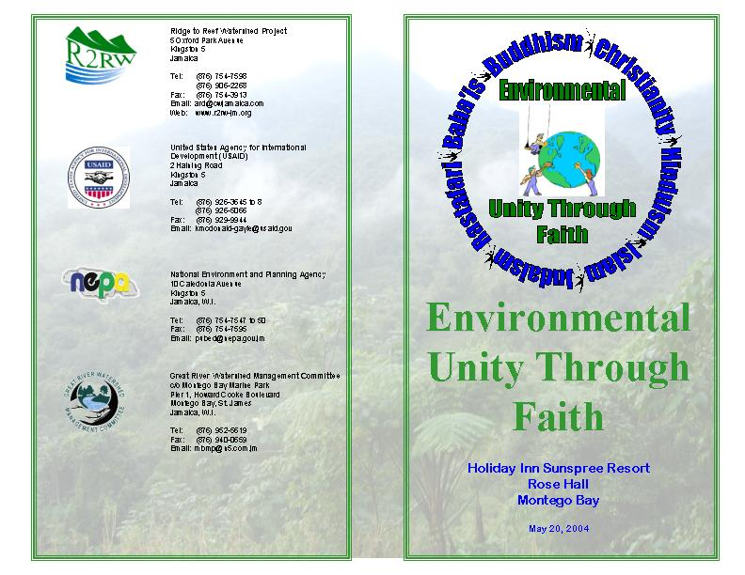

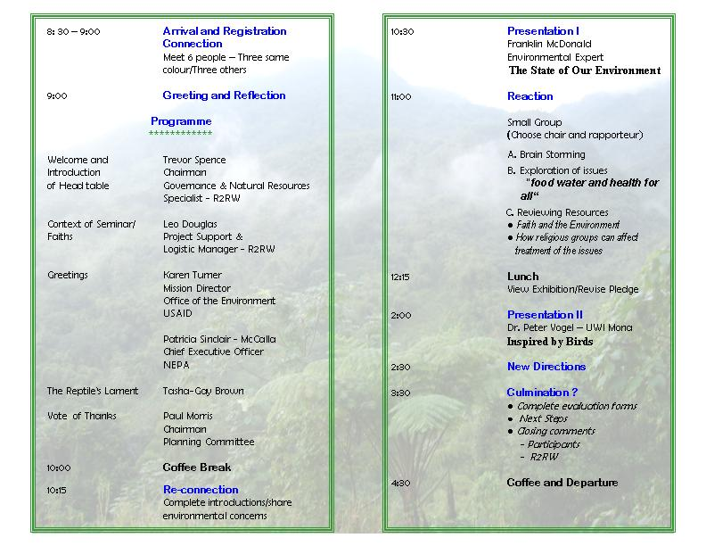

APPENDIX II

Instructions to Participants

- At the tables provided, please fill out your registration forms and return them to the secretariat.

- You will be given a kit and a label on which you are asked to write your name. Your label will have a colour.

- Please enter the conference room.

- Upon entry you will see that a ‘river’ has been created throughout the room.

- You have 20 minutes to meet six people – three people whose labels are the same colour as yours, and three people whose labels are three other colours.

- Share and learn as much as you can with these people in the time allotted.

But……

DO NOT DISTURB THE RIVER!

APPENDIX III

Concept Paper

Table of Contents

- Introduction 29

- The Problem 30

- Concerns Surrounding Tourism 31
- Waste 31

- The Jamaican Response 32

  - Communications Biblical Perspectives on the Ecological Question 32
  - Public Media Campaign 32
  - Cooperative Action 32

- Enhancing Harmony 34

- Frame Work for Action 35

  - Assets/Approaches to Consider 35

- What Can I Do 36

1. Introduction

The crisis that the environment faces is well documented. Globally, we are faced with a depletion of resources - over-fishing of marine stocks, soil erosion, the destruction of several species – an increase in environmentally related diseases, and an increasing difficulty in the world's ability to feed its people and to maintain healthy lives.

What can we learn from the world's religions to assist us in reversing this process? And how can religious adherents provide leadership through their belief systems to the communities which they serve, in not only addressing their spiritual needs, but also in providing practical guidance to halting environmental degradation?

The values and attitudes, which shape our concepts and our behaviours, come in large part from religious worldviews, which orient us to the cosmos and to our role in it. Religion uses ethics, traditions and institutional structures to influence the use and distribution of resources as well as to affect policies, which often have an effect on the environment. The weight of religion can be extremely powerful if brought to bear on the present situation, if we are to protect the legacy of future generations.

This connection between faith and the environment has been made by many of the world's religions, and more and more their leaders are coming together to combine their thinking and their efforts in this regard.

In the major religions of the world, though the theologies are different, they all share a similar approach to nature, and especially concur on the relationship between human beings and nature. The theme, which is constant in every faith, is Harmony.

Persons of faith have a commitment to preserve harmony with the rest of creation. All living things, including human beings, have been placed together within the universe by the creator, and demonstrate His glory, wonder and power. The person of faith understands his or her perfect communion with God and His world. In exercising that faith, the human being has a responsibility to protect that which the Creator has provided.

Among Christians, much emphasis is given to the passage in the book of Genesis, which speaks to man having dominion over the earth. Some have interpreted this to mean that man is all-powerful and has the right to exploit nature for his own good. Therefore, as Dr. Barry Wade points out, "instead of seeing ourselves in harmony and partnership with our environment, we spend our energies struggling with nature as though it were our enemy. In fact", he notes, "so engrossed have we become in this struggle that we tend to measure our success and advancement (even our growth in civilization) by our ability to tame nature. How much better it would be", he continues, "if we placed a higher regard on our care of nature as we were meant to do rather than on our conquest of it".

The idea of the necessity for the care of nature is expressed in different ways in all faiths, with the human being a part of rather than apart from the rest of creation.
2. The Problem

As we approach the commemoration of World Biodiversity Day with its theme 'Food, water and health for all' we are reminded of the many ways in which the lives of human beings are interconnected with the life of the rest of creation.

Biodiversity refers to the variety of living things in and of the earth, sky and sea, all of which are inter-connected and which co-exist in harmony. When the balance is disrupted, the consequences are grave. Many species have become extinct, and the trend is continuing, with disastrous effects on the quality of life, especially in developing countries. Rapid population growth with resultant increase in consumption; the production of waste; and the impact of natural disasters, technology, and science, all threaten sustainable development. Environmental problems affect us all.

In addition, global warming produces extremes in weather conditions and results from problems caused by pollution, greenhouse gasses, ozone depletion, land degradation, deforestation, and a host of other environmental concerns.

The enormity of these issues might appear beyond the scope of spirituality, which is regarded as the main focus of persons of faith. But it is precisely that spirituality, that understanding of one's place in creation that must form the basis of a new approach to the environment. All the negative conditions have originated because of the departure from the concept of the human as a part of, and as stewards of creation. Conquest has overtaken communion as the overriding feature of the relationship.

It is incumbent on people of faith to get back to basics in their practices regarding their place within and responsibility towards the universe. Though the global issues are large and may seem intractable, it is clear that how we approach them at the local level is an important indication of the way in which we live our faiths.

How in harmony with nature do we in Jamaica live?

In 1990, Norman Girvan quoting Eyre reported that:

    - Nearly 325,000 acres of forest were converted to other uses in the period 1981 - 1990, with a further 741,000 acres "seriously degraded";

    - 400 million tones of soil was lost in the same period from the surface watersheds of the island, mostly to the sea, where it chokes coral reefs and hurts other marine life;

    - average rainfall in ten watershed areas declined by 28% in the 30 years up to 1990;

    - deforestation and global warming resulted in a 2.3 degree centigrade increase in average annual temperature between 1947 and 1989;

    - 50 named rivers lost perennial flow since 1950; and

    - 409,000 tonnes of carbon are emitted each year from forest burning.

What do these statistics tell us about our level of harmony with nature?

Here in Western Jamaica where tourism is the main contributor to the economy, does the practice of our faith result in action which protects and preserves our environment in recognition of its importance to our creator? Consider the following:

Concerns Surrounding Tourism

    - The use of coastal land for building is a threat to the coastal and marine zone.

    - Urbanization and road building contribute to the destruction and loss of wildlife and other habitats.

    - Catering for tourists increases emissions from transport, air conditioning and increases the use of electricity by tourist facilities.

    - The non-treatment of sewage from hotels causes pollution of marine waters, reduced fish stock and beach quality.

    - Water resources are depleted by use for swimming pools and golf courses.

    - Forest cover is lost due to extra demand for wood and wood products

    - Off road vehicle driving causes erosion.

As there are so many links to other sectors, this does not give the complete picture of the effect of tourism on the environment. But it is clear to see that despite our faiths, we are failing to adequately care for our environment, and failing to provide for our economic and physical needs in a way that harmonizes with the rest of nature.

Waste

This lack of harmony is even more painfully demonstrated by the way that we treat waste. The question has been asked - when something is thrown 'away', where does it go? Where is 'away'?

In assessing the way we care for creation, there are several concerns about the treatment of garbage:

- Much household waste is illegally dumped in open areas, gullies, rivers and open lots, resulting in increase in vectors, and flooding caused by blocked drains;

- Littering is common;

- Legal dump sites are inadequately treated;

- Plastic waste is not biodegradable and produces poisonous gasses when burnt;

- Only 50 percent of sewage is handled by treatment facilities, and often inadequately;

- Hazardous wastes are insufficiently regulated and managed; and

- Liquid waste, not properly treated, is entering watercourses and affecting water quality.

How can a community, which professes faiths, which all acknowledge oneness with creation, fail to address these issues?

3. The Jamaican Response

Fourteen years ago in 1990, The Jamaica Council of Churches sought to address these issues in a series of seminars held in Kingston and Montego Bay. Though that body does not speak for all Christians, and certainly does not speak for all faiths, it is useful to look at the recommendations for action which arose from their activity. These were aimed at having their members act in ways which were more compatible with the tenets of their faith so as to achieve greater communion with their Creator.

Action was proposed in three basic areas:

- Communication of Biblical Perspectives on the Ecological Question
- A Public Media Campaign, and
- Cooperative Action.

These were their recommendations:

Communicate Biblical Perspectives on the Ecological Question

- Sermons, Dramatic Productions
- Special environment focus in Bible Study
- Units on Environment in Sunday School Literature
- Programs to Take Care of Church Grounds
- Essay Competition
- Sunday nearest to Environment Day to be projected as “Environment Sunday”
- Tree Planting program
- Church Bulletin Inserts
- Incorporate environmental issues in school’s devotional exercises

Public Media Campaign

- Television Discussion forum
- Radio Presentation of the environment
- Bumper Stickers
- Advertisements
- Print messages on Environment in Denominational
- Publications, on Exercise book covers, etc
- Contribute newspaper articles and Letters on the
- Environment
- Prepare handbills for students, farmers, etc.

Cooperative Action

- Lobby Government to secure physical conditions suitable for human life in neglected areas

- Publicize threats to the environment

- Prompt citizen’s association and village leaders to become environment conscious

- Organize pre-cast toilet distribution program

- Impress upon schools not to include clean up of their compounds in their punishment regime

- Establish a “Friend of the Environment” Award

- Organize boycott of goods and services of Private Sector groups which are environmentally unfriendly

- Insist on the inclusion of public sanitary convenience in Shopping Plazas, markets, government buildings, etc.,

- Urge the inclusion of environmental issues in tourism course taught in schools

- Revive tradition of tree planting when a child is born

- Establish a re-cycling plant

- Unite with schools to establish school gardens

- Establish church gardens

Though these recommendations speak specifically to churches, are the themes or activities valid for other faiths? Would such measures contribute to increasing levels of harmony between individuals and their environment?

- Enhancing Harmony

"Man should not wander as a stranger in a silent land
Nor under the wide sky move indifferent to the wind.
A Tree, A River, A Bird
Should be extensions of himself:
Written in rocks
And in the ways of wild things
Spoken in Parables of water.
Told in the gift of sunlight is the code of man's existence
And the design for his survival
For the earth is home and the ways of nature are truth."

(Author unknown)*

As religious leaders, there are several assets at your disposal, which may be employed in bringing about greater harmony between your membership and the environment.

However, the challenge is for faith-based institutions to relate their environmental teaching and activities to both their belief systems as well as to the concrete ways in which that faith is practised.

It has been suggested that the environmental stewardship demanded of religious organizations requires The Right Attitude, Enlightened Awareness and Responsible Action.

The Right Attitude involves reconnecting with the foundations of faith, thereby restoring the sense of responsibility towards the totality of creation. That would result in persons of faith showing by their example, their unity with the works of their Creator.

It is true to say that the lead on environmental issues is taken not by faith based organizations, but by technical and other non-governmental bodies, which focus on sustainability for future generations, rather than on the wholeness of the universe which has been created.

Enlightened Awareness arises from the reconnection with the teachings of one's faith. It involves informing ourselves and others of the issues and bringing the perspectives of our faith to bear on our behaviour.

Responsible action is what results from a right attitude and enlightened awareness, a tangible expression of the regard for all of creation, which should be enjoyed to the glory of the Creator.

One therefore does not only preach harmony, but indeed practices it in all its manifestations.

5. Framework for Action

The Worldwatch Institute, an NGO that has worked with a wide range of faiths in the effort to restore harmony, has proposed the following framework, which might be a useful starting point in determining the way forward.

Asset Approaches to Consider

Worldview development Assess teachings; ensure that the natural world is sufficiently represented in worldview and ethics.

Moral Authority Use the pulpit to address the global crisis of sustainability.

Use the congregational newsletter, bulletin or website as a platform

Make effective use of the media through placement of opinion articles, letters to the editor and coverage of congregation's environmental activities

Engage political leaders who make decisions affecting sustainability.

Members encourage members to write letters join boycotts or protests, or in other ways creatively bring their full political weight to bear on these issues

Educate members about consumption and encourage them to consume less and to buy products that have low environmental impact.

Encourage members to shift investments to companies with exemplary environmental and labour records.

Material Resources Use physical facilities as a venue for discussing issues of sustainability, or for organizing sustainability activities
Use physical facilities as a showcase of simplicity, and for renewable energy, energy conservation, organic gardening or other activities that could promote sustainable living.

Shift purchasing and investment decisions to favour a sustainable world

Community Building Increase bonds of trust and communication, and deepen emotional ties to the environment by organizing environmentally oriented service activities.

Build on existing social ties to support congregants in attempts to simplify their lives.

6. What Can I Do?

In determining action, though you are here as leaders at one level or another in your faith, it is important to establish your own level of personal commitment to sustaining harmonious development. Without that, your efforts could possibly be derailed if your congregation does not immediately buy-in to the process.

Secondly, it is important that the specific issues, which you target for attention, find resonance at the community level, and can be seen to have concrete impact on daily life.

Third, it is better to start small and choose a manageable objective with measurable outcomes so as to enhance your chances of success. Success breeds success, builds confidence and is empowering. It will encourage support for more complex projects in the future.

Fourth, maintain links with persons of like mind, such as are present here today. Knowledge of progress and the sharing of experiences will strengthen everyone's efforts and redound to the good of all.

Finally, never underestimate the power of one. One leader, one step, one congregation, one community can have a major effect on the whole nation.

Let it begin with you.
APPENDIX IV

Environmental Knowledge Questionnaire

(89 Persons Responded)

- What is a watershed?

  - A place to safely store water - 3.4%
  - An area of land drained by a major river - 88.7%
  - A channel through which agricultural water is passed - 4.49%
  - A facility of the National Water Commission - 2.24%

- What do you think is the most important environmental problem facing Jamaica?

  - Deforestation - 19.1 %
  - Improper disposal of garbage - 52.8%
  - Unplanned Settlements - 17.9%
  - Water Pollution - 12.3%

- What is the most important environmental problem facing the world?

  - Overpopulation - 13.5%
  - Global warming - 10.1%
  - Destruction of the ozone layer - 50.6%
  - Deforestation - 24.7%

- Do you know any of Jamaica’s environmental laws?

If yes, which?

Do not destroy forests - 3.4%
Do not pollute rivers/No washing of motor vehicles in rivers - 14.6%
Anti litter - 25.8%
Do not break bottles in public places - 1.1%
Do not start fires in the mountains - 1.1%
No burning of plastics - 1.1%
Do not build houses along river banks - 1.1%
Protect endangered species/endangered species act - 16.8%
Fisheries act - 3.3%
Improper disposal of garbage - 8.9%
Deforestation/Forestry act - 5.6%
No solid waste in the water supply - 1.1%
Don't build without an approved plan/town planning act - 3.3%
NRCA - 3.3%
Watershed act - 1.1%
Effluent discharge act - 1.1%
Sand mining law - 1.1%
Protection of coastal areas/coral reefs - 4%
- List two activities that a household can do to help to protect the environment

Proper separation and disposal of garbage - 67.4%
Teach children not to litter/have clean-up days - 15.7%
No burning (especially of plastics) - 10.1%
Use environmentally friendly products/use more oil perfumes - 3.4%
Use of biodegradable chemicals - 1.1%
Proper storage of chemical and hazardous material - 2.2%
No chemicals in river/bury biodegradable material in soil away from main watershed - 11.23%
No pesticides or chemical fertilizers/non- use of CFC chemicals - 3.4%
Reduction, reuse, recycle products/containers - 22.5%
Composting of organic matter - 12.4%
Plant trees and ornamental plants - 16.9%
Establish proper sanitary conveniences - 15.7%
Follow environmental laws - 1.1%
Reduce energy consumption/use more energy efficient goods - 4.5%
Use less water - 2.2%
Store water safely - 1.1%
Help the police - 1.1%

- Do you think environmental activities would appeal to other members of your religious organisation?

    - Definitely - 95.5%
    - To some extent (Specific) - 1.1%
    - Not at all _______________________________________________________________

APPENDIX V

Environmental Pledge

Acknowledging that we are all one people, living on one planet created by God, who works with and through us to develop and preserve the environment.

I am privileged to be an environmental steward.

I pledge to:

- Respect the natural environment, which includes all living things;

- Protect the natural heritage of the world including our own forests, coastal resources and other ecosystems;

- Actively support all positive environmental initiatives and the conservation of all non-renewable resources;

- Strongly oppose trafficking of any endangered animals or plants;

- Insist on the proper storage and disposal of waste;

- Combat the disposal of garbage in waterways, gullies, rivers or sea; and

- Strive to educate others by various means, beginning with setting my own good example.

Recognising the interdependence of all elements of creation,

I will work with all religious groups to protect the environment.

I will be an advocate for a healthy environment for all.
APPENDIX VI

List of Exhibitors/ Steering Committee Members

List of Exhibitors

Bird life Jamaica
Jamaica 4-H Clubs
Montego Bay Marine Park
National Environmental Protection Agency
National Water Commission
Pesticide Control Authority
Ridge to Reef Watershed Project

Steering Committee Members

Paul Morris
Chairman
Teamwork Christian Centre

Rev. Everald Galbraith
Vice Chairman
Methodist Church
MoBay

Valerie Lewis O'Bryan
Vice Chairman
Baha'I

Dr. Angela Samuels
Methodist Church
MoBay

Rev. Glendon Powell
Flankers Open Bible Church

Charmaine Solomon
Alleluia Jamaica Ministry

Br. Haroon Cole
Islamic Centre
MoBay

Br. Ibrahim Bucknor
Islamic Centre
MoBay

Saju Jagwani
Sai organization (Hindu)

Sis. Ita Walsh
Jungle Fest (Rastafari)

Ras Flaco
Ethiopian World Federation

Omaria Gordon
Lion Station (Rastafari)

Omosede
Lion Station (Rastafari)

Sebastian Tickle
Buddhist

APPENDIX VII

Project Outlines Presented by Groups

- Organic Community Garden

Why?

- Healthier, sustainable, less expensive – therefore more profitable, cleaner air from fewer chemicals.

Main Objective:

- To get small farmers to move from chemical agricultural practices to a healthier, safer method of agriculture

How?

- Identify someone with available land to donate for 1 year.

- Create education plan on composting to lobby support through religious and other community groups,

- Spread the word also in individual homes, encouraging them to use peel from fruit and vegetables, manure from cows and horses

- Place central bins at strategic points for collection of waste to discourage burning

- Teach use of organic insecticides – such as pepper solution and garlic

Resources

- Land – one acre received - agreement signed over by owner

Finances

- Submit proposal for funding, but put contingency in place through church offerings/club fees/fund raisers, to get project off the ground.

People

- From all community – farmers who have learnt from education process and whish to see it work/school groups.

- Recycling Plant/Centre

- Identify land in community

- Conduct Public education program

- Provide garbage bags

- Sort garbage and bring to site or

- Arrange convenient pick-up spots

- Create no-dumping zones and penalties for disobeying

- Give incentive to most cooperative households (trophy/monetary)

- Generate income from compost by selling to farmers and from produce of organic farm (on site)

- Teach other communities by our example

Resources

- Community Development Committee
- Voluntary human resources
- Land
- Sponsoring bodies – money/equipment/manpower

3. From Deforestation To Reforestation

Objectives

- To replant trees in areas suffering from deforestation to protect watershed from soil erosion.

- To sensitize the community on the negative effects of deforestation and the positive effects of reforestation.

Implementation

- Coordinate meeting of community and religious members to sensitize them about the project.

- Identify the area for reforestation.

- Notify Forestry Dept./RADA to access seedlings and materials.

- Organize planting day to carry out reforestation activities.

4. Monthly Inter-Faith Clean-up Campaign

Objectives:

  - To bring together Community members of various religious groups to be good environmental stewards in the community.

  - To create a cleaner and better community in which to live.

Implementation

- Form Inter-faith committee to plan activities.
Planning to include

Fund raising
Assembling of man-power/volunteers
Access to back hoe
Provision of Litter cans

- Establish media network to create awareness of better environmental practices

- Correcting Soil Erosion in North Gully/Salt Spring

Steps to correction:

- Promote organic farming, including composting, (less focus on recycling of plastic and bottles)

- Replanting of trees along hillsides

- Controlling of water from buildings and drains

- Mulching

- Planting of grass

- Terracing

- Organizing settlement

Education – Promoting community awareness

Resources Available /needed:

NEPA/Citizens Association/SDC/human resources/RADA/funding/chamber of commerce

6. Water Quality/Coastal Issues – Cleaning of North Gully

Why?

- To eradicate the breeding of flies, mosquitoes and other pests.

- To prevent debris from being washed into coastal waters (in order to protect our beaches, marine life, coral reefs etc.)

How?

- Promote unity between religious groups and communities
- Religious groups to form committees to launch public awareness campaigns
- Identification of sponsors and resources within the communities
- Contact the relevant authorities – Parish Council/NSWMA
- Actual clean up with religious leaders and community members

Preserving Marine Life

- Promote moderation of use of marine resources by fishermen
- Focus on preservation of stocks – resting during breeding seasons
- Education

  - T-Shirts with a message – Keep the environment clean.

  - Form small groups who actively practice clean up.

  - Provide more receptacles for garbage collection.

  - Find continuous ways of motivating people and making them more aware (such as with regular community meetings).

  - Promote sustainability by monitoring and encouraging effective policing.

- Financing

- Conduct activities to raise funds for provision of garbage bags/receptacles.

APPENDIX VIII

Songs/Poems Creates by Groups

Sung to the tune of Linstead Market

Come me Community wuk wid me
An' mek de environment work (rep)

Look land, bird, wood an' wata
Sun a shine on us all
Mek we protect the land around us
With betta agricultural work

Environment is not a religion
But a concern of us all
This is why we must work together
For the good of us all

Try organic farming people
Dash wey chemical all
Good health thru betta farming practice
Is good for one an all

Poem

Green,
Just as far as I can see
But wait
There's orange, red, yellow
Small shapes in a tree.

Where could I be?
Let's look further and see.

No cars, planes, trains,
Neither am I wearing clothes
Yes I'm naked with the smell of nature
Flowing through my nose.

A rose? For me?
Representing environmental family

Paradise! Could this really be?
Heaven! Well at least for me.

(Sung to the tune of Linstead Market)

Cya mi garbage go dung de river
Me nah throw it in deh (rep)

Cho: No, me nah pollute
Mi naw pollute de wata (rep)

Come mek we clean up de community
Mek we tek up garbage
Mek we throw it eena de bin
An me we place look better

(Cho)

Poem

Summer is coming sang the ground
Dove … coo
As he whispers in the air
The smell of the wild orchid blowing through the air
And the lust of the green grass around
Just seems to brighten the day.

Lapwings flop their wings,
singing melodiously above the watersheds
Looking down on Mother earth,
The Hummingbirds sing their way
Through the Blue Mahoe
Oh, twee, twee said the Robin
As he danced his way through the lillies.

Oh, sing little birdies, sing
The sweet lust of your voices
Just filled the day.
The sun shining on our natural beauty
What more do you want to see?
Tell me what you think
Oh, what wonder to have you all around.
(Sung to the tune of Chi Chi Bud)

Soil erosion O
What a dilemma

An me seh look pon de plastic
What a dilemma

An me she smell de wata
What a dilemma

A wha happen to de tree dem
What a dilemma

Bwoy de whole land is naked
What a dilemma.

Soil erosion O'
Solution de yah

Organic farming
No dilemma.

Recycle de plastic
No dilemma

Compost de garbage
No dilemma

Control yuh wata
No dilemma

Terrace de hillside
No dilemma

Organise yuh settlement
No dilemma

Educate de people
No dilemma

Community awareness
No dilemma

That is de solution
To the dilemma

Whe de money
ah go come from

USAID!

(Sung to the tune of Linstead Market)

Come we clean up de garbage people
Dem nuh look good at all
Don't throw de chemical in de wata
It mek de fish dem dead off

Cho:
Lord, what a sight, it nuh right
Why de place look so bad?
Lord, what a sight, it nuh right
It mek me heart feel so sad

No Miss Matty, don't throw de faeces
Over de gully bank
It will pollute de wata system
Mek yuh pickney dem sick

(Cho.)

(Sung to the tune of Linstead Market)

Come we clean up de garbage people
Dem nuh look good at all
Don't throw de chemical in de wata
It mek de fish dem dead off

Cho:
Lord, what a sight, it nuh right
Why de place look so bad?
Lord, what a sight, it nuh right
It mek me heart feel so sad

No Miss Matty, don't throw de faeces
Over de gully bank
It will pollute de wata system
Mek yuh pickney dem sick

(Cho.)

APPENDIX IX

Evaluation Form

Environmental Unity Through Faith

(83 Persons Responded)

- How useful has this seminar been? (Circle one)

Extremely useful/moderately useful/ not at all useful
75 4 0

- What was most valuable for you in the process?

Group work - 19
Leo's presentation - 3
Dr. Vogel's presentation - 9
Genuine unity among the faiths on the environment - 25
Learning how humans destroy the environment
Learning how to protect my environment - 7
Learning about interdependence in the environment - 4
Meeting new people of other faiths - 5
Information on the environment and the ways this was presented - 17
Learning how to become a change agent in my community - 3
Mr. McDonald's Presentation - 2

- What was least valuable?

Waiting for the bus
Not enough emphasis on religion
Information on the birds
Opening Ceremony
Short time especially for group work - 3
Mr. McDonald's presentation

- How do you intend to use the information gathered here?

Help to form/become part of environmental club - 10
Projects In School/Church/community/with other faiths - 26
Spread the message - 46
Organizing similar seminars
Strengthen the link between the practice of my faith and my treatment of the environment - 4
Maintaining environmental links with other faith groups - 2

- Would you be interested in being a part of an inter-faith
74
0

Environmental initiative? Yes No

APPENDIX X

List of Participants

Name |  | Address | Contact | Organization/Address
1 | Abayomi, Omosede | 204, Buena Vista, Reading P.O. St. James | 826 1032 | Rastafari/Iion Station, People's Arcade
2 | Anderson, Francella | Retrieve Cambridge P.O. St. James | 605 9697 (H)  887 6443 (C) | Brethren/Cambridge Gospel Chapel
3 | Barnett, Primrose | Cambridge, Cambridge P.O. St. James | 953 3818 (W)  358 4599 (C) | Cambridge Foursquare Gospel Cambridge, St. James
4 | Baronette, Anthony | Cambridge, Cambridge P.O.  St. James | 605 3083 (W)  449 4371 (C) | New Testament Church of God  Cambridge, St. James
5 | Barrett, Jennifer | NWC, Box 474, Montego Bay  St. James | 952 1640 (W)  952 8422 (H)  jscott@nwc.com.jm | Seventh Day Adventist,  Catherine Hall
6 | Barrett Adams, Dr. D | CASE, Box 170, Pt. Antonio  Portland | 993 5658 (W)  993 5744 (H)  science@case.edu.jm
7 | Barton, Hillary | Brissitt, Lucea P.O., Hanover | 956 2075 (H)  446 9568 (C) | Canaan Chapel, Johnson Town, Lucea
8 | Benjamin, Leroy | Pesticides Control Authority  RADA, Catherine Hall, MoBay 2  St. James | 971 0054 (W)  969 8035 (H)  373 9818 (C)  lbenj5@yahoo.com
9 | Birch, Bridgette | Salt Spring P.O., St. James | 940 3818 (H)  396 6229 (C) | Dundee Baptist, Dundee, Westmoreland
10 | Blake, Beverley | Box 1853, MoBay 2, St. James | 971 4878 (W)  952 9002 (H) | Word of Faith, Catherine Hall

Name |  | Address | Contact | Organization/Address
11 | Blake, Dwight | MoBay #1, St. James | 434 3612 (C) | ISCF, Anchovy High school
12 | Brady, Lemuel | Western Jamaica Conference of  Seventh Day Adventists  Box 176, MoBay, St. James | 952 2727 (W)  971 3847 (H)  793 3300 (C)  lemuelbrady@hotmail.com | Seventh Day Adventist Church  Mount Salem, Montego Bay
13 | Robert Brissett | Hopewell P.O., Hanover | 956 5095 (H)  774 7113 (C) | Rastafari Afrika Hall  c/o Robert Brissett, Hopewell P.O., Hanover
14 | Brooks, Nardia | New Castle, Bethel Town P.O.  Westmoreland | 957 1484 (W)  439 8584 (C) | Castle Heights Youth Club  Bethel Town, Westmoreland
15 | Brown, Shanique | Claremont, Baptist Hill P.A..  Hanover | 408 4466 (C) | Methodist Church  Baptist Hill
16 | Bucknor, Ibrahim | 1, McCatty St, MoBay  St. James | 940 4141 (W)  952 7067 (H)  772 5783 (C) | Muslim  2, Foster Ave, MoBay
17 | Bucknor, Venton | Lot 360, Caribbean Place,  Bogue, Reading P.O.  St. James | 952 1876 (W)  386 1758 (C)  venton_bucknor@hotmail.  com
18 | Buddington, Antonio | Lot 150, Orchard H/S  Hopewell P.O., Hanover | 956 5409 (H)  421 3327 (C)  jnrbud2002@yahoo.com | Seventh Day Adventist,  Pondpiece, Hopewell, Hanover
19 | Cameron, Concey | Medley, Lucea P.O. Hanover | 395 8700(C) | Methodist  Mt. Hannah, Hanover
20 | Campbell, Cecil | Flamstead Gardens  St. James | 457 4456 (C) | Vaughsfield Church Of God  Flamstead Gardens, St. James
21 | Campbell, Lilla | Lot 58, landillo Housing Scheme  Savanna la Mar, Westmoreland | 955 9129 (H) | Methodist Church, Savanna la Mar  Westmoreland
22 | Campbell, Rev. M.A | Baptist Manse, Dias,  Box 4835, Lucea, Hanover | 956 8706 (W)  359 8392 (C)  macbell33@hotmail.com | Baptist Church, Lucea
23 | Chambers, Paula | Anchovy High School  Anchovy P.O., St. James | 912 3242 (H)  354 8374 (C)  p-pchambers@yahoo.com | Methodist Church,Humber Ave.,  MoBay, St. James
24 | Chigozili, Onyije | NEPA,  17, Caledonia Ave, Kgn. 5 | 754 7540 (W)  ochigozili@nepa.gov.jm | Pan African Orthodox Christian Church  Detroit, Michigan, USA
25 | Christie, Percival | MoBay Legal Aid Clinic  17, Orange St., MoBay #1 P.O. | 971 2578 (H)  813 5525(C) | Ethiopian World Federation Inc  Ethiopian Orthodox Church, 36, Church St., MoBay
26 | Clarke, Angela | Family Church on the Rock  Reading, St. James | 940 0299 (W)  979 3479 (H)  316 8680 (C) | Family Church on the Rock
27 | Cole, Br. Haroon | Hopewell, Hanover,  Reading P.O., St. James | 869 5444 (C)  usod40@yahoo.com | Islamic Centre, MoBay  17, Foster Ave, MoBay
28 | Cookbourne, Guida | 2, Willow Drive,  Box 4662, Lucea, Hanover | 377 9882 | Methodist Church, Lucea, Hanover
29 | Davis, Keith | Green Island P.O., Hanover | 820 2562 (C)  956 9203 (H)  keithdicome@yahoo.com | Anglican Church, Green Island
30 | Dennis, Lebert | Catadupa, St. James | 979 6423 (W)  858 5581 (C) | Lapland Seventh Day Adventist  Lapland, Catadupa P.O.
31 | Dinham, Rasford | Central Flat, Dias P.O.  Hanover | 365 9606 (H)  425 4569 (C)  rasd79@yahoo.com | Baptist Church, Dias
32 | Dixon, Sadie |  | 881 9661 (C)  952 2909 (H)  sadyd@hotmail.com | Holiness, Catherine Hall

Name |  | Address | Contact | Organization/Address
33 | Douglas, Alvern | Chambers Pen P.A., Hanover | 848 5427 (C) | Hanover Federation of Adventist Youth
34 | Dryden, Lavern | Rock Pleasant, Anchovy P.O.  St. James | 894 6268 (C) | SCF, Van Haze Bldg, MoBay
35 | Dunkley, Glenford | 1, Joan Ave., Hendon P.A.  Glendevon, St James | 331 1466 (C)  445 6241 (C) | SDA, Catherine Hall/Mt. Salem
36 | Edwards, Paula | Granville District,  Granville P.O., St. James | 438 8587 | Nyabinghi, Granville, Pitfour, St. James
37 | Evson, Kayon | Belmont, Anchovy P.O.  St. James | 605 1094 (H)  389 8184 (C) | Content Full Gospel Church of God  Belmont , Reading P.O., St. James
38 | Floyd, Fitzroy | Lot 715 Dahlia Cl., West Green  MoBay 2, St.James | 952 9254 (H)  340 5274 (C)  rasflaco@hotmail.com | Ethiopian World Federation, Local 32  36, Church St. MoBay
39 | Francis, Ralston |  | 952 6814 (W)  francis-r@sdc.gov.jm
40 | Galbraith, Rev. E | Methodist Manse, Upton Drive  MoBay, St. James | 979 6968 (W)  816 7726 (C)  evergalbraith@yahoo.com | Methodist
41 | Gallimore, Marcia | Box 417, MoBay, St. James | 952 2590 (W)  313 3488 (C)  ru4susan@cwjamaica.com | Kings Chapel United Pentecostal Church  Albion, Montego Bay
42 | Gallimore, Paul-Dean | Box 417, MoBay 1, St. James | 952 3460 (H)  807 2820 (C)  paggut @yahoo.com | Kings Chapel United Pentecostal Church
43 | Gallimore, R.J. | 4, Paradise Cres., MoBay  St James | 979 2309 (H)  ru4runj@lycos.com | Pentecostal  Albion Rd., MoBay
44 | Gardner, Katherine | Mt. Horeb P.O., St. James | 952 3363 (W)  844 9812 (C) | Seventh Day Adventist, Catherine Hall, Mt. Salem
45 | Gardner, Patrick | York, Bethel Town P.O.  Westmoreland | 957 1509 (H)  417 0235 (C) | Castle Heights Youth Club
46 | Gayle, Dwight | Ramble P.O., Hanover | 782 8884 (H)  313 0728 (C)
47 | Golaub, Ahmad Roy | Box 111, Fontana Pharmacy  Fairview Mall, Bogue, MoBay | 952 4222 (W)  383 9444 (C)  rajor1@aol.com | Islamic Masjid Hussain  Georges Plain, Westmoreland
48 | Golaub, Halima | As above | 879 4776 (C)  sishalima@aol.com | As above
49 | Golaub, Henry | 1, Church St., MoBay,  St. James | 953 2594 (H)  999 9445 (C) | As above
50 | Golding, Lisa | c/o NWC, Box 474, Bogue  St. James | 979 5800 (W)  909 5133(C)  lngolding@hotmail.com | Brethren Church, YWCA, MoBay
51 | Gooden, Carolin | Box 417, MoBay, St. James | 952 2590 (W)  952 3460 (H)  curtex642000@yahoo.com | Pentecostal
52 | Gordon, Omaria | 204 Buena Vista, Reading P.O.  St. James | 826 1032(C)  oamenen@yahoo.com | Rastafari. Iion station, Peoples' Arcade, MoBay
53 | Grant, Andy | Lambs River P.O.  Westmoreland | 353 3750 (W)  843 5523 (H)  850 4343 (C) | Church of God, Lambs River, Westmoreland
54 | Grant, Christopher | Lapland, Catadupa, St. James | 891 2459 (H) | Catadupa Church of God
55 | Green, Nervelyn | Box 4805, Lucea, Hanover | 956 8000 (H)  832 8632 (C) | Greenland United Church, Dias P.O.

Name |  | Address | Contact | Organization/Address
56 | Greenwood, Leopold | Cedar Grove, Bethel Town P.O.  Westmoreland | 856 6558 (C)
57 | Groulx, Curtis | Cedar Grove, Bethel Town P.O.  Westmoreland | 875 6291 (C)
58 | Groulx, Justin | As above | 428 2812 ©
59 | Harvey, Michael | W. Jamaica Conference of SDA  Box 176, MoBay, St. James | 952 4820 (W)  359 7772 (C)  mhgodfrey2003@  yahoo.co.uk | Seventh Day Adventist
60 | Haughton, Ophelia | Cambridge P.O., St. James | 912 2246 (W)  912 2890 (H)  816 3316 (C) | Shortwood Baptist, Cambridge, St. James
61 | Haye, Roland | Lot 163, Hague, Trelawny | 954 3583 (H)  999 6736 (C)  ras_haye@hotmail.com | William Knibb Baptist, Falmouth
62 | Henry, Stainton | Three Miles River, Georges Plain  Westmoreland | 337 9745 (C) | Islam
63 | Hill, Yolanda | USAID, 2, Haining Rd., Kg. 5 | 926 3645 (W)  yhill@usaid.gov | Church on the Rock
64 | Hunter, Deanna | Box 48, Anchovy P.O.  St. James | 353 2621 (C) | Seventh Day Adventist
65 | Iteston, Iion | Box 1274, Mobay 1,  St. James | 899 9087 (C)  tuneeene@yahoo.com | Rastafari. Iion Station, Peoples' Arcade, MoBay
66 | Jarrett, Lloyd | Hopewell P.O., Hanover | 956 5129 (H)  339 6044 (C) | Missionary
67 | Jenkins, Everol | Granville, St. James | 337 3086 (C) | Pitfour Nyabinghi Centre
68 | Johnson, Everton | 24 Church St., MoBay  St. James | 952 9207 (H_  824 3834 (C)  everj77@yahoo.com | Seventh Day Adventist, Catherine Hall
69 | Johnson, Rochelle | 23 Dudley Kassin Dr.,  MoBay, St. James | 952 1130 (W) | Salvation Army, MoBay Temple
70 | Johnston, Karyll | USAID, 2, Haining Rd., Kgn 5 | 926 3645 (W)  379 5313 (C)  kjohnston@usaid.gov | Emmanuel
71 | Jones, Evelyn | Middlesex, Dias P.O., Hanover | 956 8322 (H)  fogie@cwjmaica.com | Greenland United Church, Dias, Hanover
72 | Jones, Carl | Cambridge P.O., St. James | 893 2888 (C) | Foursquare Gospel, Cambridge, St. James
73 | Kameka, Joannie | Cambridge P.O., St. James | 605 3384 (H)  879 0413 (C) | Shortwood Baptist Church, Cambridge, St. James
74 | Kerr, Everton | Malcolm Heights, Box 4812  Lucea P.O., Hanover | 953 5315(W)  956 3059 (H)  850 9964 (C)  everton_kerr@hotmail.com
75 | Lanigan, Fay | Box 10, Gayle P.O.  St. Mary | 974 5189 (W)  363 5413 (C)  wildlani@yahoo.com | Church on the Rock/Friends of the Sea
76 | Lanigan, Alex | Box 327, St. Anns Bay, St. Ann | 974 4428 (W)  381 3474 (C)  friendsofthe sea@yahoo.com | Church on the Rock, Ocho Rios
77 | Latty-Kerr, Patricia | JAMAL, 20 Barracks Rd.,  MoBay, St. James | 979 7238 (W)  772 4098 (C) | Seventh Day Adventist, Church St., MoBay
78 | Lawrence, Barbara | St. James 4-H Clubs | 940 5360 (W)  979 4085 (H) | Baptist Church, Orange, Sign P.O.

Name |  |  |  | Address |  | Contact |  |  |  | Organization/Address
79 |  | Leach, Cristal |  | Retrieve, Cambridge P.O.  St. James |  | 851 4025 (C) |  |  |  | Seventh Day Adventist Church, Catherine Hall
80 |  | Lemonius, Gerald |  | Box 25, Spur Tree P.O.  Manchester |  | 965 7504 (H)  386 7012 (C)  glemonius@hotmail.com
81 |  | Lewis O'Bryan, V. |  | Box 268, MoBay  St. James |  | 979 0044 (W)  382 5583 (C)  opm_wr@cwjamaica.com |  |  |  | Baha'i Faith, Verney House, Leader Ave, MoBay
82 |  | Lofters, Jacquline |  | St. James 4-H Clubs  RADA, St. James |  | 940 5360 (W)
83 |  | Logan, Jennie |  | Box 63, Reading, St. James |  | 979 6396 (W)  383 7658 (C) |  |  |  | Muslim, Foster Ave, MoBay
84 |  | Lynch, Rev. Percival |  | Box 49, Lucea, Hanover |  | 956 2253 (W)  849 6358 (C) |  |  |  | Anglican, Lucea Parish Church, Hanover
85 |  | Malcolm, Alexis |  | Argyle Mtn., Bethel Town P.O.  Westmoreland |  | 957 1736 (H) |  |  |  | Apostolic Church, Bethel Town, Westmoreland
86 |  | Malcolm, Thelma |  | 36 Rose St., Savanna la Mar,  Westmoreland |  | 955 3878 (H)  313 9431 (C) |  |  |  | United Church, Savanna la Mar
87 |  | Malik, Shazaad A. |  | Three Miles River, Georges Plain  Westmoreland |  |  |  |  |  | Muslim, Three Miles River
88 |  | Martin, Carlene |  | Box 1210, MoBay 1, St. James |  | 979 9600 (W)  435 7940 (C)  carlenemar@yahoo.com
89 |  | McLeod, Desrine |  | Pisgah, St. Elizabeth |  | 396 2210 (C) |  |  |  | Roman Catholic Church, Pisgah
90 |  | McFarlane, Heather |  | MoBay Marine Pk.  Hopewell, Hanover |  | 952 5619 (W)  426 6185 (C)
91 |  | McGregor, Yvette |  | Lot 77, Llandilo H/Sch, Phase1  Savanna la Mar, Westmoreland |  | 339 1612 (C)  313 0741 (C) |  |  |  | Methodist Church, Savanna la Mar, Westmoreland
92 |  | McIntyre, Anastacia |  | Lapland, Catadupa P.O.  St. James |  | 890 7470 (W)  431 4021 (H) |  |  |  | Catadupa Church of God
93 |  | McKnight, Sophia |  | DundeeP.A., Westmoreland |  | 779 8891 (C)  848 2686 (C) |  |  |  | Dundee Baptist Church
94 |  | McLenan, Mark A |  | 1568 Palm Island Terr.,  Cornwall Courts, MoBay  Box 417, MoBay 1, St. James |  | 821 0764 (C)  brakashalom@hotmail.com |  |  |  | Kings Chapel United Pentecostal Church, Albion Rd.,
95 |  | McNab, Percival |  | Middlesex, Dias P.O.  Hanover |  | 421 3830 (C) |  |  |  | Martin Castle Seventh Day Adventist, Hanover
96 |  | Medley-Beckford, A. |  | Cambridge, St. James |  | 912 2503 (H)  352 7745 (C) |  |  |  | New Testament Church of God, Cambridge
97 |  | Meo, Roodolph |  | 8, Leader Ave., MoBay  St James |  | 952 6383 (W)  meojr2000@yahoo.com |  |  |  | The Salvation Army, MoBay
98 |  | Miller, Deidrick |  | Box 1952, MoBay 1  St. James |  | 952 3821 (H)  434 4149 (C) |  |  |  | Family Church on the Rock, MoBay
99 |  | Miller, Ricardo |  | Box 1299, MoBay 1  St. James |  | 754 7540 (W)  861 4140 (C)  rmiller@nepa.gov.jm
100 |  | Mullings, Jessica |  | Box 514, MoBay 2,  St. James |  | 952 7970 (H)  405 8082 (C) |  |  |  | Westgreen Pentecostal
101 |  | Phillips,Glais |  | Hopewell, Lucea, Hanover |  | 707 1488 (C) |  |  |  | Baptist Hill Methodist
102 |  | Pierre, Robert E |  | Box 6, Lucea, Hanover |  | 956 2317 (H)  887 1417 (C) |  |  |  | Lucea Methodist Church
103 |  | Powell, Rev. Glendon |  | 3, Roosevelt Ave, MoBay  St James |  | 952 0159 (W)  883 9609 (C) |  |  |  | Open Bible Standard Churches, Box 883, MoBay
104 |  | Rashid |  | 33 Leonie Ave., Glendevon  St James |  | 772 4094 (C) |  |  |  | Muslim, MoBay Masjid
105 |  | Reid, Kerrian  (Sis. Khadijah) |  | 1, McCatty St., MoBay.  St James |  | 851 6395 (C) |  |  |  | Muslim, MoBay Masjid
106 |  | Reid, Ranya |  | 24, Segree St,. Savanna la Mar  Westmoreland |  | 955 5087 (H)  886 3715 (C)  shampooreid@yahoo.com |  |  |  | Savanna la Mar United Church
107 |  | Reid-Taylor, Veronica |  | Hopewell, Hanover |  | 956 5005 (H)  433 6658 (C) |  |  |  | Hopewell SDA
108 |  | Ricketts, Dr. Judith |  | Box 907, MoBay 1  St James |  | 971 6853 (W)  381 0380 (C) |  |  |  | Pentecostal Church, 16, North St, MoBay
109 |  | Riviere, Stephen |  | Lucea P.O., Hanover |  | 362 1441 (C) |  |  |  | Jamaica Reparations Movement, Lucea, Hanover
110 |  | Robinson, Alicia A |  | Lot 146, Eden, Anchovy P.O.  St James |  | 912 0118 (W)  912 0071 (H)  420 2101 (C) |  |  |  | St. John's Methodist, MoBay
111 |  | Robinson Carol |  | Stonehenge P.O  Chesterfield District  St. James |  | 605-3080 (W)  424-8365 (C )  kimbling2003@yahoo.com |  |  |  | Baptist  Stonehenge P.O. St. James
112 |  | Green-Rose Lloyd |  | 33 Westgreen Cresent  Montego Bay |  | 971-7541 (W)  971-2722 (H)  402-8813 (C )  lrgreen@anbell.net |  |  |  | Christian Brethren  Jonhson Town, Lucea P.O. Hanover
113 | Scarlette Patricia J.A. |  |  | Pisgah All Age School  Pisgah P.O  St. Elizabeth |  | 456-3741 (C )  352-3247(C )  leoness@hotmail.com |  | Moravian Church- Seven Day Advenist  Pisgah District, Pisgah P.A. St. Elizabeth
114 | Sharp Joan |  |  | C/o Island Mall, Boxe 3126  Half Moon P.O.  St. James |  | 953-8350 (H)  dsharp@cwjamaica.com |  | St. James Heritage Ltd. JNHT
115 | Shaw Nicolettle |  |  | Mount Salem ( Oconnor Lane)  Montego Bay  St. James |  | 424-8419 (C ) |  | The Church of Jesus Christ  Mount Salem
116 | Smith Carmen |  |  | Rushea Hot Pepper Group  Mount Horeb P.O.  St. James |  | 443-3513 (C )
117 | Solomon Charmaine |  |  | Anchovy P.O.  St. James |  | 912-3084 (H)  824-7935 ( C)  alleleuia@hotmail.com |  | Alleliuia Jamaica Ministry
118 | Sonlin James |  |  | P.O. Box 4855  Lucea P.O., Hanover |  | 956-2295 (H)  342-1298 ( C)  solin3@hotmail.com |  | Seventh Day Adventist  Seaview Drive, Lucea Hanover
119 | Stevens Pamella |  |  | Huntley Castle Dist  Pisgah District P.A.  St. Elizabeth |  | 892-0377 (C ) |  | New Testament Church of God  Pisgah District, Pisah P.A. St. Elizabeth
120 | Stone Marvin |  |  | Catadupa  St. James |  | 805-0392 (C )  350-1039 ( C)
121 | Sutton Maron E. Rev'd Dr. |  |  | San San, Drapers P.A.  Portland |  | 993-7016 (H)  865-4957 (C )  revmarion@cwjamaica.com |  | All Saints Anglican Church, Fellowship & St. Paul Anglican  Church, Moore Town, Moore Town P.O. Portland
122 |  |  | Taylor Barrington |  | c/o RADA Building  Catherine Hall  Montego Bay |  | 979-9600 (W)  399-2945 (C )
123 |  |  | Taylor Nikki |  | c/o R2RW |  | 879-3586 (C )  floydderon@yahoo.com

Name |  | Address | Contact |  | Organization/Address
124 | Thompson Bettian | Dundee District  Dundee P.A.  Westmoreland | 428-5235 (C ) | Dundee Baptist Church  Dundee P.A. Westmorland
125 | Thompson Imuzi | Beauport District  Darliston P.O.  Westmorland | 841-7464 (C ) | The Seventh Day Adventist  Rose Hill
126 | Thompson Karlene | Vaughfield Housing Scheme  Maroon Town P.O |  | Methodist
127 | Thompson Slyven | 5 Smatt Avenue  Portland, Jamaica | 715-6933 (W)  993-2039 (H)  866-5907 (C )  bushtea@msn.com | Baptist  West Baptist Ave  Port Antonio
128 | Vacciana Thelma | Mobay No 1 P.O  Box 1778  St. James | 953-2512  telnique@anngel.com.jm | Seventh Day Adventist  30 Church Street  Montego Bay
129 | Valk Jessica Vandee | Montego Marine Park  Montego Bay | 952-5619 (W)
130 | Waite Norma | Mount Horeb P.O.  Rushea | 770-0425 (C )
131 | Walsh Ola Sis. | Belmont District  Anchovy P.O.  St. James | 410-1770 (C ) | Rastafari  Pitfour, Granville  St. James
132 | Warden Doris | 16 North Street  Montego Bay | 952-8590 (W)  450-2499 (C ) | Unity  7 Dome Street  Montego Bay
133 | Webster Ronald | P.O. Box 15  Hopewell, Hanover | 956-2548 (W)  956-5454 (H)  807-4143 (C )  ronladwebster312@hotmail.com | Missionary Church Association of Jamaica  Hopewell SDA
134 | White Dawn | Portland Parish Dev Committee  Shop # 29, Village of St. George  Port Antonio | 715-6553 (W)  371-3620 ©  dmariewhite@yahoo.com | Rastafari Theocratic Reign  Scott Pass, Clarendon
135 | Webster - Whitter Marcia | P.O. Box 15  Hopewell  Hanover | 816-8626 (W)  956-5454 (H)  797-0051 ( C)  ronladwebster312@hotmail.com | Missionary Church Association of Jamaica  Hopewell SDA
136 | Whittingham Coleen | Stonehenge District  Stonehenge P.O  St. James | 884-9717 (C ) | Seventh Day Adventist
137 | Wilks Linnette | Comfort Castle P.O.  Portland | 920-8278-9 (W)  395-5351 (C ) | Orthodox  Maxfield Ave Kingston 13
138 | Williams Deniece A. | Shettlewood Height  Ramble P.O. Hanover | 387-3918 (C )  deniece@yahoo.co.uk | Seventh Day Adventist  Catherine Hall, St. James
139 | Williamson Audrey | Flamstead Garden P.A  St. James | 897-9531 (C ) | Flamstead Gardens  St. James
140 | Williamson Howard | Flamstead Gardens  St. James | 883-9054 (C ) | Seventh Day Adventist  Flamstead Gardens  St. James
141 | Wilson Donald | Lot 115 Second Avenue  Box 1170 Montego Bay  St. James | 940-4382 (H)  389-0663 ( C )  danwil@yahoo.com | Seventh Day Adventist  30 Church Street  Montego Bay
142 | Wilton Marcia | SDC  Albin Road  St. James | 952-6814 (W)  847-5429 (C )  willm_m@sdc.gov.jm | Jehovah's Witness
143 | Wisdom Wayne Athony | c/o Flamouth United Church  P.O. Box 1853  Falmouth P.O. Trelawny | 954-5412 (W)  954-3332 (H)  322-4700 (C )  waywizzy@yahoo.com | United Church in Jamaica & Cayman Island
Presenters/ Staff
Turner, Karen |  | USAID  2 Haining Road  Kingston 5 | 926-3645 -8 (W)

Name | Address |  | Contact |  |  |  | Organization/Address
Mc Donald Franklin |  | 15 East Charlemont Drive  Kingston 6 |  | 927-2564 (H)  990-1365 ( C)  fmcdonald@igc.org
Vogel, Dr Peter |  | c/o Birdlife Jamaica |  | 927-1202 (W)
Nolan, Mark |  | Ridge to Reef Watershed Project  5 Oxford Park Ave  Kingston 5 |  | 754-3910-2 (W)
Spence, Trevor |  | Ridge to Reef Watershed Project  5 Oxford Park Ave  Kingston 5 |  | 754- 3910-2 (W)
Douglas, Leo |  | Ridge to Reef Watershed Project  5 Oxford Park Ave  Kingston 5 |  | 754- 3910-2 (W)
Harris Sonja |  | Ridge to Reef Watershed Project  5 Oxford Park Ave  Kingston 5 |  | 754- 3910-2 (W)
Dally-Stephenson Marline |  | Ridge to Reef Watershed Project  5 Oxford Park Ave  Kingston 5 |  | 754- 3910-2 (W)
Whyte, Marcia |  | Ridge to Reef Watershed Project  5 Oxford Park Ave  Kingston 5 |  |  | 754- 3910-2 (W)
Morgan, Mark |  | Ridge to Reef Watershed Project  5 Oxford Park Ave  Kingston 5 |  |  | 754- 3910-2 (W)
Ellis, Owen |  | C/o Ellis & Associates |  |  | 880-8726 (C )
Lawes, Carol |  | 14 Waterloo Avenue  Kingston 10 |  |  | 906-0778 (W)  374-8922 ( C)
Appendix XI

