Ridge to Reef Watershed Project
USAID Contract No. 532-C-00-00-00235-00

Water Quality Monitoring Program,
Rio Grande Watershed,
Portland

Final Report

June 12, 2005

Prepared for the

Government of Jamaica’s
National Environment and Planning Agency

And the

United States Agency for International Development

Implemented by:

Associates in Rural Development, Inc.
P.O. Box 1397
Burlington, Vermont 05402

Prepared by:

Jason Excell

Table of Contents

Acronyms 4

1. Introduction 5
2. Scope of report 6
3. Sampling Methodologies 7
4. River Conditions during Study 8
5. River Water Quality Data 11
5.1 Data Presentation 11
5.2 Data Quality 11
5.3 Fresh Water Quality Standards 11
5.4 Discussion of River Sites Data 20

5.4.1 BOD 20
5.4.2 Nutrients (Nitrogen & Phosphorous) 20 5.4.3 Faecal Coliforms 20

6. Conclusions 21

List of Tables

Table 1 Sampling Sites 7
Table 2 Flow Data for Sampling Days 8
Table 3 Data Quality Parameters 8
Table 4 Water Quality Standards for Embayments and Coastal 12
Table 5 Site 1 – Data at Millbank 12
Table 6 Site 2 – Data at Alligator Church Bridge 14
Table 7 Site 3 – Data at Fellowship 16
Table 8 Site 4 – Data at Berridale 17
Table 9 Site 5 – Data at Burlington 18
Table 10 Site 6 – Data at Breastworks 19

List of Figures

Figure 1 Map of Watershed and Sampling Sites 7
Acronyms

CC Cartagena Convention
NEPA National Environment and Planning Agency
NGO Non-governmental Organisation
NWC National Water Commission
R2RW Ridge to Reef Watershed Project
USEPA United States Environmental Protection Agency
WRA Water Resources Authority

1. Introduction

The Rio Grande Watershed is 30,970 hectares in area and has a rich natural, and cultural heritage. This legacy and the relatively low but increasing level of degradation makes it one of the most important watersheds on the island of Jamaica for intervention by way of watershed management and conservation. Under the R2R project a multifaceted Rio Grande Watershed Management Committee was formed. This committee comprises CBO’s (e.g. Maroon community leaders), NGO’s (e.g. PEPA, The Nature Conservancy), state agencies (NEPA, WRA, NWC) and educational institutions (e.g. UWI, CASE) in or with interests in the Rio Grande watershed. The aim of the Committee is to facilitate appropriate sustainable watershed practices and interventions, which will serve to improve and protect both the quality of land and water, and the quality of life in Rio Grande communities.

Water quality is intrinsically a critical element of watershed health and coastal zone condition. The Rio Grande Watershed Management Committee has therefore created a Water and Sanitation Task Force. This Task Force is assigned the responsibility of developing a water quality-monitoring programme and network for the watershed. The monitoring programme will inform the management of the Rio Grande watershed as well as associated initiatives such as the Port Antonio Blue Flags project. Between March 2003 and January 2004, three meetings were held in order to develop consensus among task force members and assess the level of monitoring currently in the watershed. This report is the product of these inter-agency consultations and a one-year pilot Water Quality Monitoring Programme.

The sites and dates of sampling are detailed in the data tables that follow. The sites are shown on the map of the watershed (Figure 1). The report ends with a summary of the conclusions reached and some recommendations for actions within the watershed, which could lead to, improved water quality.

2. Scope of Report

This report presents the data generated from the titled study and interprets those data to the extent of the following stated aims of the study:

- Quantify, with respect to the selected parameters the quality of the water in the Rio Grande,

- Illustrate, through the data generated, how the water quality varies along the river and thereby identify possible point and non-point sources of contaminants to the river.

3. Sampling Methodologies

The sampling sites (Figure 1) were selected, in collaboration with R2RW, NEPA, NWC, WRA and community stakeholders, to span the upper, middle and lower reaches of the river (Table 1).

Table 1 Sampling Sites
Site |  | Site number
Milbank |  | 1
Alligator Church Bridge |  | 2
Fellowship |  | 3
Berridale |  | 4
Burlington |  | 5
Breastworks |  | 6

Figure 1 Map of Watershed and Sampling Sites

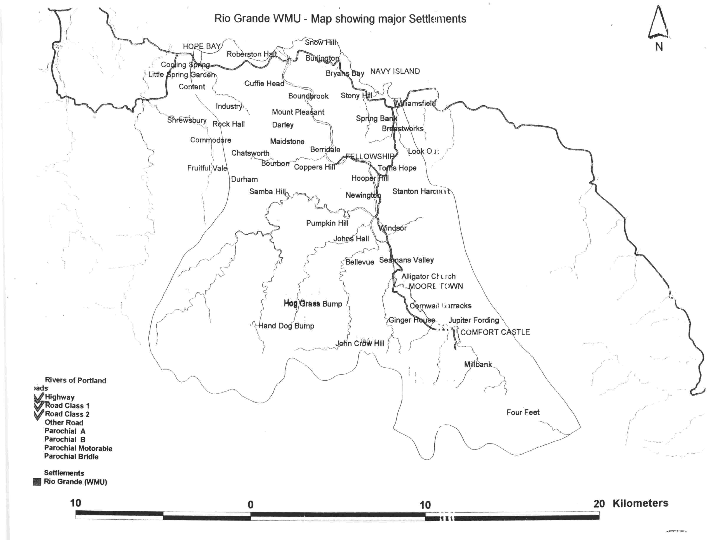
1
2
3
4
5
6
1
4. River Conditions During the Study

In order to assess how representative the data generated from the sampling exercises are of general river conditions, the flow of the river was ascertained from the WRA monitoring equipment on the days the samples were taken. The impact of water quality on communities will be most significant during the lower flow regimes (more likely times for access to the river).

Max flow – 56,713 ft³/sec or 1606.11 m³/sec

Min flow – 104 ft³/sec or 2.95 m³/sec

Ave. flow – 1,219 ft³/sec or 34.52 m³/sec

Table 2 Flow Data for Sampling Days
Sampling Date | Trip number | Flow  ft³/sec | Flow m³/sec | Flow Range
May 26,2004 | 1 | 1186 | 33.79 | LM
July 23, 2004 | 2 | 305 | 8.64 | L
August 26, 2004 | 3 | 239 | 6.77 | L
September 30, 2004 | 4 | 410 | 11.61 | L
October 28, 2004 | 5 | 418 | 11.84 | L
November 28, 2004 | 6 | 168 | 4.76 | L
January 26, 2005 | 7 | 448 | 12.69 | L
March 3, 2005 | 8 | 248 | 7.02 | L

Flow Range based on Data from Jan 2004 - December 2004 , Low (L) 100 – 1,000 ft³/sec, 2.83 – 28.32 m³/secLow – Medium (LM) 1,000-2,000 ft³/sec, 28.32 – 56.64 m³/sec, Medium (M) 2,000-10,000 ft³/sec, 56.64 – 283.2 m³/sec, High (H) > 10,000 ft³/sec, > 283.2 m³/sec

The data was also ranked according to magnitude and flow percentiles identified. For example in 2004 the maximum daily flow was 1606.11m³/sec (100%) and 50% of the time the flow was more than or equal to 12.17 m³/sec. The percentiles for the flow on during 2004 are presented in Table 3.

Table 3 Data Quality Parameters

Water Resources Authority Flow Duration
Station Number: | 10MA004
Name: | RIO GRANDE @ FELLOWSHIP (10MA004)
Time-Series: | Mean Daily Flow
Period of analysis from: 1-Jan-2004 to 31-Dec-2004
Seasonal flow duration analysis from Jan to Dec
Time interval (days) = 1 Intervals in period = 366
 | Station
 | 10MA004
Intervals with data | 366
Intervals missing or out of season | 0
Mean daily flow | 34.508
95 percentile (Q95) | 5.171
90 percentile (Q90) | 6.059
75 percentile (Q75) | 7.675
50 percentile (Q50) | 12.172
25 percentile (Q25) | 23.18
10 percentile (Q10) | 52.227
5 percentile (Q5) | 111.251
Percentiles in cumecs
Mean daily flows from 1-Jan-2004 to 31-Dec-2004
Class | Station
Interval | 10MA004
2.943 | 100.00%
3.347 | 98.90%
3.806 | 98.40%
4.329 | 97.00%
4.923 | 95.90%
5.598 | 93.40%
6.367 | 87.70%
7.241 | 77.90%
8.234 | 71.30%
9.364 | 65.00%
10.649 | 57.40%
12.111 | 50.30%
13.773 | 42.90%
15.663 | 37.70%
17.812 | 33.60%
20.257 | 29.20%
23.037 | 25.10%
26.198 | 22.10%
29.793 | 18.00%
33.882 | 14.50%
38.532 | 13.40%
43.82 | 11.50%
49.833 | 10.40%
56.672 | 9.30%
64.449 | 7.90%
73.294 | 7.70%
83.352 | 6.00%
94.791 | 5.70%
107.8 | 5.20%
122.593 | 4.40%
139.417 | 3.60%
158.55 | 3.60%
180.309 | 3.30%
205.053 | 3.00%
233.193 | 2.20%
265.195 | 1.90%
301.589 | 1.60%
342.978 | 1.60%
390.046 | 1.40%
443.574 | 1.40%
504.447 | 1.10%
573.674 | 1.10%
652.402 | 0.50%
741.934 | 0.50%
843.753 | 0.30%
959.544 | 0.30%
1091.227 | 0.30%
1240.98 | 0.30%
1411.285 | 0.30%
1604.962 | 0.30%
Table giving percentage of time each class interval is equaled or exceeded
5. River Water Quality Data

  - Data presentation

The data for the river sites are presented on data sheets 1 – 6, one site per page. The nineth column indicates the flow conditions that prevailed on each trip (l- low, m- medium, h – high; Table 2). The chemical and bacterial data was collected and presented in columns 2 – 8 in the data tablets.

Below the data tables are graphs of key water quality parameters. The concentrations (y axes) are plotted against trip number (x axes).

5.2 Data Quality

The uncertainties arise primarily from the sampling exercise and reflect in-homogeneities in the water at the site and variations arising during storage, transport and handling of the samples. Care should be taken to consider these uncertainties when comparing data.

5.3 Fresh Water Quality Standards

The final three columns of Table 4 give the fresh water standards for some authorities. The NEPA standard defines concentration ranges for ambient Jamaican waters and was arrived at by considering available data. It does not define allowable maximum concentrations but rather indicates the ranges within which concentrations can be expected to be found. The Cartagena Convention (UNEP-CEP, 2002) standard refers to discharges to Class I marine waters which include, amongst others, recreational waters, and waters containing coral reefs, sea grass beds or mangroves. The Hawaiian standard (USEPA website) can be considered to be representative of water quality standards as applied in the USA where each state or territory defines its own standards according to USEPA guidelines. Parameters for which concentration limits are defined and the actually defined limits therefore vary from place to place and even in some cases from river to river. The most commonly agreed on limit, although not for the three cited authorities, is that faecal coliform should not exceed 400MPN/100ml although even then some authorities use the number as absolute while others require that no more than 25% of the samples should exceed 400MPN/100ml. Nutrient standards are normally refer to total nitrogen and total phosphorus but limits are often not defined. Many USA state water quality standards say that nutrient concentrations shall not be altered so as to cause an imbalance in the natural populations of flora and fauna.

Table 4 Water Quality Standards for Embayments and Coastal

Parameter | Units | Detection limit | uncertainty | Fresh Water Standards
 |  |  |  | NEPA | CC* | Hawaii
pH |  |  | ± 0.1 | 7.0 -8.4 | 5 – 10
Total suspended solids (TSS) | mg dm⁻³ | 4 | <10, 50%  >10, 20% |  | 30 | 50
Nitrate + nitrite (TOxN) | mgN dm⁻³ | 0.003 | < 0.5, 20%  > 0.5, 10% | 0.1 – 7.5 |  | 0.18
Total dissolved phosphorus (TDP) | µgP dm⁻³ | 1 | < 15, 30%  > 15, 20% |  |  | 100
Faecal Coliforms (coli) | MPN/100ml | 2 | At 120, 200%  At 400, 400% |  | 200

dm³ – cubic decimetres (litres); mg – milligrams; µg – micrograms; O₂ – oxygen. CC* Cartagena convention is the UNEP-CEP Convention for the protection and Development of the Marine Environment of the Wider Caribbean Region. (UNEP-CEP, 2002)

Water Quality Data

Table 5 Site 1 - Millbank
Date | NO3-N (mg/l) | PO4-P (mg/l) | TSS (mg/l) | TDS | BOD | Faecal Coliform (MPN/100ml) | pH | Flow Condition
26-May-04 | 0.020 | 0.036 | <10 | 150 | 0.05 | * | 8.2 | Low – Medium
23-Jul-04 | 0.266 | 0.088 | <10 | 120 | 2.4 | 1600 | 8.47 | Low
26-Aug-04 | 0.283 | 0.165 | <10 | 186 | 0.57 | 70 | 8.22 | Low
30-Sep-04 | 0.112 | 0.160 | <10 | 48 | 0.99 | 30 | 8.34 | Low
28-Oct-04 | 0.047 | 0.607 | <10 | 138 | 1.25 | 500 | 8.14 | Low
28-Nov-04 | 0.266 | 0.049 | <10 | 132 | 0.66 | 110 | 8.35 | Low
26-Jan-05 | 0.120 | 0.040 | <10 | 168 | 1.06 | 170 | 7.46 | Low
3-Mar-05 | 0.070 | 0.010 | <10 | 156 | 0.46 | 240 | 8.36 | Low
Monthly Ave. | 0.148 | 0.144 | <10 | 137 | 0.930 | 340 | 8.19

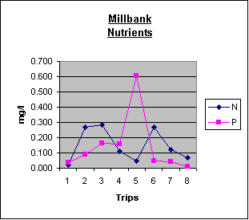
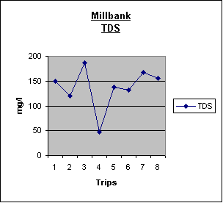
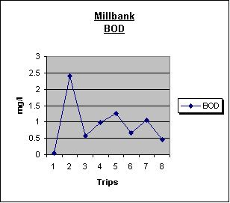
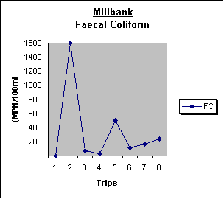

Table 6 Site 2 - Data at Alligator Church Bridge
Date | NO3-N (mg/l) | PO4 (mg/l) | TSS (mg/l) | TDS | BOD | Faecal Coliform (MPN/100ml) | pH | Flow Condition
 | (4500-NO3-E) | (4500-P-E) | (2540-B) | (2540-C) | (5210-B) | (9221-E)
26-May-04 | 0.060 | 0.180 | <10 | 190 | 0.03 | * | 8.29 | Low – Medium
23-Jul-04 | 0.269 | 0.040 | <10 | 144 | 0.37 | 1600 | 8.44 | Low
26-Aug-04 | 0.176 | 0.239 | <10 | 152 | 0.47 | 900 | 8.01 | Low
30-Sep-04 | 0.075 | 0.450 | <10 | 126 | 0.55 | 1600 | 8.51 | Low
28-Oct-04 | 0.373 | 0.148 | <10 | 164 | 1.41 | 300 | 8.44 | Low
28-Nov-04 | 0.269 | 0.021 | <10 | 118 | 0.68 | 8 | 8.46 | Low
26-Jan-05 | 0.130 | 0.020 | <10 | 172 | 1.09 |  | 7.15 | Low
3-Mar-05 | 0.050 | 0.010 | <10 | 156 | 0.76 | 1600 | 8.31 | Low
Monthly Ave. | 0.175 | 0.139 | <10 | 153 | 0.670 | 751 | 8.20

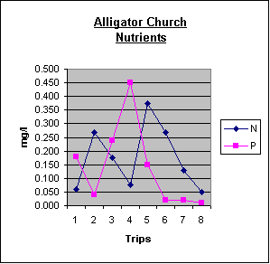
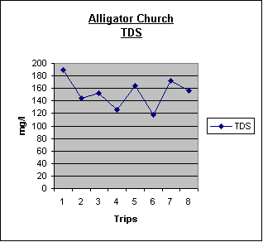
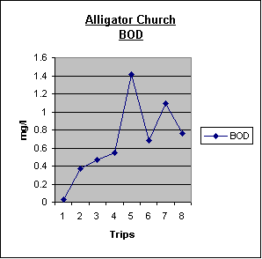
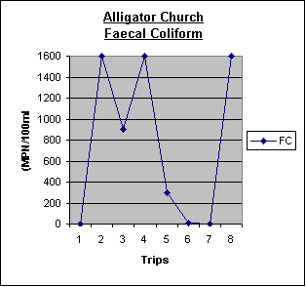
Table 7 Site 3 - Data at Fellowship
Date | NO3-N (mg/l) | PO4 (mg/l) | TSS (mg/l) | TDS | BOD | Faecal Coliform (MPN/100ml) | pH | Flow Condition
 | (4500-NO3-E) | (4500-P-E) | (2540-B) | (2540-C) | (5210-B) | (9221-E)
26-May-04 | 0.120 | 0.022 | 12 | 144 | 0.03 |  | 8.11 | Low – Medium
23-Jul-04 | 0.266 | <0.005 | <10 | 160 | 0.42 | 300 | 8.5 | Low
26-Aug-04 | 0.338 | 0.186 | <10 | 176 | 0.89 | 280 | 7.92 | Low
30-Sep-04 | 1.760 | 0.070 | <10 | 98 | 0.71 | 240 | 8.5 | Low
28-Oct-04 | 0.132 | 0.072 | <10 | 148 | 1.62 | 110 | 8.5 | Low
28-Nov-04 | 0.266 | 0.021 | <10 | 138 | 0.7 | 6 | 8.44 | Low
26-Jan-05 | 0.170 | 0.010 | <10 | 140 | 0.53 | 30 | 7.46 | Low
3-Mar-05 | 0.040 | 0.020 | <10 | 122 | 0.93 | 11 | 8.49 | Low
Monthly Ave. | 0.387 | 0.050 | <10 | 141 | 0.729 | 122 | 8.24
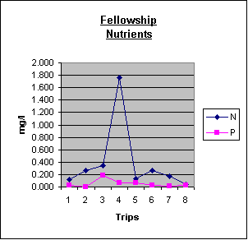
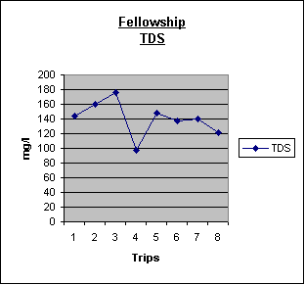
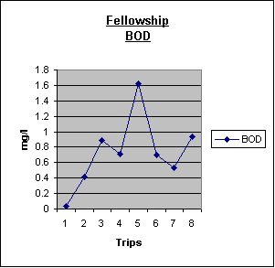
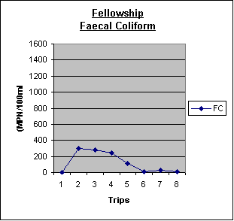
Table 8 Site 4 - Data at Berridale
Date | NO3-N (mg/l) | PO4 (mg/l) | TSS (mg/l) | TDS | BOD | Faecal Coliform (MPN/100ml) | pH | Flow Condition
 | (4500-NO3-E) | (4500-P-E) | (2540-B) | (2540-C) | (5210-B) | (9221-E)
26-May-04 | 0.100 | 0.093 | 34 | 140 | 0.13 |  | 8.14 | Low – Medium
23-Jul-04 | 0.273 | 0.013 | <10 | 120 | 0.29 | 240 | 8.51 | Low
26-Aug-04 | 0.571 | 0.223 | <10 | 149 | 0.43 | 500 | 7.98 | Low
30-Sep-04 | 0.075 | 0.440 | <10 | 400 | 0.78 | 280 | 8.49 | Low
28-Oct-04 | 0.273 | 0.091 | <10 | 144 | 1.88 | 240 | 8.51 | Low
28-Nov-04 | 0.266 | 0.089 | <10 | 192 | 0.99 | 8 | 8.21 | Low
26-Jan-05 | 1.140 | 0.040 | <10 | 140 | 0.38 | 80 | 7.26 | Low
3-Mar-05 | 0.060 | 0.010 | <10 | 144 | 0.82 | 500 | 8.22 | Low
Monthly Ave. | 0.345 | 0.125 | <10 | 179 | 0.713 | 231 | 8.17
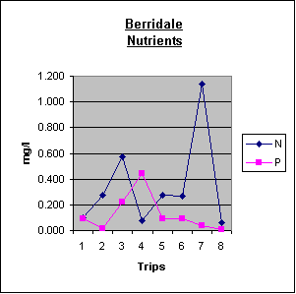
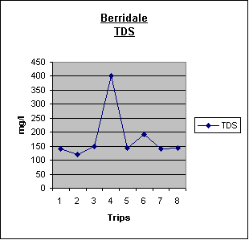
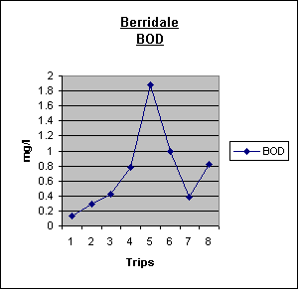
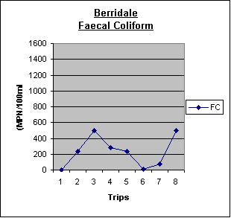
Table 9 Site 5 - Data at Burlington
Date | NO3-N (mg/l) | PO4 (mg/l) | TSS (mg/l) | TDS | BOD | Faecal Coliform (MPN/]  100ml) | pH | Flow Condition
 | (4500-NO3-E) | (4500-P-E) | (2540-B) | (2540-C) | (5210-B) | (9221-E)
26-May-04 | 0.180 | 0.040 | 30 | 62 |  |  | 8.14 | Low – Medium
23-Jul-04 | 0.269 | <0.005 | <10 | 145 | 0.37 | 1600 | 8.51 | Low
26-Aug-04 | 0.965 | 0.784 | <10 | 182 | 0.53 | 33 | 7.98 | Low
30-Sep-04 | 0.168 | 0.590 | <10 | 118 | 0.51 | 36 | 8.49 | Low
28-Oct-04 | 0.139 | 0.067 | <10 | 166 | 2.27 | 500 | 8.51 | Low
28-Nov-04 | 0.269 | 0.075 | <10 | 128 | 0.48 | 10 | 8.21 | Low
26-Jan-05 | 4.830 | 2.970 | <10 | 764 | 0.6 | 14 | 7.26 | Low
3-Mar-05 | 0.090 | <0.005 | <10 | 162 | 0.62 | 90 | 8.22 | Low
Monthly Ave. | 0.864 | 0.625 | <10 | 216 | 0.673 | 285 | 8.17
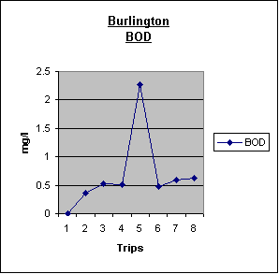
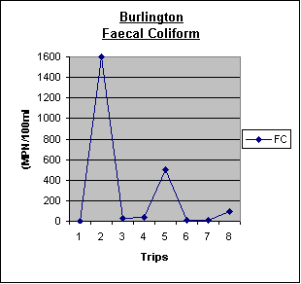
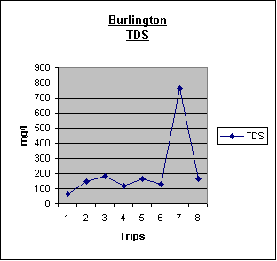
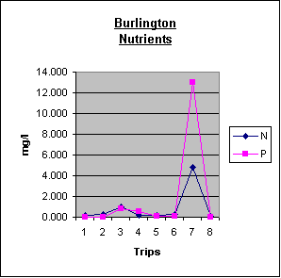
Table 10 Site 6 - Data at Breastworks
Date | NO3-N (mg/l) | PO4 (mg/l) | TSS (mg/l) | TDS | BOD | Faecal  Coliform  (MPN/  100ml) | pH | Flow Condition
 | (4500-NO3-E) | (4500-P-E) | (2540-B) | (2540-C) | (5210-B) | (9221-E)
26-May-04 | 0.180 | 0.037 | <10 | 44 | 0.38 |  | 7.98 | Low –  Medium
23-Jul-04 | 0.304 | 0.118 | <10 | 242 | 0.89 | 1600 | 8.02 | Low
26-Aug-04 | 0.207 | 0.356 | <10 | 238 | 1.07 | 30 | 7.66 | Low
30-Sep-04 | 0.298 | 0.370 | <10 | 48 | 1.75 | 48 | 8.07 | Low
28-Oct-04 | 0.359 | 0.132 | <10 | 54 | 0.59 | 900 | 8.06 | Low
28-Nov-04 | 0.304 | 0.024 | 18 | 126 | 0.87 | 20 | 8.44 | Low
26-Jan-05 | 0.140 | 0.040 | 20 | 296 | 0.69 | 2 | 7.83 | Low
3-Mar-05 | 0.020 | 0.010 | <10 | 256 | 1.37 | 90 | 7.99 | Low
Monthly Ave. | 0.227 | 0.136 | <10 | 163 | 0.951 | 336 | 8.01
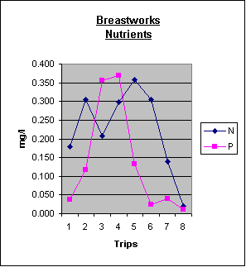
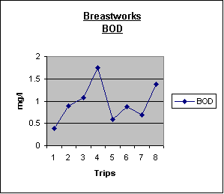
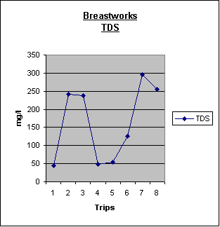
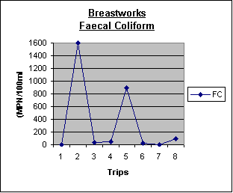
5.4 Discussion of River Sites Data

5.4.1 BOD
The biological oxygen demand is a parameter used to measure the amount of biological activity taking place in a sample of water. The greater the number of organisms living in the water, the greater the demand will be on the dissolved oxygen on a sample of that water. Typically one would not want to discharge treated wastewater from residential or commercial properties into a river, gully or stream with a BOD higher than 20 mg/l. The data showed average readings between 0.5 – 1.0 mg/l of BOD across the six sites, which implied relatively low levels of dissolved organic matter in the river.

5.4.2 The Nutrients (Nitrogen & Phosphorous)
The nutrients or more specifically nitrate (nitrogen) and phosphates (phosphorus), are the inorganic compounds that the plants use to grow and repair themselves. When there levels rise too high it can cause an imbalance of limiting photosynthesis at those sites.

The balances of nitrogen to phosphorous appeared to be out, in normal river systems there should be 10-20 times more nitrogen that phosphorous. The phosphorous is most likely coming from the fertilizers used in the farming communities. Further investigation would be necessary to clarify this assumption.

    - Faecal Coliforms
Faecal coliforms have their origins in the intestines of warm blooded mammals along with some naturally occurring soil bacteria. They are usually used to indicate contamination from faeces and suggest the presence of bacteria which negatively affect human health. For recreational waters most water quality authorities state that concentrations on any occasion should not exceed 400MPN dm⁻³ (see section 5.4). When determining the coliform concentrations an upper determination limit of 1600 MPN/100ml was set by the NEPA laboratory and so when concentrations exceeded that they reported > 1600MPN/100ml. Such concentrations have been reported as 1601 in the data sheets.

The preliminary data collected in the Rio Grande Watershed shows that the activity along the Rio Grande are beginning the affect the water quality of the river. The average valves measured for Faecal Coliform (FC) was found to below the 400 MPN/100ml, the international standard for recreational water bodies, in 5 out of the 6 sites where the samples were taken. The Alligator Church site was the only site that the FC measures where above 1600 MPN/100 ml on 3 of the 8 site visits. as a result we recommend that this area be look at more closely to identify what might be causing this elevated FC level.
6. Conclusion

Firstly, the areas surrounding the Alligator Church Bridge should be look at more closely to identify what might be causing this elevated FC level. Secondly, the sanitation solutions for dwelling located along the river need to be appropriate (i.e. no absorption pits along riverbanks) to reduce the potential for Faecal Coliform contamination of the river. Thirdly, the removal of livestock from areas along the riverbank would also reduce the potential FC contamination of the river. Finally, the implementation of the soil conservation techniques demonstrated on the anchor project, will not only save the soil but also help keep the fertilizers (phosphorous) out of the river.

