Beyond the Surface
By Tannisha Scarlett

“Did you know that we should all be friends of the sea?” asked Jerome.

“And what does that mean?” asked Shaun.

“Well, Jerome replied, “I am just sitting here looking at the water and I noticed that there are so many wonderful things under the sea that we never try to understand and appreciate, instead, we destroy them…”

The day was a very hot one, Jerome and Shaun got very sweaty after a full day of chores so they decided to go for a swim at Frenchman’s Cove in Portland, which is very near to their homes. Swimming was one of Jerome’s favourite past-times and it is something he had been doing ever since he was six years old.

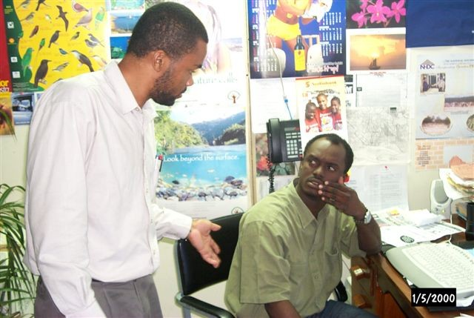

“Why is it that every time we are out here you start talking to yourself?” asked Shaun, “I am really worried about you. I think you are going mad.”

“No I’m not going mad;” replied Jerome. “It’s just that I have been learning so much about the environment, especially the coastal areas and how we should take care of it but sometimes we who should be the protectors are not doing our jobs, instead, we are selfish and don’t really care about anything or anyone else.

“So tell me, what are coastal areas and what do you mean by ‘we are selfish’?” asked Shaun.

“Coastal areas are places that relate to water or the sea, to be specific, as for the answer to the second question, you would have to come and dive with me so we can both experience all the things beyond the surface.”

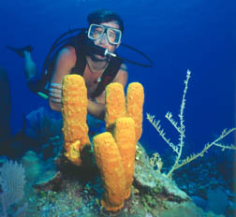

Shaun was very scared at first because it was the very first time that he was underwater for such a long time and he realized that his breathing had changed. After a while he got used to it and started to enjoy the wonderful but different world without gravity, a very colorful and different world from the one in which he lived. He thought it was great. The sounds were different, in a way that he could not explain.

After being under water for a while, Shaun started to mentally put all the things he saw into groups. First he grouped things that moved… these were all the fishes, crabs and reptiles. Some examples of the fishes were, parrot, surgeon, snapper, jellyfish, jack fish, damselfish, wrasse and turtles. The second category was made up of stationary things; these were corals, algae and sea grass.

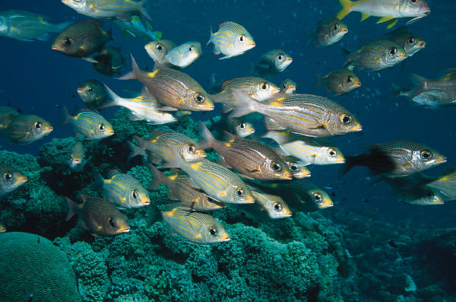

After all the fun under-water, the guys returned to the surface and Jerome began to explain the importance of all they had seen.

“Everything in the underwater environment has a role to play in the ecosystem,” he said

“The echo what?” asked Shaun.

Jerome laughed and said. “The ecosystem… and I will tell you what that is before you ask”.

“An ecosystem is an environment where plants and animals live together and benefit from each others way of life. All these plants and animals make up our biodiversity.

“What is biodiversity”? asked Shaun

Jerome explained that biodiversity is the short term for biological diversity, which means all form of life on earth or all of the plants and animals that we have.

He continued, “Algae grow and provide shelter and food for fish. Fishes on the other hand help to provide nutrients for the growth of algae. The corals provide sand for the beaches and they are also the main builders of coral reefs, which protect our beaches from high-energy waves”.

Jerome then started to talk about the turtles.

He said, “Turtles are some of the oldest animals on earth. They spend most of their lives in the sea. However, they do come ashore to lay their eggs and also feed among the coral reefs and sea grass beds.
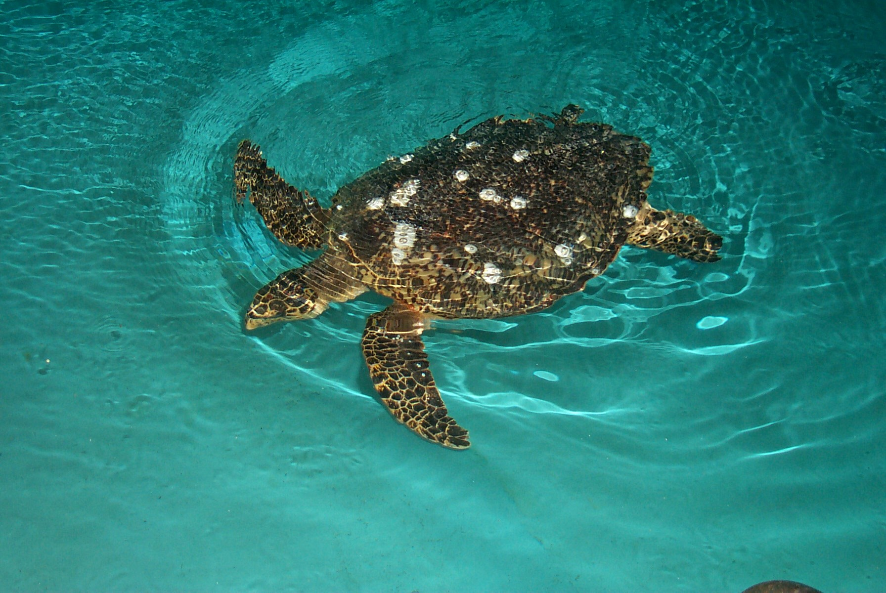

“They do, I didn’t know that”, replied Shaun, “go on”.

“By feeding in this area, they keep the wetland ecosystems healthy as they eat sick fishes that would otherwise pass on diseases to healthy fishes and cause a decline in the fish stock. Also, because of their beauty and relatively gentle nature they can be approached quite easily when diving and are attractive to watch”.

“Wow, that’s true, I really enjoy watching them”. Shaun added.

“I also heard we get our foreign exchange from the use of the coastal areas of Jamaica. Is that so?”

“Yes it is. But is there anything else you would like to ask me?”

“Believe me Jerome, I have learnt so much today. I can’t begin to explain, but one thing is for sure, I am going to pass the information on to someone else because things like this you just cannot keep to yourself. By the way, I did not know that you were this bright, but thanks anyway!”

“Go away Shaun,” Jerome said jokingly, “but you are welcome,”

With that they went their separate ways.

