Peter and the crocodile
By Zadie Neufville

Peter loves crocodiles. He works as a crocodile catcher at the Conservation office in town.

Peter catches crocodiles because they are protected. This means people who stone or kill crocodiles can go to jail.

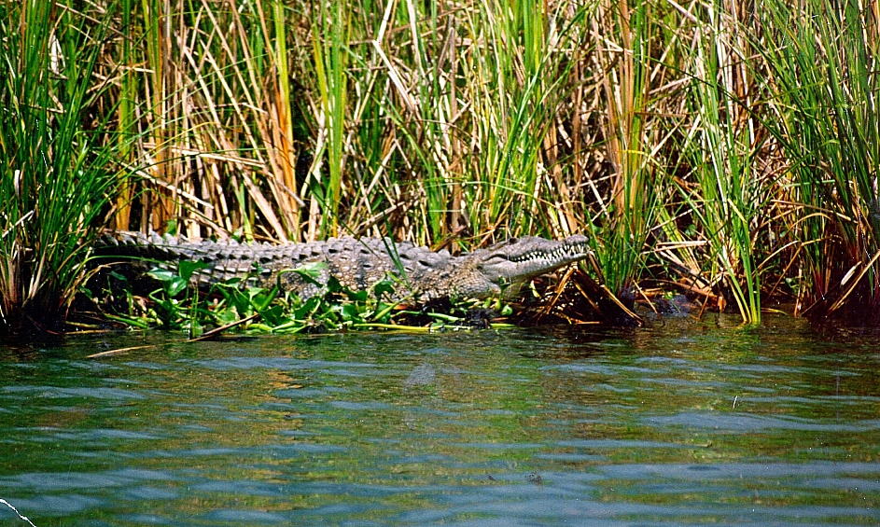

One day when Peter went to work. A man who lives near the mangroves called Peter on the telephone.

“Come quick,” said the man.

“There is a big crocodile in the river and people are throwing sticks and stones in the river to hit it,” he said.

The river runs through the mangrove. It is a nice cool place with shady trees.

Crocodiles love rivers and mangroves. The crocodile was looking for a nice cool place to stay.

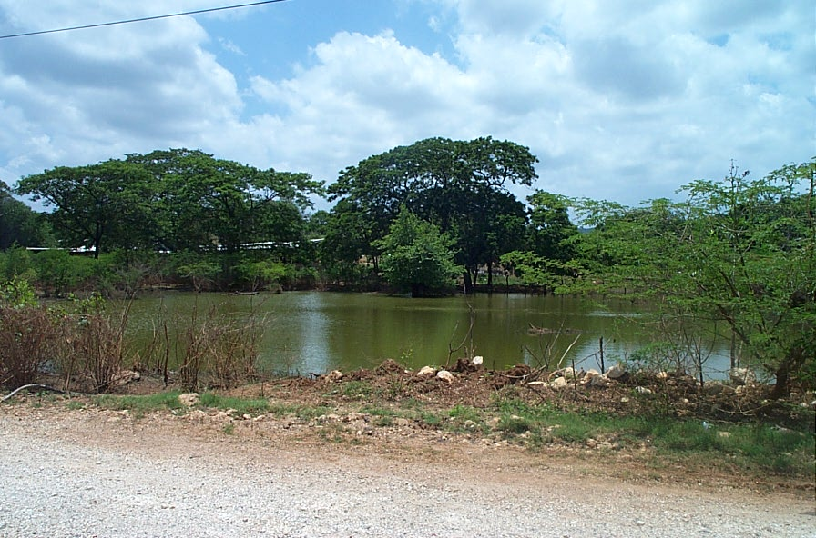
Many people are afraid of crocodiles so Peter must get to the river quickly. Many people live close to where the crocodile is staying.

Peter put on his water boots and his hat. He got some rope and a strong stick. He then jumped into his van and went off to the river.

When Peter the Crocodile Catcher got to the river, lots of people were looking down at the crocodile.

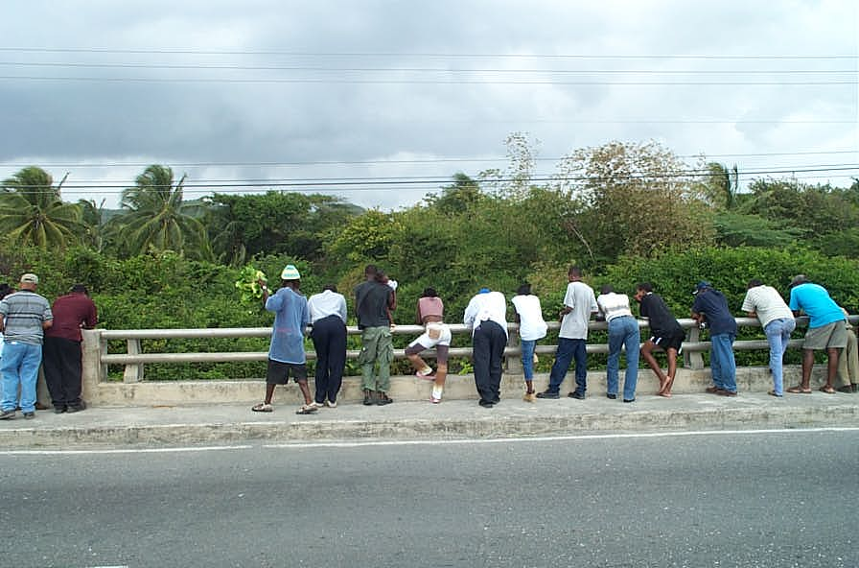

“Look!” said a girl in a big hat, “There is the crocodile!”

“Hit it!” said a boy with big water boots. He was climbing the bridge to throw stones into the water.

“Stop!” said Peter, “You can’t stone crocodiles”.

“And why not,” asked the boy.

“If you stone crocodiles you will hurt them. And if you hurt crocodiles you can go to Jail,” said Peter.

The boy dropped the stone.

“I never knew that,” he said. “I won’t stone crocodiles again”.

Then Peter told every one that they must help him to protect the crocodiles.

“We don’t have a lot of crocodiles left,” he said.

Why? asked the girl.

So Peter told them about the crocodiles.

“Crocodiles are descendants of the dinosaur. They look the same as they did millions of years ago. We don’t have as many crocodiles now because people cut the mangrove and used too much water. Now the Crocodile must live where man lives and this is hard,” said Peter.

“But they will eat us”, said the girl.

“Crocodiles eat fish and will only eat other animals if they are hungry and there is no fish!” said Peter.

“Crocodiles are shy and will run away, but if you are close to their babies and their eggs they will attack and may hurt you,” Peter said.

“Oh, I never knew that. I will tell my brother,” said the boy.

“If crocodiles are so nice why did you come for him,” asked the girl.

“I will put him in a safe place where no one can hurt him,” said Peter.

“We will help you,” said the people.

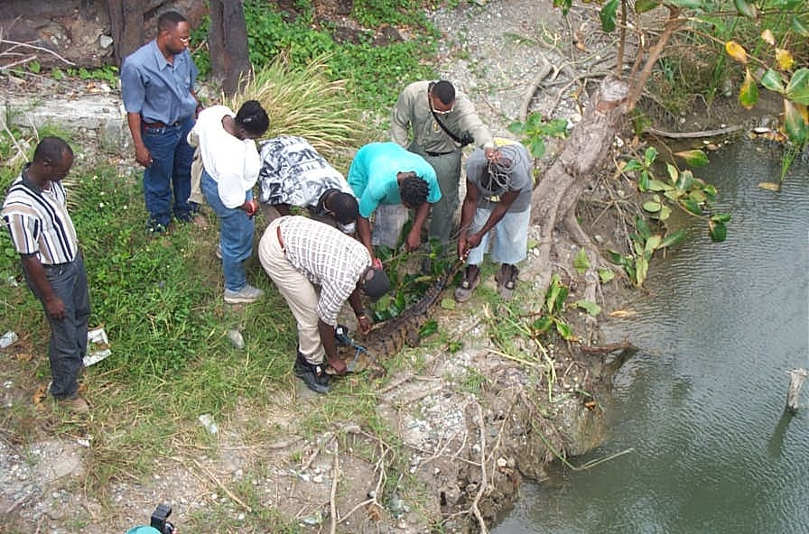

They followed Peter down to the River and helped him to catch the crocodile.

Then Peter tied up the crocodile so he could not bite anyone.

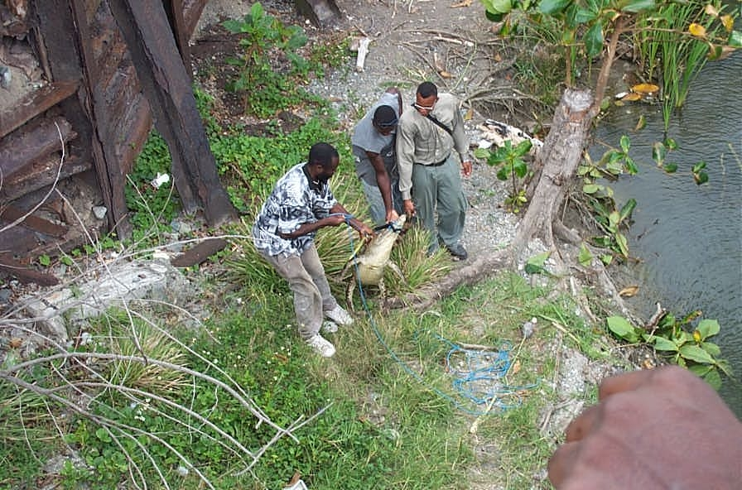

He then put him in the van and drove off to the Zoo.

CROCODILE FACTS

- There are 21 species of crocodiles
- But there is only one specie of crocodile in Jamaica
- Crocodiles can grow up to 5 metres
- Crocodiles hunt their food at night
- Crocodiles are meat eaters
- Crocodiles will hunt for food in garbage if they are hungry

Dos and Don’ts
- Don’t go fishing or bathing in rivers where there are crocodiles
- Don’t tie pigs and goats close to rivers and swamps with crocodiles
- Don’t dump garbage in rivers or swamps or beaches. This will attract crocodiles
- If you see a crocodile near your home call NEPA at 1-888 991-5005

